Natural fibres |  |  | Manufactured fibres
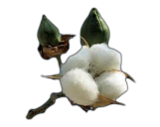  Natural fibres are ----------------------------------------------------------------------------------------------------- |  |  | 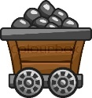  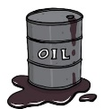  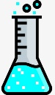  Manufactured are man-made fibres that are either completely made --------------------- (not living) materials or ----------- materials ----------- with -----------------  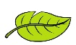
Aramid fibres  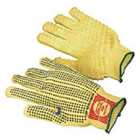  Are a class of ————————————————————- They are used in ——————————— applications (—————————- are examples)  Properties--------------- ----------------- |  |  | 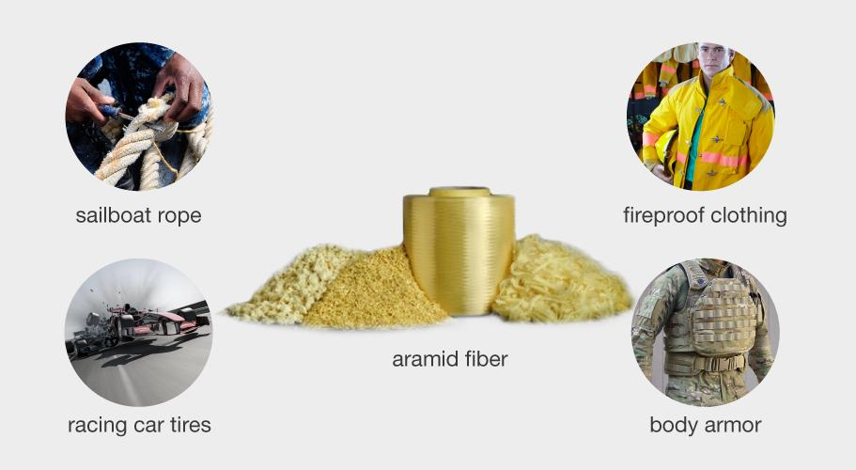
Strength |  | A material that soaks up liquid or moisture.
Elasticity |  | It is hydrophobic (a material that is completely resistant to water.
Absorbency |  | Strength of Materials: the behaviour of materials when forces are applied to them (pulled, tension, stress).
Durability |  | How long lasting and hard wearing a material is.
Insulation |  | A material that does not build-up of static electricity.
Flammability |  | The prevention or reduction of losing heat.
Water – repellence |  | How much a material can stretch and then return to its original position.
Anti-static |  | How well a material can stop or prevent reacting to something E.g.. Bleach, sunlight, chemical…..
Resistance to… |  | Materials ability to ignite and burns rapidly with a flame

Natural fibre properties  - These fibres come from ---------------------  - They are also -------------- (Something that will decay (break down) over time)  - Generally ---------------  - ------------ resistance to ----------------  - ---------------- – especially ---------- fibres |  | Manufactured fibre properties  - ---------------- than natural fibres.  - --------- less than ----------- fibres  - ----------------- for than natural fibres (i.e. wash/clean)  - Resistant to -------------------  - Durable
Microfibers  Microfibres have a -----------------. This creates less  --------- and -------------- and leads to --------------  Fibre examples are – T------------ and T----------------- |  | These are -------------------------  They are less than ------------------  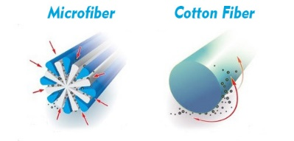  How much finer than one human hair?  What product are commonly made from them?
Fibre blends means …..  The combining of 2 or more --------------------------------------------------------------------------------------------- |  | Fibre mix means …..  This is when a fabric is made from ----- or more --------- types of -------------
Why are they blended/mixed? (i.e. what are the benefits)

1---------------------- 2 ------------------------ 3 ------------------------------ 4----------------------------
 | Product ----------------- Why?---------------------------------------------
 | Product ----------------- Why?---------------------------------------------
 | Product ----------------- Why?---------------------------------------------

