Fantastic fish session plan

Overview
The aim of this session is to help children understand that are lots of different types of fish which can be used to make a variety of dishes. The main activity, Have a go, involves learning how to prepare a simple dish called Splendid seaside salad, based on a prawn cocktail. The Consolidate activity involves children ‘fishing’ to catch fish for different dishes.

Learning
The aim of this session is for children to:
- recall the names of a selection different of fish and dishes made with fish;
- explain that we should eat fish twice a week;
- perform simple food skills safely with a focus on mixing, dividing and spooning.

You will need
- Splendid seaside salad recipe and the ingredients and equipment listed
- Setting up a cooking session guide
- Get ready to cook cards
- Fish dish cards – cut out and laminated
- Fish photographs – cut out and laminated
- Fish label - cut out and laminated
- Fish dish game boards – cut out and laminated
- Fantastic fish take home letter

Before session preparation
Prepare the ingredients and equipment in advance. What you will need is listed on the Splendid seaside salad recipe. See the Setting up a cooking session guide for more information about running cooking activities.

If children will be undertaking the Consolidate activity, see the Consolidate activity for information about the resources needed.

Listen and respond
Explain to the children that they will be learning about fish.
Question the children:
- What dishes made from fish have you eaten?
- Have you eaten any of these fish dishes? (Show the Fish dish cards.)
- What is your favourite fish dish?
- Do you know the name of the fish used to make your favourite dish? For example, cod, prawns, mackerel or salmon.
Show the four Fish photographs.
- Show the fish one at a time.
- Ask the children to describe the look of the fish, e.g. colour, shape.
- Ask the children to name the fish.
- Tell children the name of the fish and match the correct Fish label to each one (answers at the bottom of the next page*).
- Ask the children if they can name a dish made with each fish. They can look at the Fish dish cards images to help.

Explain that fish is good for us and we should try to eat it twice a week. Some fish are oily and this is good for our heart. Oily fish is darker in colour, like salmon and mackerel. We should try to eat one type of oily fish each week and one other type of fish, such as white fish or shellfish.

Have a go
Organise the children into groups of four. Each group can take turns to work with an adult to make a Splendid seaside salad. Make sure the children are ready to cook by using the Get ready to cook cards to talk through steps they need to take. Refer to the Settling up a cooking session guide for more information about why each step is important. Allow the children to make the dish.

Consolidate
This activity is for four children. You will need:
      - Fish dish game boards
- Fish photographs – two copies so there are eight fish in total;
- 8 x paperclips;
- 16 x counters;
- a ruler, string and a magnet - to create a fishing rod;
- a bucket or similar container.

Attach a paperclip to each fish. Create a fishing rod by attaching string to a ruler, stick or a similar object which can be used as a rod. Tie the magnet to the end of the string. Place the eight fish into the container, e.g. bucket. Give each child a Fish dish game board. The aim of the activity is for the children to take it in turns to ‘go fishing’ by dangling the rod into the container to try and ‘catch’ a fish. Once they have caught a fish, they must name it and say which dish on the board they can make with the fish (answers at the bottom of this page**). If they are correct, they can cover the dish with a counter. If they are wrong, the dish cannot be covered. The fish must then be returned to the container. If children catch more than one fish at a time, they may choose one from those caught and return the rest. The first to catch the correct fish to make all the dishes on their board is the winner.

At home
Make a copy of the Fantastic fish take home letter for each of the children. Explain to the children that next time they go food shopping with an adult they can search for the fish to make different dishes.

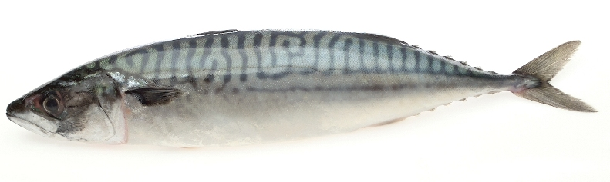
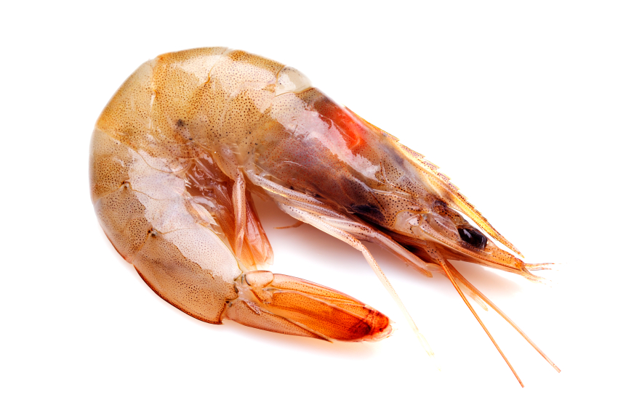
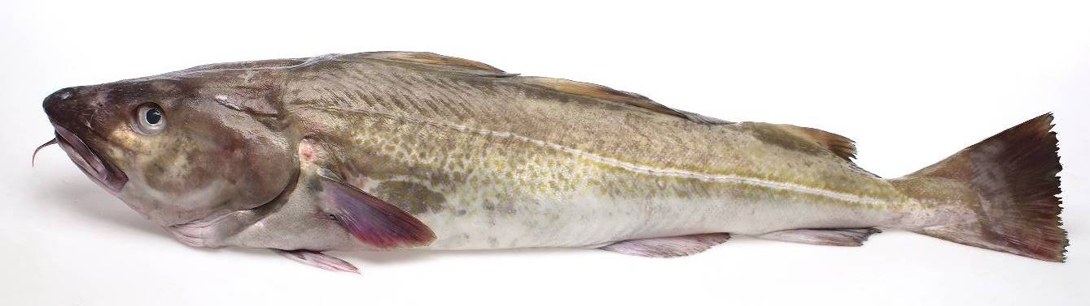
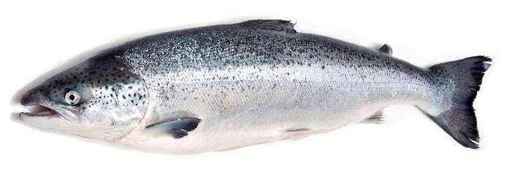
*

Cod Salmon Mackerel Prawn

** Cod = fish fingers, salmon = salmon fillet, mackerel = pâté, prawns = paella.

