Fantastic fish take home letter

Dear parent/carer

We have been learning that are lots of different types of fish which can be used to make a variety of dishes. We have learnt that we should try to eat fish twice a week.

Here are some of the fish dishes we have been learning about. Next time you are shopping for food with your child, see if they can find the fish for these dishes.

Fish dish | Find the… | Colour each fish when you find it!
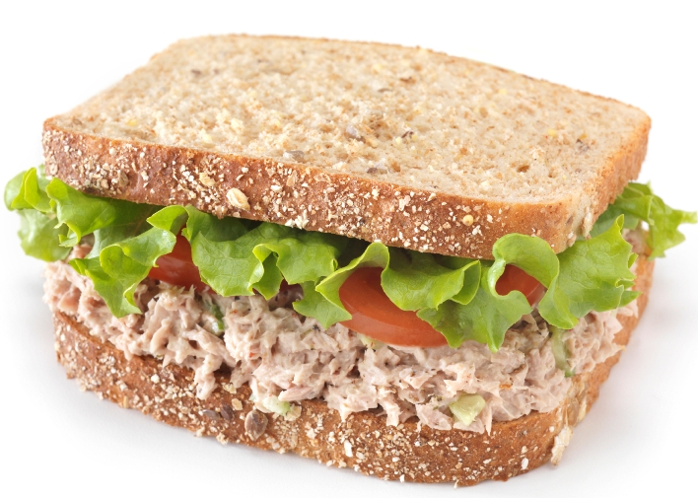  Tuna sandwich | 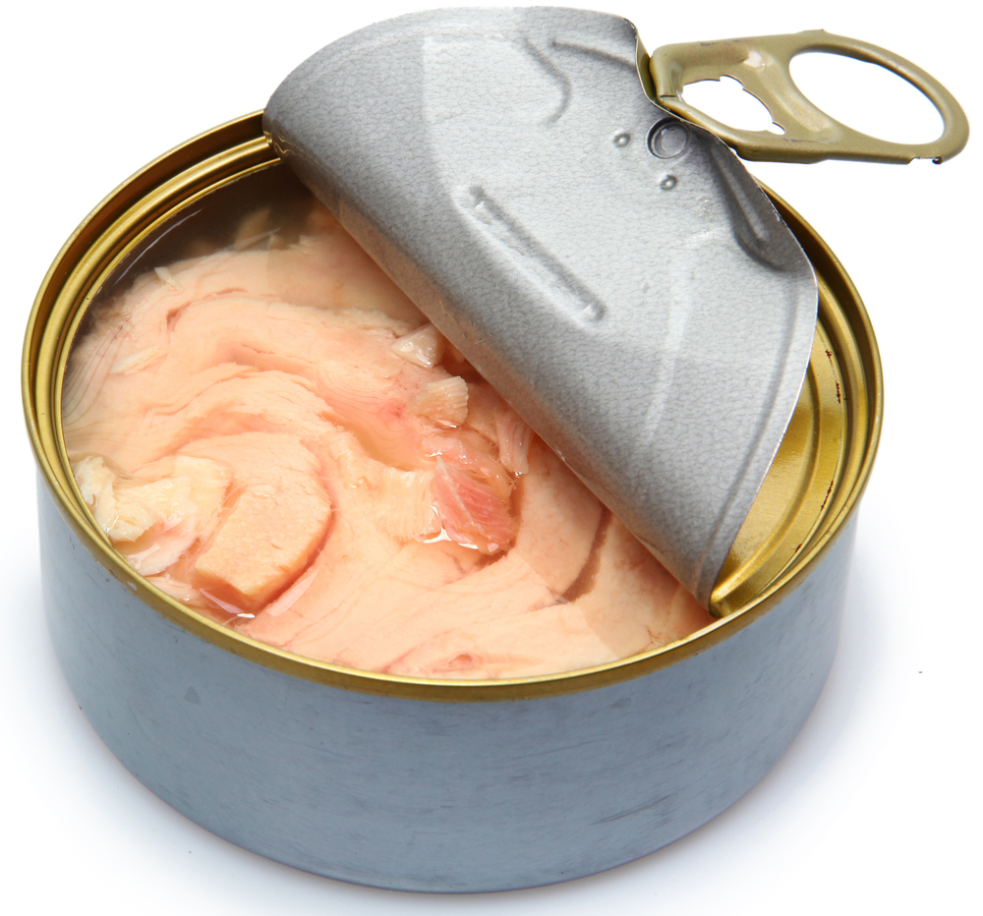  Tuna | 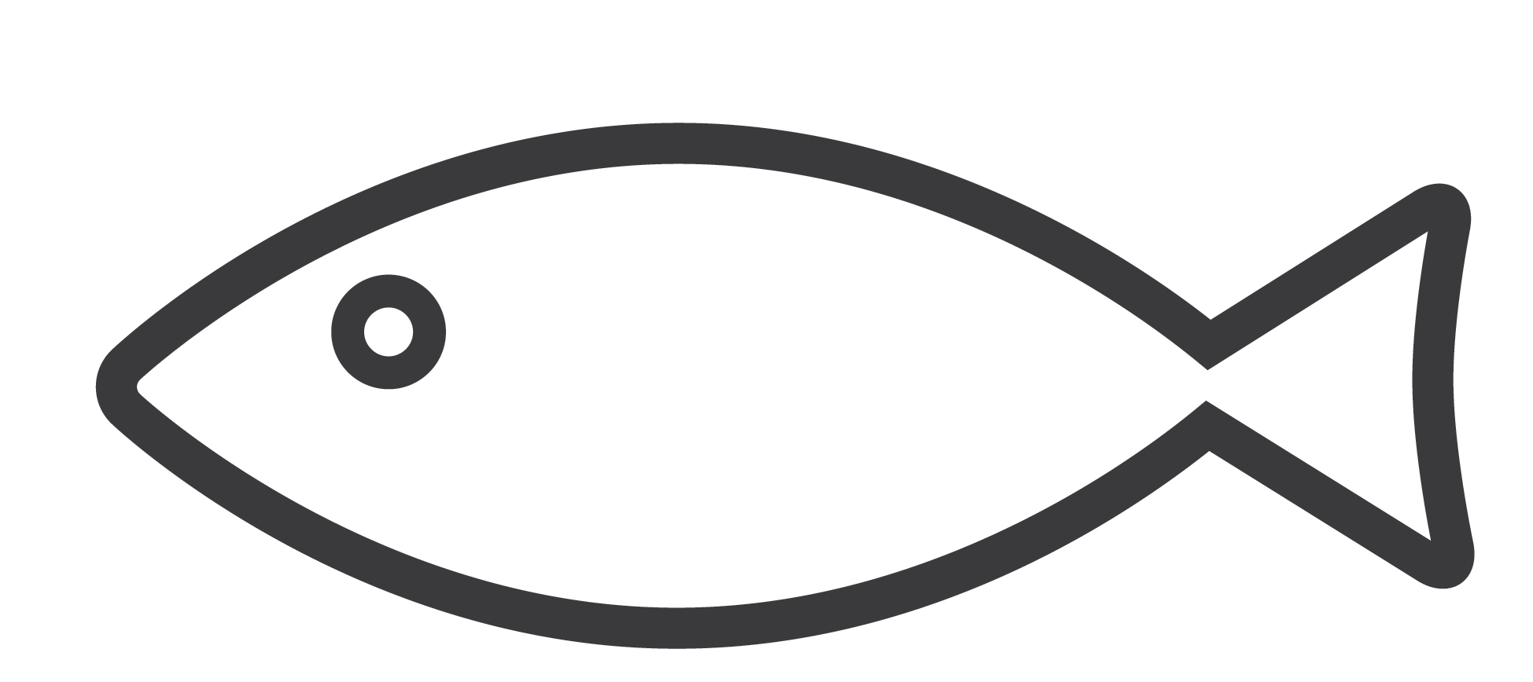
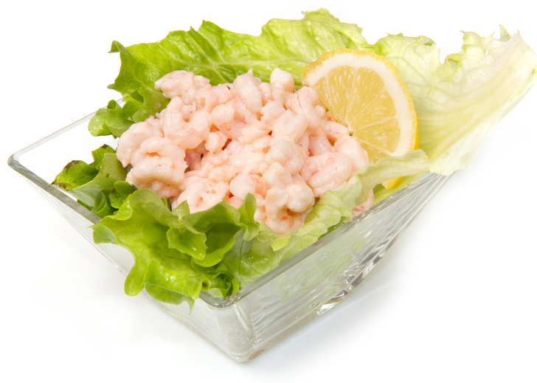  Prawn cocktail | 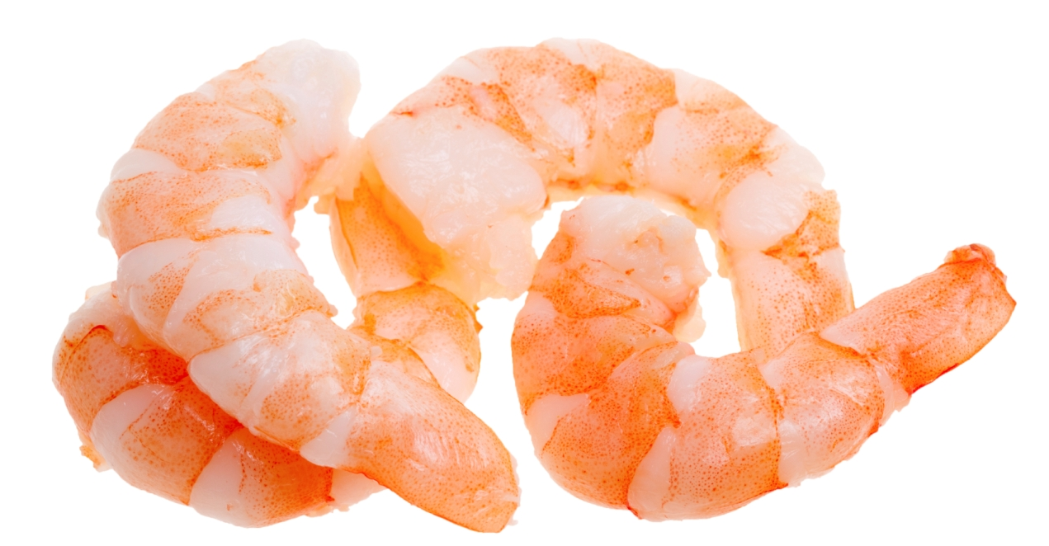  Prawns
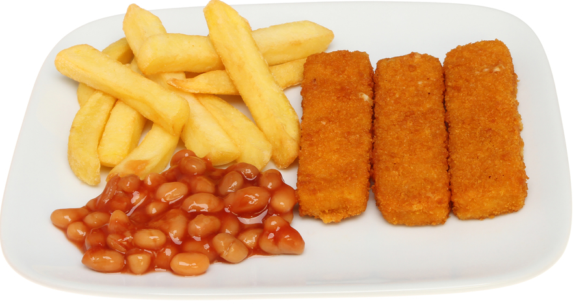  Fish fingers | 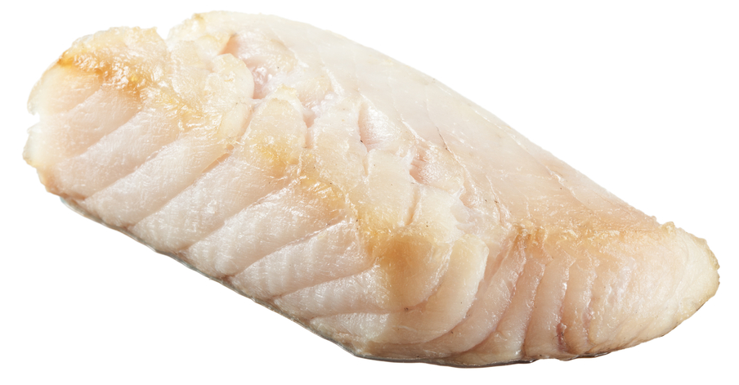  Cod
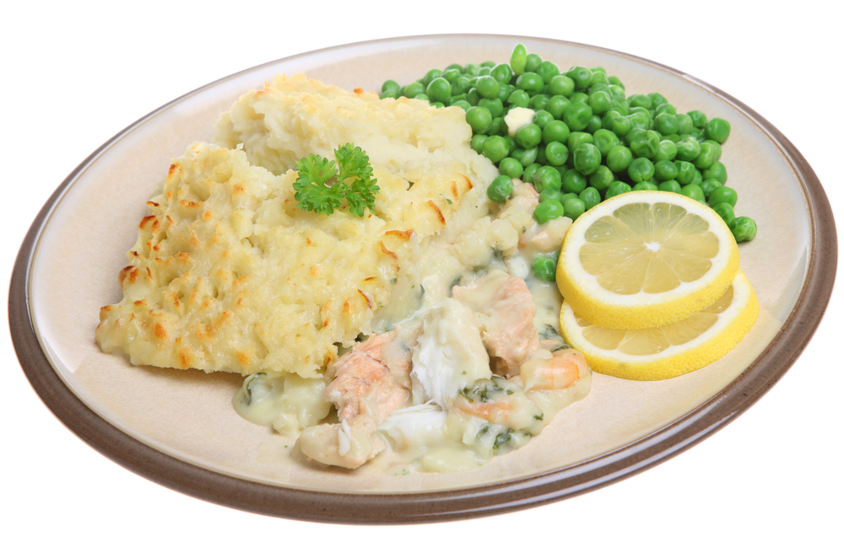  Fish pie | 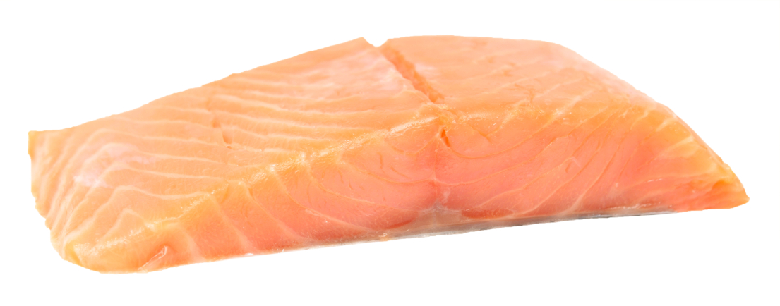  Salmon

