Setting up a cooking session

To ensure all food sessions are safe and enjoyable, it is essential to plan properly and in advance. The following bullet points are designed to help practitioners organise safe sessions.

First steps:
- Check if your establishment has a food policy you need to follow. If not, it would be good practice to write one.
- Send the Ingredient check letter home to parents/carers to check for allergies, religious or cultural reason why children may not be able to taste or handle a particular food (this can be found on the Food – a fact of life website).
- If you will be assisted by other adults in this session, ensure they are fully briefed on how you want the session run, e.g. key information you want to communicate to the children, food safety, how the equipment should be used, how to demonstrate best practice.

Cooking area:
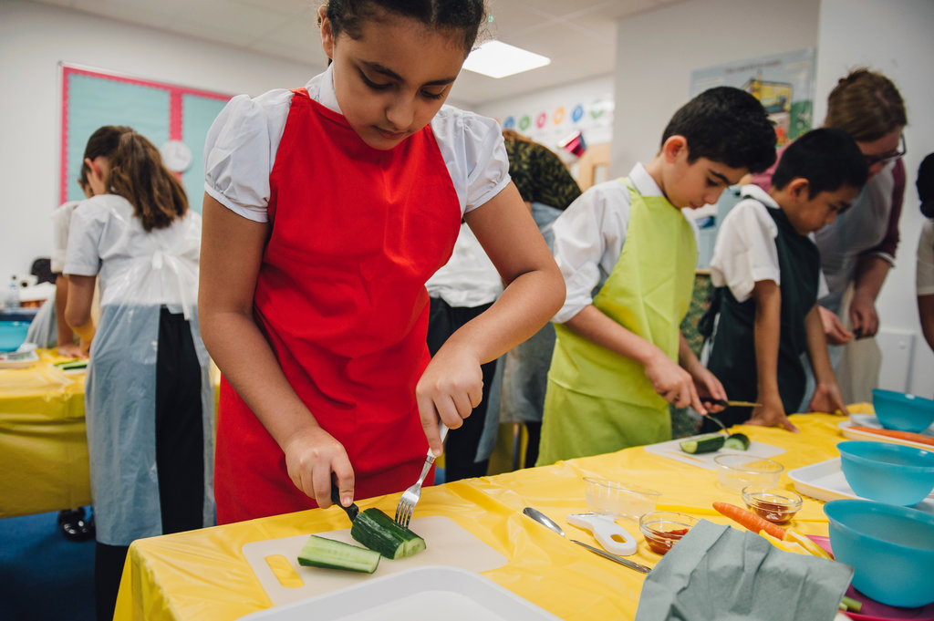
- Ensure the space to be used for food work is clear and uncluttered.
- If you are working in a designated food area, clean the surfaces to remove any visible dirt and then wipe them down with anti-bacterial spray. If you will be preparing food in a municipal area, cover the tables with clean, plastic table cloths and then wipe these with anti-bacterial spray.
- Make sure there is a sink with hot and cold water where you and the children can wash your hands before handling food as well as during and after, if required.
- Ensure that a waste bin and/or food compost bin is available so children can dispose of waste and keep their work areas orderly.

Ingredients:
- Plan the ingredients you will need for the session and demonstration. What will be needed? Who will buy the ingredients? Where do they need to be stored once they have been bought? Check all ‘use by’ and ‘best before’ date marks to make sure the food will be safe to use in the session.
- Wash fresh fruit and vegetables before the session, unless this is a teaching point and you want the children to do this.
- If you are pre-cooking any food before a session, plan to do this on the same day the food will be prepared and eaten. Ensure pre-cooked food is stored correctly. For example, pasta for pasta salad can be cooked, cooled with cold water and then stored in a covered container in the fridge until later the same day.
- If you have any children with intolerances or allergies to a particular food, remember to check all food packaging to ensure that any food to be used does not contain these ingredients. Make sure ingredients children can eat do not come into contact with ingredients they cannot eat – cross contamination. If there are any children who have a severe allergy to an ingredient, this should not be used at all in your session.
- Some food may need to be partly prepared or measured out before the session. This might be because time is tight or it is not appropriate for the ability/age of the children, e.g. cutting up a whole melon, weighing flour.
- Plan how and when this ingredient preparation will be done, and where this food will be stored.
- Just before the session, ensure all the ingredients needed for demonstrating are prepared and place them on a tray.

Equipment:
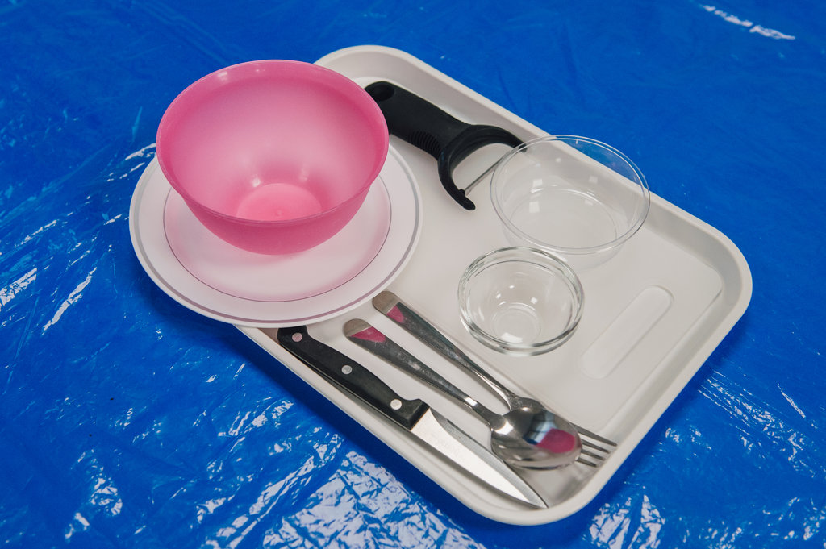
- Make sure all the equipment to be used is clean and in good working order. (Rusty or cracked equipment must not be used.)
- Children’s hands are smaller than adults – so check that equipment is an appropriate size.
- Ensure all the equipment needed for demonstrating is ready and place it on a tray.
- Use transparent containers when demonstrating so children can see what is happening.
- Avoid giving children glass bowls and measuring jugs to use just in case they are broken.

Leader:
- Ensure that you are confident and competent to demonstrate the skills and recipe. It is a good idea to try the recipe yourself before the session. Remember, you will be the role model and need to demonstrate good practice as you use equipment to prepare ingredients.
- Make sure children are able to see what you are doing when you demonstrate different skills. Can all the children see what you are doing?
- Before you begin any demonstrations, talk through what you are doing to prepare yourself to cook. This should include the following:
- remove any jewellery – this is to prevent it falling into the food or bacteria trapped under jewellery, such as rings and watches, coming into contact with food;
- tie back long hair – this is to prevent hair falling into the food or needing to be touched and transferring bacteria onto hands;
- roll up long sleeves – this is to stop clothing dangling into food;
- put on an apron – this is to prevent any contaminants transferring from clothes into food and also keeps clothes clean;
- wash and dry hands carefully – hands must be washed thoroughly with warm water and soap. Drying your hands properly is equally as important as warm, damp hands are an ideal breeding ground for bacteria.
- Equipment and ingredients needed by the children will need to be ready in advance. A useful technique is to put all the equipment and ingredients needed by a group of children on a tray or two so that can then simply be transported to their table when the cooking begins. Older children may have a tray each or per pair.

Demonstrating:
- Ensure that children understand why you are demonstrating. Recap your learning objectives.
- If you are showing a knife technique, ensure that all the children can see what you are doing – it might mean that you need to move your hands out of the way.
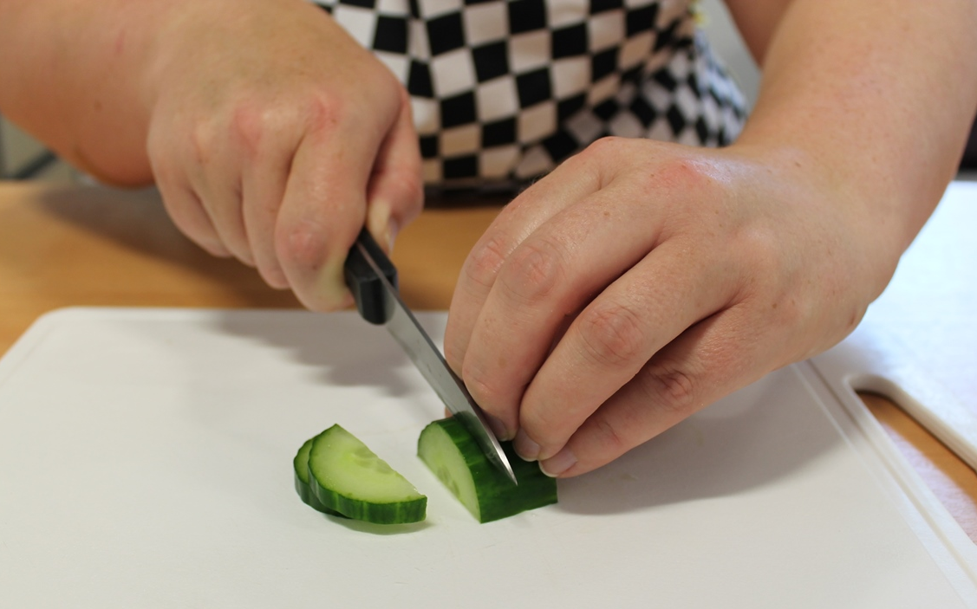
- Ask children questions about what is happening, e.g. Can you name the ingredients or equipment? What do I need to do to get ready to cook?
- Involve children in the demonstration. They could help weigh or prepare ingredients, e.g. weigh 100g flour or quarter tomatoes.

Children:
- Before the children undertake any food work, ensure they are ready to cook. They should follow the steps listed above in the Leader section. You could display the Get ready to cook cards as a reminder of the steps (these are available on the Food – a fact of life website).
- Ensure the children know:
  - they must wash their hands again if they blow their nose, cough or sneeze into their hands, touch hair, cuts or spots;
  - they must remove their apron if they go to the toilet and wash their hands afterwards in the toilet sink, and also re-wash their hands in the classroom sink before they go back to their cooking;
  - how to use the equipment safely (teacher demonstrate).
- Ensure children are clear about the expectations for the lesson, e.g. how they get their ingredients and equipment, behave in a cooking environment, prepare the dish, clear away afterwards.

