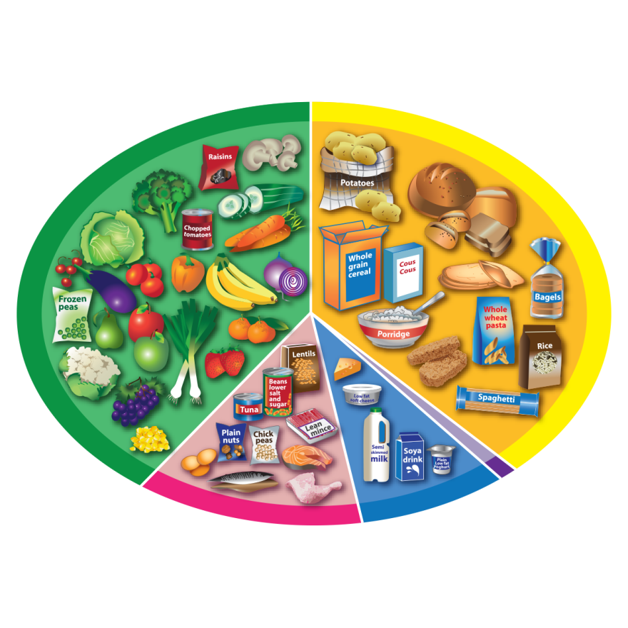 **The Eatwell Guide**

**Fruit and vegetables**

**Potatoes, bread,   
 rice, pasta**

**and other starchy   
 carbohydrates**



**Oil and spreads**

**Dairy and   
alternatives**

**Beans, pulses,   
fish, eggs, meat   
and other proteins**



**6-8**

**a day**