The Eatwell Guide information
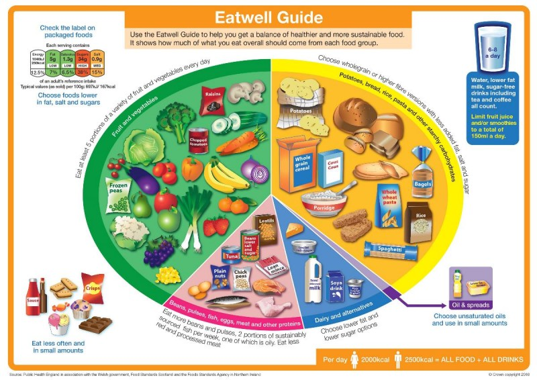

The Eatwell Guide is the UK healthy eating model. It shows the proportions in which different types of foods are needed to have a well-balanced and healthy diet. The proportions shown are representative of your food consumption over the period of a day or even a week, not necessarily each meal time.

The Eatwell Guide is based on the Government’s Eight tips for healthy eating, which are:

1. Base your meals on starchy foods.
2. Eat lots of fruit and vegetables.
3. Eat more fish – including a portion of oily fish each week.
4. Cut down on saturated fat and sugar.
5. Try to eat less salt – no more than 6g a day for adults.
6. Get active and be a healthy weight.
7. Don’t get thirsty
8. Don’t skip breakfast.

The Eatwell Guide applies to most people regardless of weight, dietary restrictions/preferences or ethnic origin. However, it doesn’t apply to children under two because they have different nutritional needs. Between the ages of two and five, children should gradually move to eating the same foods as the rest of the family, in the proportions shown on the Eatwell Guide. Anyone with special dietary requirements or medical needs might want to check with a registered dietitian on how to adapt the Eatwell Guide to meet their individual needs.

Healthy eating is all about balance, meaning that there are no good or bad foods and all foods can be included in a healthy diet as long as the overall balance of foods is right. All foods provide energy and nutrients and it is achieving the correct intake of those nutrients that is important for health.

No single food contains all the essential nutrients the body needs to be healthy and function efficiently. For example, dairy products such as milk and yogurts are great sources of calcium, but they are a poor source of vitamin C, citrus fruits are good sources of vitamin C, but they do not provide any iron.
The Guide is divided into five food groups. It shows the types of foods that fit into the five food groups and the proportions of these foods that should be eaten from each group.

More foods should be eaten from the Potatoes, bread, rice, pasta and other starchy carbohydrates group and the Fruit and vegetables group compared with the Beans, pulses, fish, eggs, meat and other proteins group and Dairy and alternatives group. Small amounts of oils and spreads can be included in a healthy diet.

Foods high in fat, salt and sugars are not needed in the diet. If these are consumed, it should be infrequently and in small amounts.

It is not necessary to achieve the Eatwell Guide balance at each meal but it should be applied to food eaten over a day or even a week. The amounts that should be consumed will vary depending on energy needs (based on age, sex and physical activity levels). Dishes containing more than one food can also fit into the model. For example, a pizza has a dough base with toppings. The dough base counts as a starchy food so having a thick base is a good idea. If the pizza is home-made the topping could be made with a reduced fat cheese or less cheese and more tomato and a side salad could be included to increase the amount of vegetables eaten.
Key message
The key message from the Eatwell Guide is that having a balance and variety of foods in the diet is important for health. Aiming to achieve this balance every day is a sensible and practical approach, although it is not necessary to achieve it at every meal occasion. Choosing different foods from within each group is also important as this adds to the range of nutrients consumed, as well as variety to the diet.

Fruits and vegetables

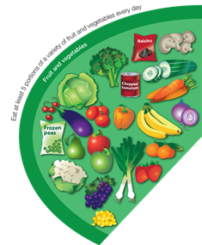
Eating at least five portions of fruit and vegetables every day is recommended for health. All fruits and vegetables count towards 5 A DAY except for potatoes. Fruits and vegetables can be fresh, canned, dried, frozen or juiced.

Fruits and vegetables are low in fat and high in fibre, so help to provide us with a range of important nutrients without exceeding our energy requirements. We need fibre in our diet to help us maintain a healthy gut.

They also contain vitamins and minerals – the main ones being vitamin C, vitamin A and folate. Some fruit and vegetables are higher in some vitamins and minerals than others, e.g. bananas are high in potassium, whereas dried apricots are high in iron. This is why it is important to eat a range of fruit and vegetables rather than having the same ones all the time.

Top tips:
• Choose fruit or chopped vegetables as a snack.
• Add dried or fresh fruit to breakfast cereals. (To reduce the risk of tooth decay, dried fruit is best enjoyed as part of a meal, not as a between meal snack.)
• Have a salad with sandwiches or with pizza.
• Add vegetables to casseroles and stews and fruit to desserts.
•Try to eat different fruits and vegetables every day.

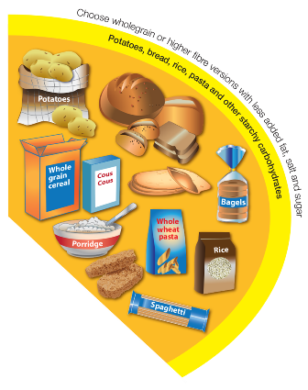
Potatoes, bread, rice, pasta and other starchy carbohydrates

Foods from this group should make up a third of the food we eat and be included at each meal. They provide energy in the form of starchy carbohydrates. Eating more starchy foods such as bread, potatoes, rice and pasta helps to reduce the amount of fat and increase the amount of fibre in the diet. Wholegrain and higher fibre versions should be included to increase fibre intake, which helps keeps the gut healthy.

Potatoes, yams, plantains and sweet potatoes fall into this group, rather than fruit and vegetables, because they contain starchy carbohydrates.
• Base your meals around foods from this group.
• Choose wholegrain or higher fibre versions of foods such as bread, pasta and breakfast cereal.
• Avoid frying or adding too much fat to these foods

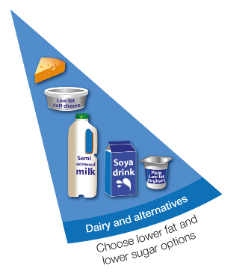
Dairy and alternatives

These foods provide calcium and are important in the diet for helping maintain healthy bones and teeth. These foods should be eaten in moderate amounts every day.

A serving of milk is a 200ml glass, a serving of yogurt is a small pot (150g), a serving of cheese is 30g (matchbox size). Choose lower fat and lower sugar options, such as semi-skimmed milk, low fat yogurt and reduced fat cheese.

• Choose low fat milk, i.e. semi-skimmed or skimmed milk.
• Choose low fat yogurts and reduced fat cheeses.

Beans, pulses, fish, eggs, meat and other proteins

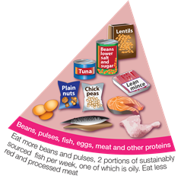
These foods provide protein for growth and development and minerals such as iron, zinc and magnesium and also B vitamins. Leaner cuts of meat and lower fat versions of these foods should be eaten in moderate amounts every day.

Visible fat and skin should be trimmed from meat and poultry, and cooking methods that do not add fat should be used, e.g. grilling, baking, steaming or poaching instead of frying. This helps to reduce the amount of saturated fat in the diet.

It is recommended that fish is included in the diet at least twice a week and that at least one of these is an oily fish, e.g. salmon, trout, mackerel or sardines.

Other sources of non dairy protein include nuts, tofu, mycoprotein, textured vegetable protein (TVP), beans such as kidney beans and canned baked beans, and pulses such as lentils.

• Choose lean cuts of meat.
• Cut visible fat including skin from meat and poultry and drain away fat after cooking.
• Try to grill, poach, steam, bake or microwave meat and fish rather than frying.
• Eat two portions of fish a week, one of which should be oily.

Oil and spreads
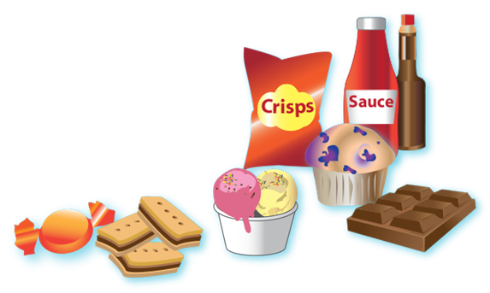
Although some fat in the diet is essential, generally we are eating too much saturated fat and need to reduce our consumption.
Unsaturated fats are healthier fats that are usually from plant sources and in liquid form as oil, e.g. vegetable oil, rapeseed oil, olive oil.

Swapping to unsaturated fats will help to reduce cholesterol in the blood, therefore it is important to get most of our fat from unsaturated oils.
Choosing lower fat spreads, instead of butter, is a good way to reduce your saturated fat intake.

Remember that all types of fat are high in energy and should be limited in the diet.

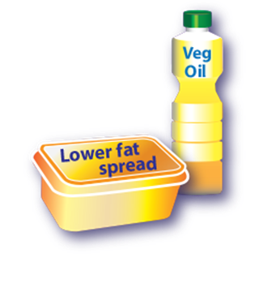
Foods and drinks high in fat, salt and sugars

This includes products such as chocolate, cakes, biscuits, full-sugar soft drinks, butter and ice-cream. These foods are not needed in the diet. If these are consumed, it should be infrequently and in small amounts.

Food and drinks high in fat and sugar contain lots of energy, particularly when you have large servings.

Check the label and avoid food which is high in fat, salt and sugar.

• Eat small quantities of these foods.
• Choose low fat or reduced sugar foods where possible.
• Use spreads and oils sparingly – opt for vegetable fats and oils.
• Try to limit consumption of sugar-containing foods and drinks between meals.
• Try not to add fat to foods when cooking.

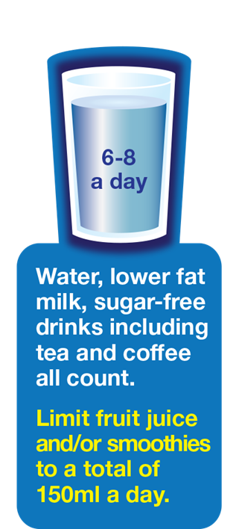
Fluids

It is important to drink enough to remain well hydrated. One of the most common causes of inability to concentrate is dehydration. Even mild dehydration of around 2% affects concentration, yet not enough to stimulate feelings of thirst. Drinking plenty of water can help concentration, sports performance and prevent headaches.

When the weather is hot, or during and after exercise or strenuous activity, more fluid is needed to replace what is lost from the body. It is recommended that we have at least 6-8 drinks a day.

Further information

Public Health England – Eatwell Guide
https://www.gov.uk/government/publications/the-eatwell-guide

British Nutrition Foundation www.nutrition.org.uk

