Lesson 2 – 1,2,3 Programming Activity
(Adapted from Barefoot Computing’s teaching resources. See the full lesson plan at https://www.barefootcomputing.org/resources/bee-bots-1-2-3-programming)
Before starting: Print the command cards, fakebot and numerals 0-9. Have the numerals in view for your child/ren to refer to.
No printer? Each resource can be drawn onto paper.
Notes for adults: This activity continues to use a fakebot (a printed or drawn Beebot) to create numbers.
Many of the concepts and approaches built into this lesson support computational thinking (problem solving):
• They use decomposition to break down the numerals into sections, making it easier to write the algorithm
• They write an algorithm that traces out the shape of each numeral
• They debug their algorithm or program if there is an error in it
• They persevere as they encounter bugs in their work and work through how to fix these
Starter:
- Be very bossy and instruct your child/ren to do something e.g. stand up, go to door, open it, come back to you and sit down.
- Ask what the special name is for a set of instructions to make something happen (algorithm). Algorithms are important as they help us to know what to do and how to make things happen.
- Explain today’s learning is about programming and how algorithms help us write in a language that computers can understand: code. They are steps to make something happen and are for people to understand but that programs are for computers.
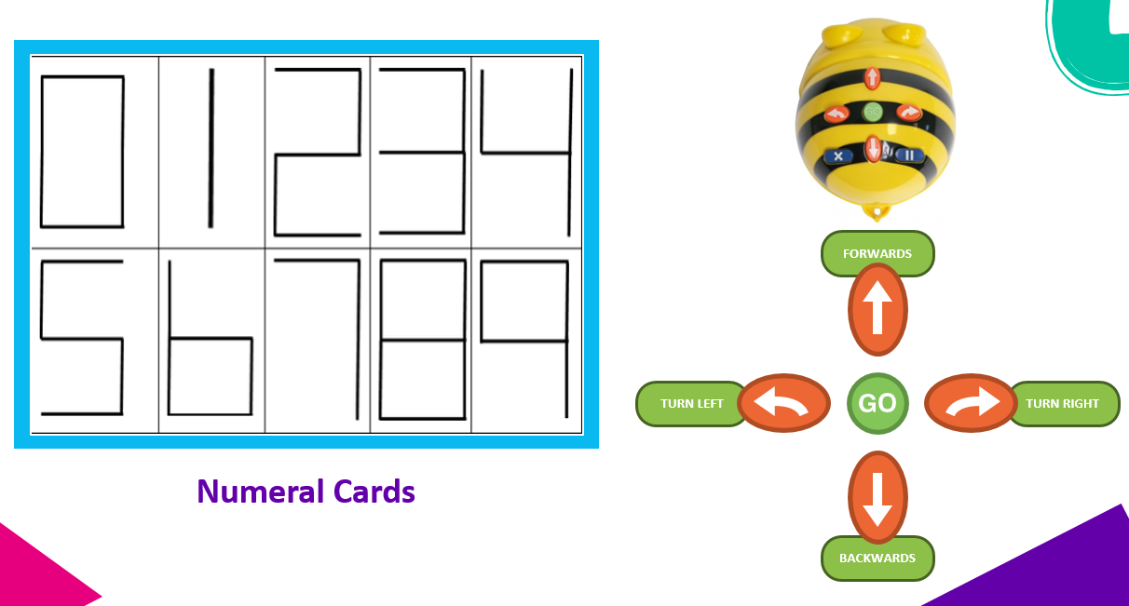
Activity 1:

- Show your child/ren the numerals 0-9 and ask, ‘how could we get the fakebot to make a 1?’ They may suggest forward, forward. Some children might start at the top of the number, others at the bottom
- Encourage your child to think about how to write the number 1 (starting at the top) reinforcing number formation
- Ask your child/ren how they could record their plan. Ask them what they call this plan. Hopefully, they remember from earlier work on algorithms that this is an algorithm. Let them have a go at drawing their algorithms on paper or using the command cards.
- Explain it is often a good idea to walk through an algorithm before we program it. Stand up and walk through the algorithm and/or use the fakebot to test the algorithm.
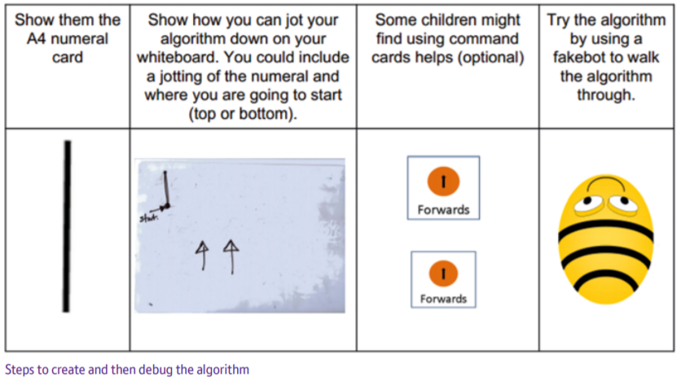
Activity 2
- Give your child/ren the task of creating an algorithm to make each digit 0-9.
- Give command cards if they are finding it tricky to work out the sequence of steps. Encourage your child/ren to try just 2 or 3 commands before they test it so they work on small bite-size chunks. This is always a useful approach to programming.
- Can your child/ren set out the algorithm on their own? Walk through the steps using the fakebot and command cards if needed. If any part does not go as planned, it is time to debug the algorithm.
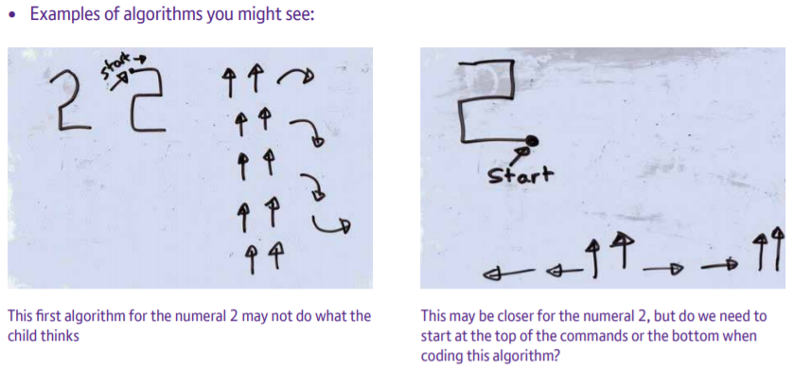
How they record their algorithm is less important than whether they can explain it and use it to program the fakebot.

