Lesson 3 – Algorithms and Programming
(Adapted from Barefoot Computing’s teaching resources. See the full lesson plans and resources at https://www.barefootcomputing.org/resources/bee-bots-1-2-3-programming and https://www.barefootcomputing.org/resources/bee-bots-tinkering-activity)
Before starting: Print the command cards, the picture of the Beebot (this is called a ‘fakebot’), a square grid, the star grid, the challenge word cards and the planning sheet.
No printer? Each resource can be drawn onto paper. N.B. The fakebot needs to fit into one square of the grid.
Notes for adults: This activity continues to use a fakebot (a printed or drawn Beebot). It explains the terms ‘algorithm’ (a set of steps, instructions or rules) and ‘debugging’ (fixing an error) as the children learn to create instructions for a programmable device.

Activity 1:
- Draw two shapes onto the grid, spaced apart.
- Mark a starting square for the fakebot.
- Place the fakebot on the starting square and use the command cards to lay out and create a sequence of instructions (this set of instructions is called an algorithm), that transport the fakebot to one of the shapes.
Children can write their algorithm using words, drawing arrows, or use a code/key e.g. ‘F’ = ‘Forward’.
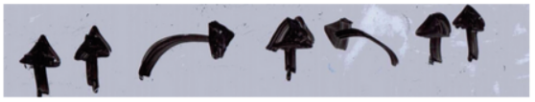
The algorithm using arrows might look something like this:

- Move the fakebot as it follows the algorithm. Did the algorithm work? If not, locate the part that needs fixing (debugging) and change it.

Activity 2:
- Using the star grid resource, create an algorithm that takes the fakebot from the starting square to one of the stars on the grid.
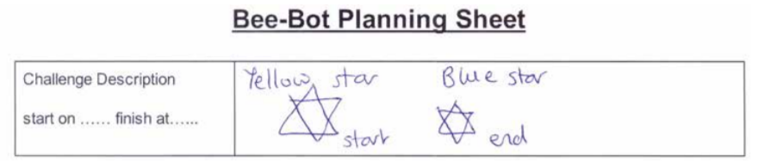
- Use the planning sheet to set and complete this challenge:

- Which is the quickest route?
- Which route uses the least commands?
Activity 3: Add to your challenge
Use the challenge word cards to add an obstacle.
Ask pupils to extend their challenges to make them more difficult. There are a number of challenge word cards to support this, such as pause on, spin on, avoid, shortest route, longest route etc.
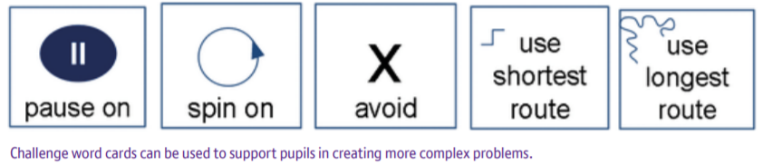
The challenge word cards:

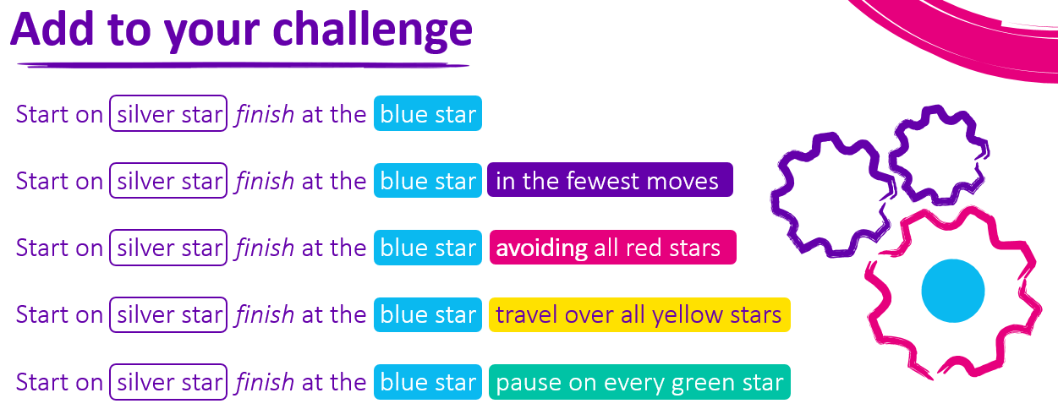
Example of how to use the challenge word cards:
Evaluate:
- Did the programming of the fakebot work and if not, what needs to be changed?
- Was it the algorithm that had a bug or did we make a mistake when we programmed it?
- Give your child/ren the opportunity to change the program and/or algorithm and explain this is debugging – an important step in programming
Be Creative:
- Change the shapes for numbers and link this activity to their maths lessons. E.g. the fakebot collects all the even numbers.
- Make the fakebot the wolf and create an algorithm that takes it to the three little pig’s homes, in the right order.
- Create an algorithm where the fakebot travels around the grid, collecting magical stones (sequins or gems from the craft box).
- If you have outdoor space, use chalk to make a grid for the fakebot. Add pictures or toys into the grid and create algorithms for the fakebot to travel from the starting square to these.

