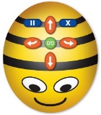
Mini Fakebots – for use with the grid activity.

