Simple Flowcharts
- From looking at this flowchart, what do you think each of these symbols means?
Terminator (start/stop) [1]
Process/task [1]

- What is the first thing that someone following this algorithm would need to do?

Unlock the door [1]

- What is the last thing that they would need to do?

Close the door behind them [1]

- Using the symbols you see above, use a pencil and ruler to draw your own flowchart showing how a person would brush their teeth.
Start

Put toothpaste on toothbrush
Accept any reasonable answer that shows correct use of terminators and processes [2]
Move brush back and forwards over teeth

Rinse mouth with water
Put toothpaste and brush away
End
More Complex Flowcharts
- From looking at this, what do you think the diamond symbol means?
Decision / question [1]

- What is the first thing that a person following this algorithm would have to do?
Check whether the door is locked [1]
- Imagine the following: A door is closed but not locked. The room beyond the door is dark. Complete the list of steps that a person would need to take according to the algorithm:

Step 1: Check whether the door is locked
Step 2: Check whether the door is closed [1]
Step 3: Open the door [1]
Step 4: Check whether the room is dark [1]
Step 5: Turn on the light [1]
Step 6: Close door behind you

- Use a pencil and ruler to draw your own flowchart to represent Miss Scott’s morning routine:

Step 1: Wake up
Step 2: Get out of bed
Step 3: Check if she’s running late
Step 4: If not running late, go to step 5. If running late, skip straight to step 6
Step 5: Have a cup of tea
Step 6: Check whether hair is messy
Step 7: If hair is messy, go to step 8. If hair is not messy, skip to step 9.
Step 8: Straighten hair
Step 9: Get dressed
Step 10: Brush teeth
Step 11: Eat breakfast

Start

Wake up

Get out of bed

Accept inverse logic for decisions, e.g. “on time?” rather than “running late?”

No
Running late?

1 mark for correct use of terminators
1 mark for appropriate processes in correct order
2 mark for decisions written in diamonds
1 mark for correct arrows from decisions and processes

Yes
Have a cup of tea

Is hair messy?
Yes
Straighten hair

No

Get dressed

Brush teeth

Stop
Eat breakfast
- What can you see in this flowchart that makes it different from the others we have looked at so far?
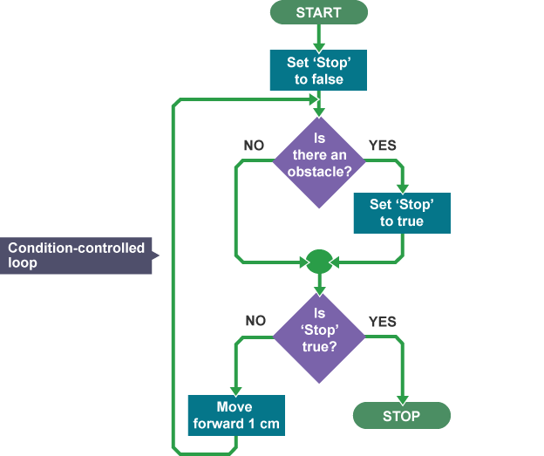
It has an arrow which loops back to an earlier point in the flowchart [1]
- What effect do you think this has?
Causes the processes to repeat / loop [1]

- Explain, in your own words, what this algorithm will do:
“Stop” will be set to false at the start [1]. If there is no obstacle, stop will remain false [1] and the robot will move forward 1cm [1], then check again for an obstacle. This process will repeat [1] until the robot comes to an obstacle when “stop” will be set to true [1] and the robot will stop moving [1].

- What does the symbol mean?

Input or output (1 mark)

Extension Task
Think of your own scenario which involves decisions and loops. Write it out below, first as a list of steps, then as a flowchart. When you are done, give it to a friend and ask them to write underneath what the algorithm will do. Is it the same as what you were planning?
1 mark for appropriate list of steps
1 mark for flowchart processes which match list of steps
1 mark for correct use of terminators
1 mark for including a decision
1 mark for including a loop
1 mark for including input or output
1 mark for getting peer feedback

Worksheet total: 32

