Simple Flowcharts
- From looking at this flowchart, what do you think each of these symbols means?
Terminator (start/stop) [1]
Process/task [1]

- What is the first thing that someone following this algorithm would need to do?

Unlock the door [1]

- What is the last thing that they would need to do?

Close the door behind them [1]

- Using the symbols you see above, use a pencil and ruler to draw your own flowchart showing how a person would brush their teeth.
Start

Put toothpaste on toothbrush
Accept any reasonable answer that shows correct use of terminators and processes [2]
Move brush back and forwards over teeth

Rinse mouth with water
Put toothpaste and brush away
End
More Complex Flowcharts
- From looking at this, what do you think the diamond symbol means?
Decision / question [1]

- What is the first thing that a person following this algorithm would have to do?
Check whether the door is locked [1]
- Imagine the following: A door is closed but not locked. The room beyond the door is dark. Complete the list of steps that a person would need to take according to the algorithm:

Step 1: Check whether the door is locked
Step 2: Check whether the door is closed [1]
Step 3: Open the door [1]
Step 4: Check whether the room is dark [1]
Step 5: Turn on the light [1]
Step 6: Close door behind you

- Complete the flowchart below to represent Miss Scott’s morning routine:

Step 1: Wake up
Step 2: Get out of bed
Step 3: Check if she’s running late
Step 4: If not running late, go to step 5. If running late, skip straight to step 6
Step 5: Have a cup of tea
Step 6: Check whether hair is messy
Step 7: If hair is messy, go to step 8. If hair is not messy, skip to step 9.
Step 8: Straighten hair
Step 9: Get dressed
Step 10: Brush teeth
Step 11: Eat breakfast

Start

Wake up

Get out of bed [1]

No
Running late?

Yes
Have a cup of tea [1]

Is hair messy? [1]
Yes
Straighten hair

No

Get dressed

Brush teeth [1]

Eat breakfast [1]
Stop
- Have a look at this flowchart.
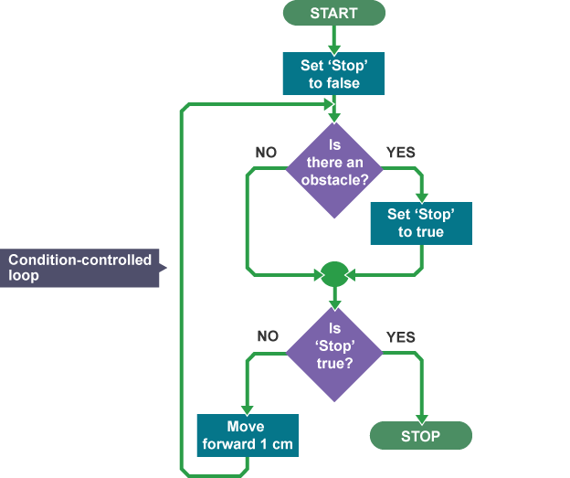
- What does the arrow from “move forward 1cm” do? (Hint: this is called a loop).
Goes back and repeats part of the algorithm [1]
- Complete the following to describe the algorithm:

“Stop” will be set to false at the start. If there is no obstacle, stop will remain false and the robot will move forward 1cm, then check again for an obstacle. This process will repeat until the robot comes to an obstacle when “stop” will be set to true and the robot will stop moving [4].

12. What does the symbol mean?

Input or output (1 mark)

Extension Task
Think of your own scenario. If you are feeling brave this might include decisions and/or loops, or input/output! Write it out below, first as a list of steps, then as a flowchart. When you are done, give it to a friend and ask them to write underneath what the algorithm will do. Is it the same as what you were planning?
1 mark for appropriate list of steps
1 mark for flowchart processes which match list of steps
1 mark for correct use of terminators
1 mark for including a decision
1 mark for including a loop
1 mark for including input/output
1 mark for getting peer feedback

Worksheet total: 30

