Flowcharts and Algorithms
Task 1
Complete the following definitions
Algorithm – a series of ___________ to solve a ______
Program – a set of ___________ to be followed by a ____________ to solve a ______.

Task 2 Simple Flowcharts
- From looking at this flowchart, what do you think each of these symbols means?

- What is the first thing that someone following this algorithm would need to do?

______________________________________________________________________

- What is the last thing that they would need to do?

______________________________________________________________________

- Using the symbols you see above, use a pencil and ruler to draw your own flowchart showing how a person would brush their teeth.
Task3 More Complex Flowcharts
- From looking at this, what do you think the diamond symbol means?

- What is the first thing that a person following this algorithm would have to do?
______________________________________________________________________
- Imagine the following: A door is closed but not locked. The room beyond the door is dark. Complete the list of steps that a person would need to take according to the algorithm:

Step 1: Check whether the door is locked
Step 2: __________________________________________________________
Step 3: __________________________________________________________
Step 4: __________________________________________________________
Step 5: __________________________________________________________
Step 6: __________________________________________________________
Step 7: Close door behind you

- Use a pencil and ruler to draw your own flowchart to represent Miss Scott’s morning routine:

Step 1: Wake up
Step 2: Get out of bed
Step 3: Check if she’s running late
Step 4: If not running late, go to step 5. If running late, skip straight to step 6
Step 5: Have a cup of tea
Step 6: Check whether hair is messy
Step 7: If hair is messy, go to step 8. If hair is not messy, skip to step 9.
Step 8: Straighten hair
Step 9: Get dressed
Step 10: Brush teeth
Step 11: Eat breakfast

- What can you see in this flowchart that makes it different from the others we have looked at so far?
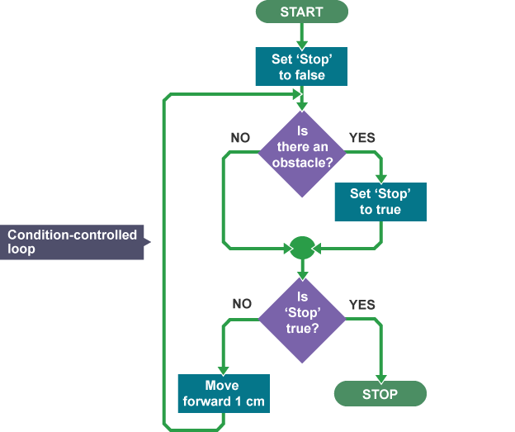
_____________________________________________________________________
- What effect do you think this has?
_____________________________________________________________________
- Explain, in your own words, what this algorithm will do:

- What does the symbol mean?

__________________________________________________________________

Extension Task
Think of your own scenario which involves decisions, loops and input/output. Write it out below, first as a list of steps, then as a flowchart. When you are done, give it to a friend and ask them to write underneath what the algorithm will do. Is it the same as what you were planning?

