UNPLUGGED
Real-Life Algorithms: Paper Airplanes
U

LESSON OVERVIEW
In this lesson, will relate the concept of algorithms back to everyday real-life activities by making a paper airplanes. The goal here is to start building the skills to translate real-world situations to online scenarios and vice versa.

KEY VOCABULARY
- Algorithm - Say it with me: Al-go-ri-thm

LESSON OBJECTIVES

Children will:
- Name various activities that make up their day
- Decompose large activities into a series of smaller events
- Arrange sequential events into their logical order

MATERIALS, RESOURCES AND PREPARATION

A4 paper for folding into airplane
- L1 -Paper Airplane

L1- Assessment Worksheet

Scissors and glue

TEACHING SEQUENCE

Ask what 'algorithms' are. Explain that an algorithm is a sequence of instructions or a set of rules that are followed to complete a task. This task can be anything, so long as you can give clear instructions for it.
Can the student think of sets of instructions that we may follow in everyday life (E.g. How to make a fruit smoothie, getting dressed for school, tying a shoelace etc)
Ask if the instructions need to be in a precise order for the instructions to work. Think of the order of the steps in making a fruit smoothie. Will it be a good idea for us to switch the blender on before putting a lid on the blender? (Answer: No, because we will make a huge mess)

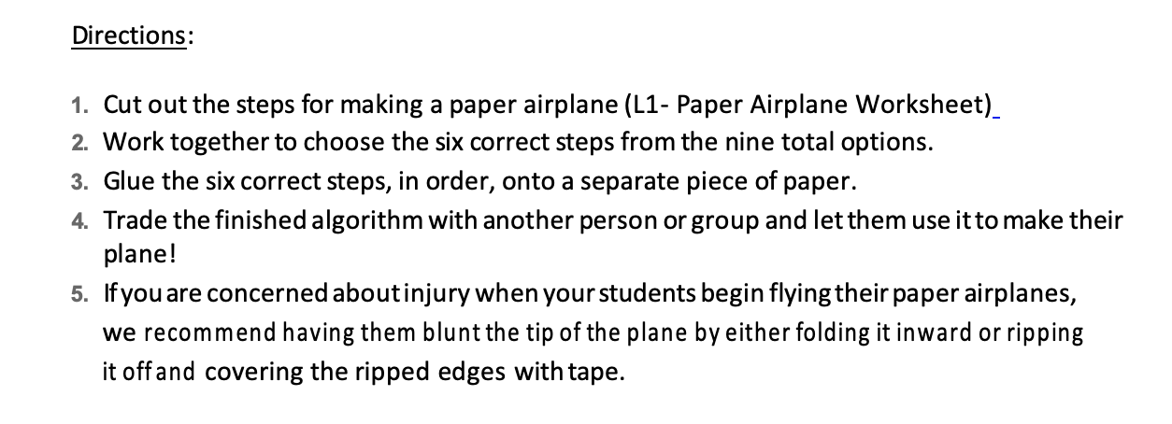
Main Activity 1 - L1 Paper Airplane Worksheet
Main Activity 2 – Testing out the Algorithm
Test whether the algorithm works by making a paper airplane using a piece of A4 paper.
If it does not work, why not? Discuss
Discuss any changes your child needed to make to their sequence of commands. These changes are called debugging and children need encouraging to persevere when fixing any errors.
Point out that being able to debug is a really valuable tool for life when we’re solving problems. These opportunities to debug are often when the most learning takes place.

Assessment Opportunity
Use the L1- Assessment Worksheet to see what the student has remembered about algorithms. This is to be attempted independently after explaining what the task is.

Extra information:
Computers won’t understand your algorithm as they use a different language. It will need to be translated into code which the computer will then follow to complete a task. This code is written in a programming language. There are many different types of programming languages. Some that you may come across are Logo, Scratch, Blockly, Python and Kodu. Each of these languages are suited to different things.

This curriculum is available under a Creative Commons License (CC BY-NC-SA 4.0)
If you are interested in licensing Code.org materials for commercial purposes, contact us: https://code.org/contact

