2D Shape
Drawing Activity

An introduction to debugging algorithms

LESSON OVERVIEW
In this activity, children follow an algorithm to draw pictures constructed from 2D shapes. The algorithms followed will include errors and children will use logical reasoning to detect and correct these.

LESSON OBJECTIVES

children will:

Use logical reasoning to detect and correct errors in an algorithm (Computing)

Draw 2D shapes (Mathematics)

MATERIALS, RESOURCES AND PREPARATION
- Image (Activity 1) + sheet of blank paper + pen/pencil or whiteboard + drywipe pen
- L2- 2D Activity Worksheet (Activity 2) + Pens/ pencils
- Colour pencils for making corrections to algorithms and shading drawings

LESSON SEQUENCE

Recap what 'algorithms' are. An algorithm is a sequence of instructions or a set of rules that are followed to complete a task. This task can be anything, so long as you can give clear instructions for it.

You will be following algorithms made up of a sequence of instructions. These algorithms will include errors, and your task is to detect and correct the errors in the algorithm. This process is called debugging.

You will be using logical reasoning which allows us to us to ‘think through’ the steps in algorithms to determine their outcome. We can use logical reasoning to identify where errors might be happening and fix them

Activity 1 – ALGORITHMS AND DEBUGGING

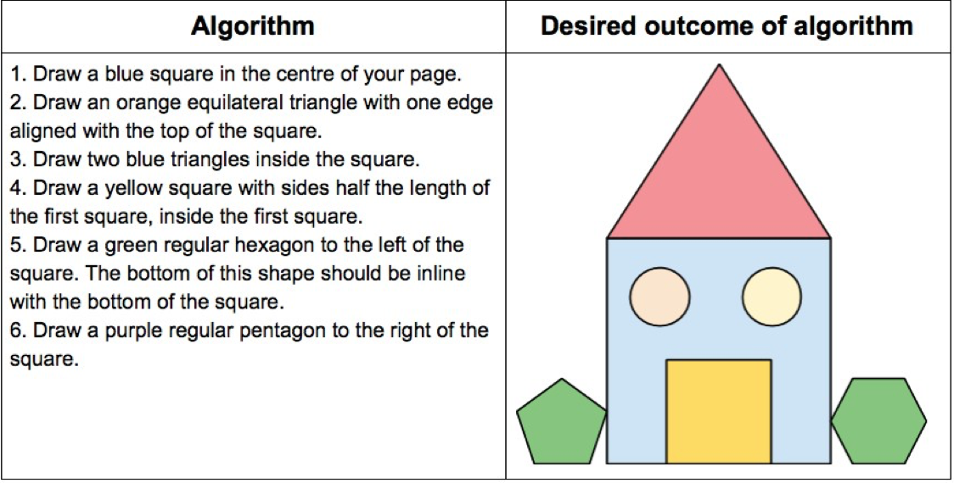

- Look at the image above- The writing on the left is a set of algorithms.
- Using this and [sheet of blank paper + pen/pencil] or [whiteboard + drywipe pen] , follow the algorithm as it is.
- Do you find that there are problems with the algorithm and can you debug it using logical reasoning? Ask your adult to help you if you are really stuck but keep working on it until you can understand what the algorithm should be for it to work. Write these down to help you or record your steps if you have a mobile phone, iPad/ tablet or other recording device.
TIP: There are many errors to debug, which includes;

- Type of shape
- Size of shape
- Location of shape
- Missing steps

ACTIVITY 2- CREATE YOUR OWN DRAWING AND ALGORITHM (L2-2D Activity Worksheet)

- Using your L2-2D Activity Worksheet and pen/pencil, you have 10 minutes to draw a simple 2D shape drawing on the right hand side of the worksheet table and write the algorithm on the left side.
- On purpose, make 3 mistakes in your algorithm steps (see example below)

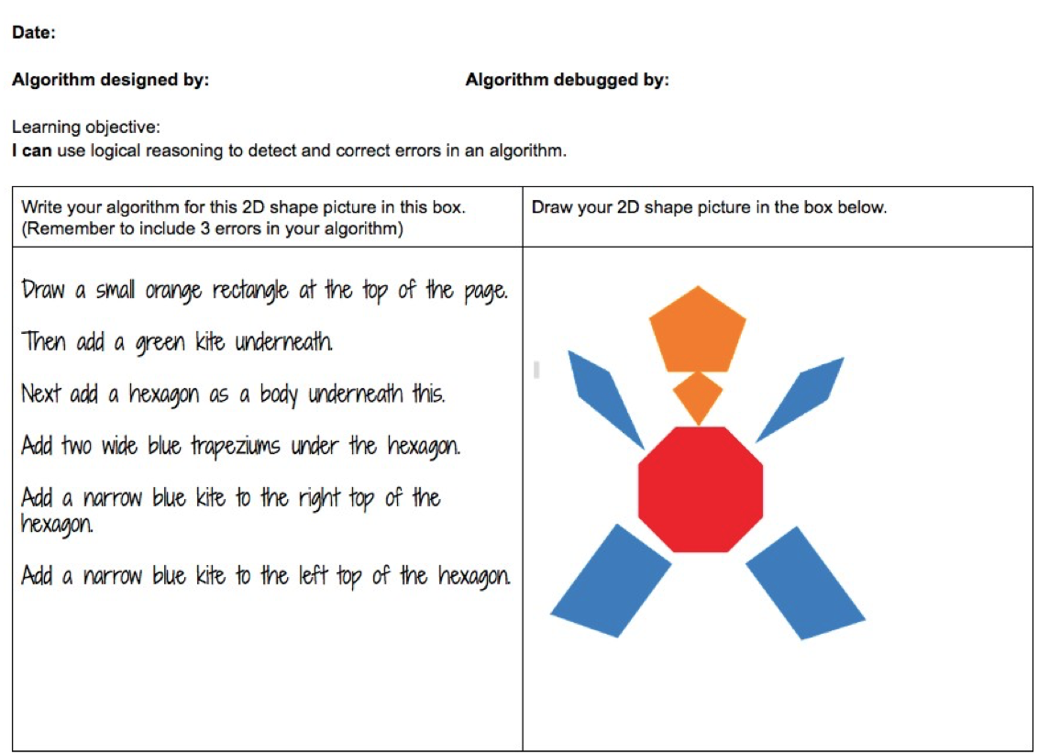

- You then hand this to the adult who is working with you/ sibling and see if they can find the errors. They are to use their logical reasoning and debugging skills to work it out.

ASSESSMENT OPPORTUNITY

Informal debugging and discussions.
- Have you found out something new today?
- What are the 3 key vocabulary terms that you have learned today?
- How do you use this knowledge in different subjects such as Mathematics, English and Science, Art and other subjects? Do you use this knowledge in your home or outdoor environment?

Adapted from Barefoot Computing resources (Open Government License) 2D Shape Drawing Debugging

