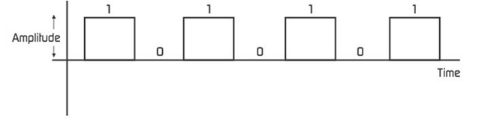
How Computers Use 1s and 0s to Represent Data

Task 1 Describe one-bit colour
In the box below give a description of what one-bit colour is and how it can be used to make an image.

Task 2 Numbers of bits

- How many bits are in a byte?

- What is meant by the following terms?

- nibble

- kilobyte

- gigabyte

- terabyte

- Why might a kilobyte (kilo generally means 1000) not actually be 1000 bytes? – it is 1024…but why?

Task 3: Combinations of a Nibble
- How many combinations of 1’s and 0’s can you make from four bits? 1010 is one combination, 1100 is another etc.

Denary  (base 10) | Binary  (Base 2) | Denary  (base 10) | Binary  (Base 2)
0 | 0000 | 8
1 |  | 9
2 |  | 10
3 |  | 11
4 |  | 12
5 |  | 13
6 |  | 14
7 |  | 15 | 1111
- If 0000 = 0 (in denary – base 10) and 1111 = 15 in denary (base 10), can you figure out the denary equivalents of each of the other combinations?

