IMI LESSON PLANS
MATHS – STUDENT PACK

About the industry
The automotive industry influences everyone, from delivering goods on time to commuters travelling to work and emerging services being able to respond to crisis, the motor industry helps keep the country moving.

About The IMI
The Institute of The Motor Industry is the professional body for individuals working in the motor industry and the authoritative voice of the retail automotive sector. The IMI’s aim is to ensure that the automotive retail sector has a skilled, competent and professional workforce that is fully equipped to keep pace with the demands of new technology and changing markets. A key part of business for manufacturers and dealers is to encourage the best and brightest people to join their business in a variety of roles.

INTRODUCTION
All lessons are based on real life activities with the motor industry as a backdrop, encompassing sub-sectors such as motorsport, motorcycle, heavy vehicle, motor parts, paint and finishing and sales as well as green issues such as vehicle emissions. The rationale behind “Indicate” is to a) introduce students to the various aspects of the motor industries b) allow students to demonstrate a fluency and confidence in a range of “real life” mathematical techniques and processes in an unfamiliar context.

Further, these lessons will allow students to select the most appropriate way to communicate mathematics both orally and in writing and allow them to understand and interpret mathematics that is presented in a range of forms.

Students will have the opportunity to become familiar with a range of resources and tools to enable them to achieve their objectives, coupled with the opportunity to explore and use mathematical concepts (equivalence, proportional thinking, relationships and proof operations).

These lessons will allow students to pose questions: they should be able to adopt a questioning approach to mathematical activity.

They are designed to provide a helpful context based around the motor industry. Teachers may want to use all or just some of the lesson ideas. They may also want to decide whether some of the tasks in these lessons are undertaken by an individual student or in small group. There will also be flexibility for the teacher to decide the level of difficulty they wish to set, depending on the abilities of their students.

Finally, within each lesson plan in this teacher pack are some notes for further guidance as well as a comprehensive list of website links.

Lesson overview

Lesson 1 P
Module: Sales
Topic: Statistics/Data analysis

Lesson 2 P
Module: Buying a car
Topic: Finance & Money

Lesson 3 P
Module: Designing a race circuit
Topic: Shape, Space & Measure

Lesson 4 P
Module: Car emissions
Topic: Sequences and functions

Lesson 5 P
Module: F1 Lap times
Topic: Compound Measures

Lesson 6 P
Module: Drag Racing
Topic: Budgeting

Lesson 7 P
Module: Motorcycle trip
Topic: Measures

Lesson 8 P
Module: Paint job
Topic: Measure

Lesson 9 P
Module: Heavy vehicle
Topic: Statistics/Data analysis

Lesson 10 P
Module: Off Road
Topic: Angles

Lesson 11 P
Module: Parts
Topic: Statistics/Data analysis

Lesson 12 P
Module: Buying a motorbike
Topic: Statistics/Data analysis
Lesson 1
Topic: Statistics/Data analysis

Module: Sales

Learning Objectives:
- To be able to analyse and interpret data
- To be able to present data in different formats

Task
The UK retail car industry is made up of many car manufacturers selling vehicles. You work in the Corporate Division at Jaguar Land Rover (JLR) and you have been asked (using the attached data) to provide information for a presentation by your manager to the Board of VW, illustrating sales of all VW vehicles and the sales performance of other car manufacturers who are your competitors.

Your closest competitors in this market are Mercedez Benz, Audi, Volvo and BMW. Using the raw data, develop some different ways and methods of presenting this. Use pictograms, bar charts and pie charts to support your findings and to make it easier for your manager to explain to the Board.

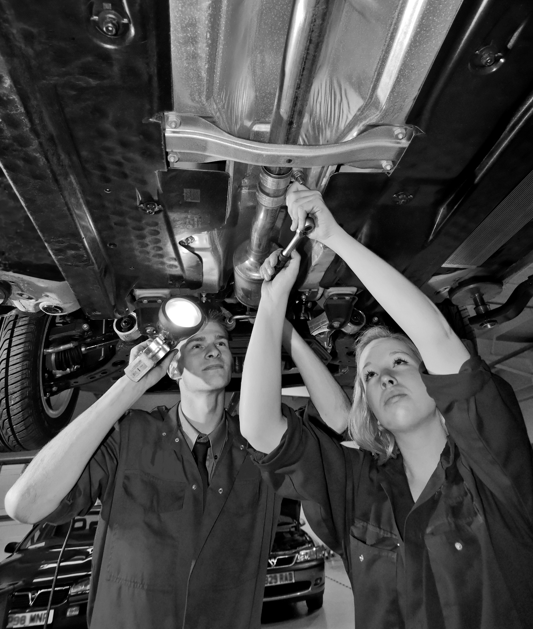
New car data sheet

Car Manufacturer | No of Cars sold in 2010
Audi | 88,355
Bentley | 891
BMW | 92,083
Citroen | 64,183
Fiat | 47,405
Ford | 246,770
Honda | 55,421
Hyundai | 54,872
Jaguar | 13,939
Jeep | 1718
Kia | 50,278
Land Rover | 32,654
Lexus | 5629
Mazda | 40,113
Mercedes-Benz | 64,187
MG | 266
MINI | 36,003
Nissan | 77,113
Peugeot | 95,529
Porsche | 5568
Renault | 83,286
SEAT | 28,235
Skoda | 35,360
Smart | 6730
Suzuki | 18,627
Toyota | 77,231
Vauxhall | 214,593
Volkswagen | 151,025
Volvo | 33,112

Lesson 2
Topic: Finance/Money

Module: Buying a car

Learning Objectives:
- To prepare a cash-flow forecast.
- To understand the importance of cash flow and how to improve it.

Task 1
You are buying a Ford Fiesta 1.3L car on a finance plan for £5795. Your parents have agreed to give you the £2000 deposit but you must fund the rest out of your Apprentice salary of £320 per month (after tax and National Insurance). Fill in the cash-flow plan taking account of the following:

- Monthly car repayments are £96.20 (from the second month, no payment for the first month)
- You need to tax the car as soon as you get it which costs £130 for the year.
- You insure the car - £185 for the first month and £85 per month for the rest of the year.
- You will need to allow £40 per month for fuel.
- On your Birthday in July, you get £100 in cash.
- Your car needs an MOT in July which costs £50.
- Your car has to be serviced in September which costs £150.
- You get a flat tyre in November and pay £55 for a new one.
- You ask for money for Christmas and get given £200
- You have a major engine problem in January and split the cost of repair over January and February. You pay £410 in January and £270 in February.

Remember the closing balance each month is your total income less your total payments plus whatever you had left in the bank from the month before.

Task 2
Produce a table (attached template) detailing what other monthly expenses you would expect to have as an apprentice and realistically how much you can expect to have at the end of the year. From October to February, your repayment will rise by 10% - add this in to your forecast.

Cash flow chart

 | Mar | Apr | May | Jun | Jul | Aug | Sep | Oct | Nov | Dec | Jan | Feb
Income

Deposit form parents

Salary

Extra cash

Total Income

Payments

Deposit on car

Monthly repayments

Insurance

Fuel

Tax

MOT

Service

Unexpected expenses

Total payments

Closing balance each month

Lesson 3
Topic: Shape/Space/Measure

Context: Designing a race circuit

Learning Objectives:
- To be able to use shapes (2D and 3D) and appreciate/understand surface areas and volumes.
- To be able to appreciate scale – making sense of plans, diagrams and construction kits.

Task
Motor sport is an ever growing popular pastime and new circuits and tracks are needed. You have been asked to develop plans and layout for a new track in the middle of England. You have sufficient budget to design what you want. Draw to scale and use relevant ICT to design the layout. You can decide the layout of the track. Once you have developed and constructed the race track, you will need to consider seating for spectators and where you are going to locate stands. You will have a limited area of space to work in (5000 m2) and you need to fit in all the requirements in the space that has been allocated.

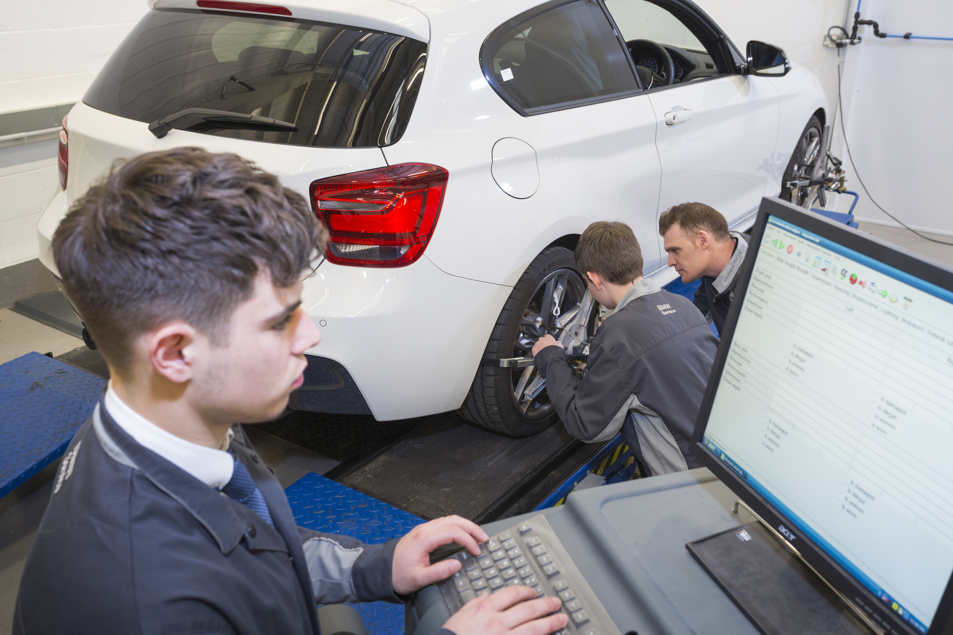

Lesson 4
Topic: Sequences and functions

Module: Car emissions

Learning Objectives:
- To communicate mathematics effectively
- Identify and classify patterns

Task
You have been asked to produce a short report to outline the costs and efficiencies of various different models of cars in terms of what they cost in road tax. The rate of tax will depend on both engine size and C02 emissions. Find out the C02 emissions, engine size, miles per gallon, car tax bracket code and actual car tax cost for the following cars and present your findings in the form of a table – format will be provided. You will be directed to the internet to ascertain the data you need.

- Ford Focus Model Year Pre 2010 ¼ - Diesel 1.6 Duratorq TDCi (90PS) 5 door saloon.
- Peugeot 3008 (from October 2009 onwards) – Petrol 1.6 THP (156 bhp) Energy Saver Tyres
- Audi Q7 – Petrol 4.2 V8 TDI 340PS Quattro 8 speed triptronic
- Ferrari – Petrol 599 Aperta
- Toyota Prius MY2010 – Alternative Fuel, T Spirit 1.8 VVTi hybrid E-CVT

Discussion
What is the relationship between engine size, CO2 emissions, mpg and car tax code? Can you draw any conclusions from this? If you were to advise somebody wishing to buy a car that would result in lower costs, what advice would you give them about CO2 emissions and engine sizes? What car would you recommend to someone who wanted low car tax costs and why?

From your home, work out how far you can get on one tank of fuel in each of these cars.

Table 1 shows the rates by car band

This table is taken from the DirectGov website “Find New Car Details” hyperlink below (Feb 2012):

http://carfueldata.direct.gov.uk/search-new-or-used-cars.aspx

Standard rates
The following table contains the rates of vehicle tax for already registered cars.

Petrol car (TC48) and diesel car (TC49)

Band | CO2 emission (g/km) | 12 months rate | 6 months rate
A | Up to 100 | £0.00 | Not available
B | 101-110 | £20.00 | Not available
C | 111-120 | £30.00 | Not available
D | 121-130 | £95.00 | £52.25
E | 131-140 | £115.00 | £63.25
F | 141-150 | £130.00 | £71.50
G | 151-165 | £165.00 | £90.75
H | 166-175 | £190.00 | £104.50
I | 176-185 | £210.00 | £115.50
J | 186-200 | £245.00 | £134.75
K* | 201-225 | £260.00 | £143.00
L | 226-255 | £445.00 | £244.75
M | Over 255 | £460.00 | £253.00

Table 2
Table of results matching your filter section

Table of results for new cars matching your filter selection
Manufacturer | Model | Description | Gearbox | Engine size (cc) | Fuel type | CO2 | Tax band
ABARTH | 500 | Abarth | M5 | 1368
ABARTH | 500 | 500C | SAT5 | 1368
ABARTH | Punto Evo | 1.4 16v Turbo MultiAir 165 | M6 | 1368
ALFA ROMEO | 159, 2011 onwards | 1750 TBi 200 bhp | M6 | 1742
ALFA ROMEO | 159, 2011 onwards | 2.0 JTDm 16v 170 bhp | M6 | 1956
ALFA ROMEO | 159, 2011 onwards | 2.0 JTDm 16v 136 bhp | M6 | 1956
ALFA ROMEO | 159 Sportwagon, 2011 onwards | 2.0 JTDm 16v 170 bhp | M6 | 1956
ALFA ROMEO | 159 Sportwagon, 2011 onwards | 2.0 JTDm 16v 136 bhp | M6 | 1956
ALFA ROMEO | 159 Sportwagon, 2011 onwards | 1750 TBi 200 bhp | M6 | 1742
ALFA ROMEO | Brera, 2011 onwards | 2.0 JTDm | M6 | 1956
ALFA ROMEO | Brera, 2011 onwards | 1750 TBi | M6 | 1742
ALFA ROMEO | Giulietta | 1.4 TB 120 bhp | M6 | 1368
ALFA ROMEO | Giulietta | 1750 TBi 235 bhp | M6 | 1742
ALFA ROMEO | Giulietta | 1.4 TB MultiAir 170 bhp | M6 | 1368

Lesson 5
Topic: Compound Measures

Module: F1 Lap Times

Learning Objectives:
- To be able to make sense of information involving compound measures and present data using graphs and other diagrams/tables

Task
In F1 there are many practice laps before the actual race. This allows both the drivers and mechanics to test the cars and the engines as well as getting used to new parts and the track. With the information provided, represent the lap times for the first ten practice laps for three drivers (Laps 3 to 13): Vettel, Webber and Hamilton. Plot the times on the same graph as a way of comparison. You decide the scale and the titles of the graph’s axes. Data will be provided.

Lap times for the three drivers are provided:

Driver | S. Vettel | M. Webber | L. Hamilton
Lap Times | 1:17.493 | 1:17.350 | 1:16.404
 | 1:14.667 | 1:19.362 | 1:15.078
 | 1:16.387 | 1:18.687 | 1:23.681
 | 1:14.575 | 1:15.645 | 1:14.503
 | 1:17.085 | 1:14.766 | 1:21.725
 | 1:14.445 | 1:14.040 | 1:14.296
 | 1:21.311 | 1:19.122 | 1:27.215
 | 1:14.025 | 1:14.055 | 1:13.961
 | 1:22.008 | 1:14.443 | 1:14.938
 | 1:14.511 | 1:24.411 | 1:19.697
 | 1:16.812 | 1:17.175 | 1:13.963

Lesson 6

Topic: Budgeting

Module: Drag Racing

Learning Objectives:
Part | High |  | Medium |  | Low
 | Cost | Points | Cost | Points | Cost | Points
Engine | 2500 | 10 | 1500 | 7 | 1000 | 5
Body | 1000 | 10 | 750 | 5 | 400 | 5
Suspension | 1000 | 10 | 750 | 7 | 200 | 3
Wheels | 800 | 10 | 600 | 8 | 300 | 3
Tyres (four) | 1800 | 10 | 1200 | 7 | 800 | 4
Weight reduction kit | 2000 | 10 | 1500 | 7 | 1000 | 5
Supercharger | 1500 | 10 | 1200 | 7 | 1000 | 5
Fuel | 2500 | 10 | 2000 | 7 | 1500 | 4
Parachute (fixed cost) | 300 |  | 300 |  | 300
- This exercise allows the student to “play” with variable factors, to achieve the best result possible. It should introduce them to ideas of trade off and value for money.

Task
You have been asked to design and build a drag racing car at the world famous Santa Pod raceway. You have been given a specific budget to spend and you have several options available to choose to build and develop a specification for the car. You need to have all seven parts to ensure the car will race properly plus one compulsory part (the parachute) at a fixed cost.

You will not have enough budget to always buy the best parts, so you will have to make a judgement and look at the relative value of each part. Each part has an associated financial value and point’s total. Your objective is to achieve the highest number of points within budget.

Drag Racing parts table
Budget is £10,000…..what is the maximum number of points you can achieve?
Lesson 7
Topic: Measures

Module: Motorcycle trip

Learning Objectives:
- Making sense of and understanding information involving compound measures, for example fuel consumption, speed and acceleration.
- To understand the importance of varying factors and trade off (e.g. speed over fuel consumption).

Task
You are planning a holiday. You are going to travel from Lands End to John O’Groats from the SW of England to the NE of Scotland, on a motorbike. The total journey is 1580.2 kilometers and will take about eight days with overnight stops and meal breaks. You will be riding a Honda NC700 and details about the bike that you need to know to be able to complete this task, will be given to you. Look at the weblink below to get some more information:

http://www.honda.co.uk/motorcycles/adventure/#!/nc700x/specifications/

The journey is broken up into 8 days of travel which are detailed in the handout sheet.

Your task is to work out:
- What is the total mileage of the trip? Convert kilometres to miles to get an understanding of distance in Imperial measure.
- How much fuel will you use? Find out the mpg for the specific model of motorbike and convert to MPL.
- How much the whole trip will cost? You will be given a set of data to assist in this process and some assumptions (i.e. cost of fuel and accommodation)

Table 1 – Chart for completion by student (completed for teacher pack)

Day | Point | Mileage | KMS | Cum Mileage | Cum KMS | MPG | KPG | MPL | KPL
1 | Land's End | 0 | 0 | 0 | 0
1 | Bath | 214
2 | Stratford upon Avon | 87
3 | Nottingham | 68
4 | Blackpool | 124
5 | Gretna Green | 111
6 | Loch Lomond | 116
7 | Fort William | 78
8 | John O’Groats | 184

Table 2 – Motorbike itinerary
- On day 1 you set off from Land’s End in Cornwall and drive to Bath and stay overnight.
- On day 2 you drive from Bath to Stratford upon Avon and stay overnight.
- On day 3, you drive from Stratford upon Avon to Nottingham
- On day 4 you drive from Nottingham to Blackpool and stay overnight.
- On day 5 you drive from Blackpool to Gretna Green and stay overnight.
- On day 6 you drive from Gretna Green to Loch Lomond and stay overnight.
- On day 7 you drive from Loch Lomond to Fort William and stay overnight.
- On day 8 you drive from Fort William to John O’Groats and stay overnight and your trip is complete.

Lesson 8
Topic: Automotive Finishing/Paint

Module: Paint job

Learning Objectives:
- Calculate accurately, selecting mental methods or calculating devices as appropriate.
- Record methods, solutions and conclusions.
- Estimate, approximate and check working

Task 1
You have bought a car and you have decided that you wish to both re-spray it to have a new colour and you wish to add some car art detail that you have seen advertised.

- To obtain the colour you want, you are going to have to mix paints (red, white & blue) in the following ratio 1:2:4. Your car has the following measurements:
- Length – 4961mm, Width – 2053mm and Height – 1460mm
- Assume the surface area of the car is HxWxL. Also assume that to paint one metre square (m2) you will need 0.30 (300ml) litre of paint.
- How much of each colour are you going to need?

Task 2
Once the car has been re-sprayed, you decide that you want add some further colour to the sides of the cars by creating a flame effect.
- Black, red and orange
- Total amount of paint is 1.35 litres.
- How much of each colour do you need?

Lesson 9
Topic: Geometry and Measure

Module: Heavy Vehicle

Learning Objectives:
- Perimeters, areas, surface areas, weights and volumes

Task 1
You work in a distribution centre that loads car parts onto lorries for distribution across the country. Your company has just bought a new Scania truck with a curtain slider trailer (the truck pulls the trailer).

The trailer is 13.6 meters in length and 3.048 high. The width of the trailer 2.743. What is the cubic capacity of the trailer?

If the boxes of parts that you send out to clients are uniform and are sized 0.5 x 0.5 x 0.75, how many boxes will you be able to fit as a maximum in the trailer?

Task 2
Once the truck and trailer have departed with their cargo, they need to visit a weighbridge to ascertain the weight of the load. Assume that each box weighs 7.5 kgs, what is the weight of the load?

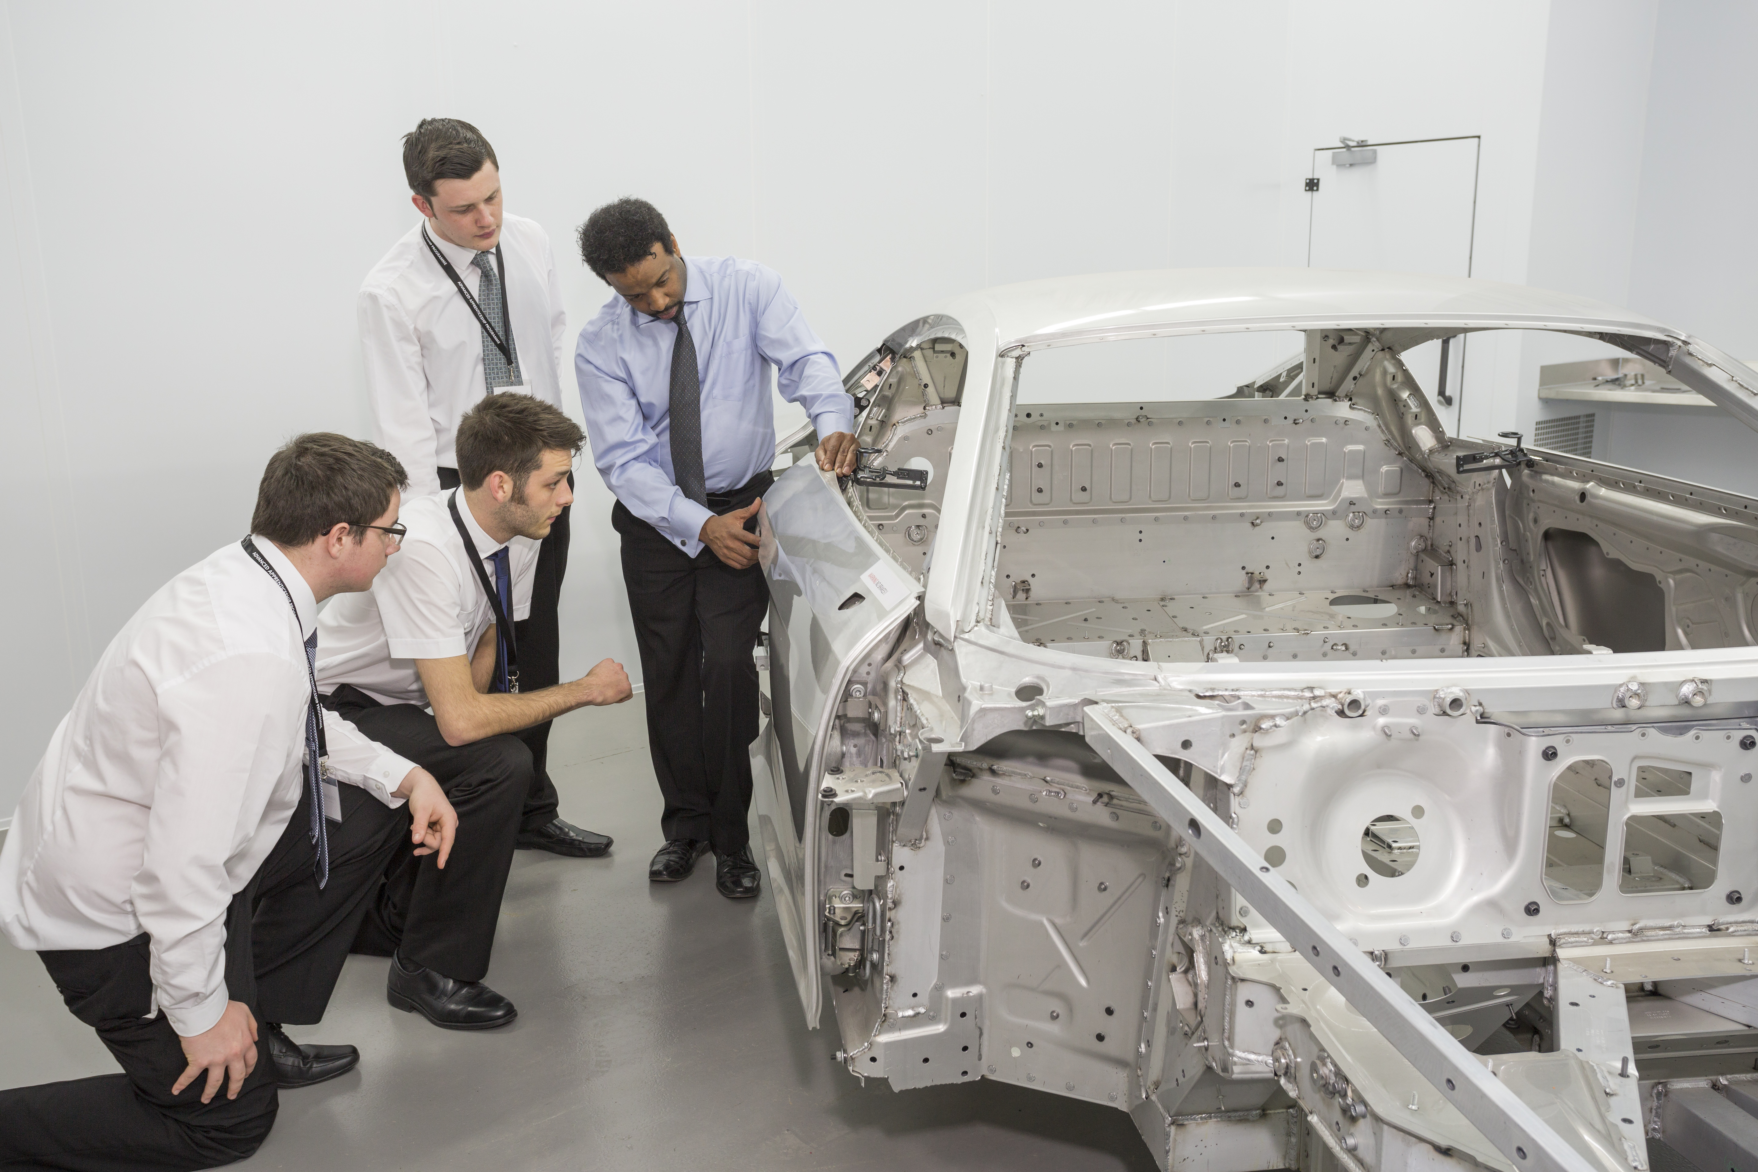

Lesson 10
Topic: Angles and gradients

Module: Off road

Learning Objectives:
- To get an appreciation of how angles and gradients apply to off road vehicle activity.

Task
This lesson is set in the context of vehicles undertaking extreme driving in terms of going off road, looking at some of the limits that such vehicles have in tackling climbs and descents with a focus on angles and gradients. Students can research data via manufacturers’ website and other promotional material about the abilities and limitations of such vehicles to cope with such angles and gradients.

Task 2
Choose a 4x4. Given the data that you have uncovered in Task 1 about individual vehicle’s ability to deal with angles and gradients, design a short test track that incorporates such challenges that your chosen vehicle can complete. You could include going up and down a certain gradient, looking at the angle the vehicle could achieve without rolling over, looking at the clearance levels for the vehicle going through water etc..

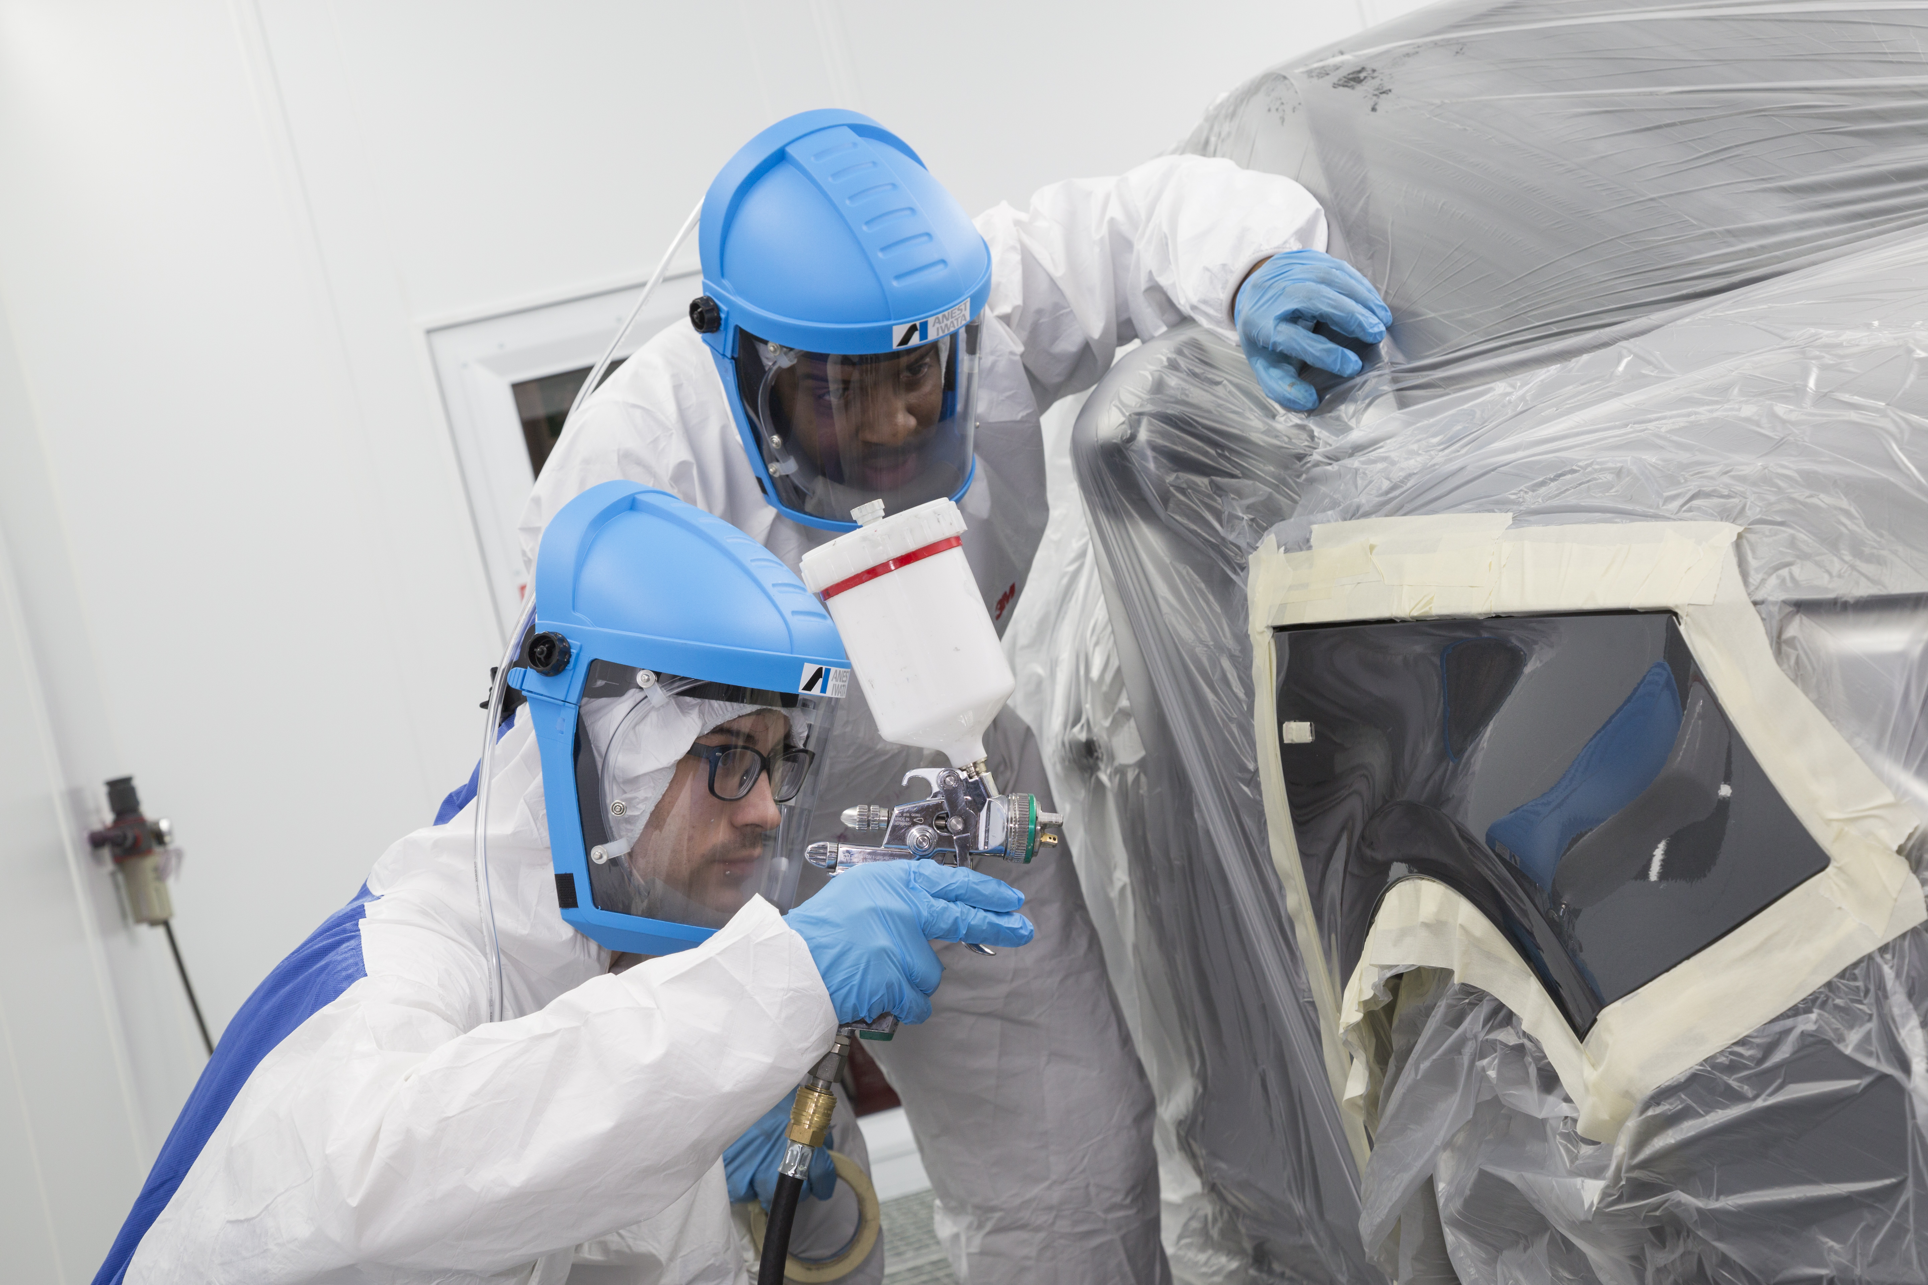

Lesson 11
Topic: Parts

Module: Calculations and manipulation with numbers

Learning Objectives:
- Using mental and written methods to make sense of everyday situations, including financial statements and transactions.

Task 1
You work in a car parts retailer and you have responsibility for pricing. You buy in car parts at a certain price (trade price) and you are then responsible for adding a 17.5% mark up on those items. You will be given a table of ten items and their cost price. You must work out what their mark-up price will be.

Task 2
Your employer has now expanded into the global market via internet sales and is offering parts all over the world. Orders are coming in from several countries but they want to know what your prices are in their currency.

Task 3
Nominal weights have been given to each item. Research the cost of sending all the items on an individual basis to the USA (New York).

Use the Post Office’s online facility to enter the destination and weight for each part to obtain a cost. Nominal weights for each item are given on the student handout sheet.

http://www.postoffice.co.uk/price-finder

Part type | Trade price | (17.5%) | USD | Euro | HKD | Nominal weight of item | Postage costs (£) Choose one country from US, HK or Europe | Total cost  (£)
Tyre | 37.20 |  |  |  |  | 5 kg
Synthetic Oil (2 litres) | 12.37 |  |  |  |  | 3.2 kg
5 litre diesel oil | 33.00 |  |  |  |  | 7.5 kg
65 piece socket set | 24.75 |  |  |  |  | 3.7 kg
2 ton ratchet axel stands | 19.79 |  |  |  |  | 47 kg
Advanced Trolley Jack | 74.24 |  |  |  |  | 22 kg
Bodywork Shampoo/Conditioner | 6.59 |  |  |  |  | 325g
Easy fit wiper blade set | 12.78 |  |  |  |  | 150g
Turtle wax concentrate | 3.29 |  |  |  |  | 400g
Dynamic Jump starter | 49.49 |  |  |  |  | 6.7kg
55W H7 car Bulb | 7.01 |  |  |  |  | 15g

Lesson 12
Topic: Finance/Money

Learning Objectives:
- To prepare a cash-flow forecast.
- To understand the importance of cash flow and how to improve it.

Task 1
You are buying a motorbike – a Honda CBF 125 on a finance plan for £2,500. You have saved a £1000 deposit but you must fund the remaining £1,500 from your earnings - £400 per month (after tax and National Insurance). Fill in the cash-flow plan taking account of the following:

- Monthly bike repayments are£ 68.40 (after the third month, no payments for the two months)
- The bike was taxed when you purchased it.
- You insurance for the bike is £400 per year – you pay by direct debit on a monthly basis (split evenly across the 12 months).
- You also need to speed £300 on a helmet and protective clothing for riding the bike.
- You will need to allow £32 per month for fuel.
- In August you get a bonus at work of £100.
- Your bike has to be serviced in September which costs £150.
- You get a flat tyre in November and pay £55 for a new one.
- You ask for money for Christmas and get given £150
- You have a major exhaust problem in January and split the cost of repair over January and February. You pay £200 in January and £170 in February.
Remember the closing balance each month is your total income less your total payments plus whatever you had left in the bank from the month before.

Task 2
Produce a table (attached template) detailing what other monthly expenses you would expect to have as an apprentice and realistically how much you can expect to have at the end of the year. From October to February, your repayment will rise by 10% - add this in to your forecast.

Cash flow chart

 | Mar | Apr | May | Jun | Jul | Aug | Sep | Oct | Nov | Dec | Jan | Feb
Income

Deposit you have saved

Salary

Extra cash

Total Income

Payments

Deposit on bike

Monthly repayments

Insurance

Helmet and protective clothing
Fuel

Service

MOT

Unexpected expenses

Total payments

Closing balance each month

ANNEX C
Website Resources

- http://www.plansmotorsport.com/track/
- http://www.trackdesigns.co.uk/
- http://www.trackdays.co.uk/tracks/tockwith_motorsports_centre.htm
- http://www.wilsonmotorsport.com/public_html/code/maps.htm
- http://en.wikipedia.org/wiki/Formula_One_car
- http://www.fia.com/en-GB/mediacentre/f1_media/Pages/timing.aspx
- http://www.halfords.com
- http://www.theaa.com/
- http://www.rac.co.uk/
- http://www.contourtraining.com/index.php?page=4x4-off-road-driving-course-content
- http://www.funbrain.com/osa/index.html
- http://www.coolmath-games.com/0-crazy-taxi-m12/index.html
- http://www.mathschallenge.co.uk/
- http://www.mathschallenge.co.uk/online-resources/documents/jmc_2012.pdf
- http://www.mathschallenge.co.uk/
- http://www.fia.com/en-GB/mediacentre/f1_media/Pages/timing.aspx
- http://en.wikipedia.org/wiki/Weighbridges
- http://retexa.co.uk/node/15
- http://www.direct.gov.uk/en/Motoring
- http://www.postoffice.co.uk/price-finder
- http://www.clipartguide.com/_search_terms/graph.html
- http://www.santapod.co.uk/index.php

All websites are external and the IMI is not responsible for any content.

