Activity 1:
In this activity you need to:
- Identify the parts of the seagrass plant
- Add the names of the organs into the boxes
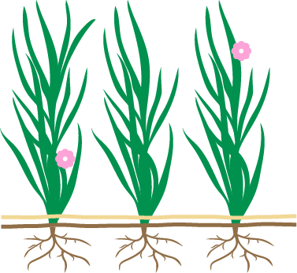

Extension task: What do you think the functions of the organs are?

