Is it a bird…?
Classification key
A key is a set of questions that can help us to classify an organism (living thing) into a group.
Use this key to help you to classify penguins, bats and whales.

Does it have wings?

Yes
No

Does it have feathers?
Does it have gills,
and scales on its skin?

Yes
No
Yes
No

It’s a
BIRD
It’s a
MAMMAL
It’s a
FISH
It’s a
MAMMAL

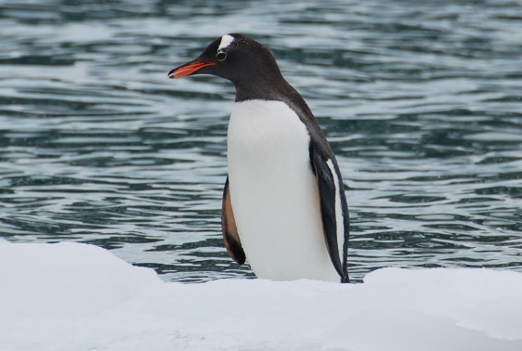
Is it a bird…?

Part 1: Penguin
Some children talk about how to classify a penguin.
B. Ellie
But it can’t fly, so it can’t be a bird.
- Calvin
It’s definitely a bird. It has feathers!

D. Yasmin
It has wings but can’t fly. I think it’s a mammal.
C. Layla
It lives on land and in the water, so it’s an amphibian.

Who do you think is correct?
A | Calvin
B | Ellie
C | Layla
D | Yasmin
Remember to use the key to help you decide.

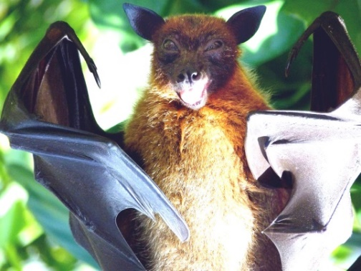
Is it a bird…?

Part 2: Bat
Some children talk about how to classify a bat.

A. Calvin
A bat must be a bird because it can fly.
B. Ellie
I think it’s a bird because it has wings.

D. Yasmin
Mammals can’t fly, so it must be a bird.
C. Layla
It’s a mammal because it has fur not feathers.

Who do you think is correct?
A | Calvin
B | Ellie
C | Layla
D | Yasmin
Remember to use the key to help you decide.

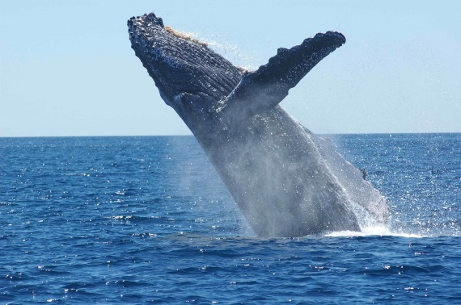
Is it a bird…?

Part 3: Whale
Some children talk about how to classify a whale.

B. Ellie
Are those fins or wings? If they are fins, it’s a fish.
- Calvin
When it jumps out of the sea it looks like it’s flying so I think it’s a bird!

D. Yasmin
It lives under water but it’s a mammal because it doesn’t have scales.
C. Layla
It can swim, so it’s a fish.

Who do you think is correct?
A | Calvin
B | Ellie
C | Layla
D | Yasmin
Remember to use the key to help you decide.

BEST > Living things and their habitats > Is it a bird?
Diagnostic question
Is it a bird…?

Overview
Learning focus: | Organisms can be identified and classified into groups based on their observable characteristics.
Observable learning outcome: | Use a simple key to help classify living things into broad groups.
Question type: | Talking heads, simple multiple choice, classifying/sorting
Key words: | Classification, classify, key, organism, mammal, fish, bird, amphibian.

Common preconceptions and misunderstandings
This diagnostic question targets the following misunderstandings that pupils might have:
- that penguins are amphibians (rather than birds) because they divide their time between land and water;
- that bats are birds (rather than mammals) because they have wings and can fly through the air;
- that whales are fish (rather than mammals) because they live in the sea.
This diagnostic question should reveal whether pupils understand that using a key is a more accurate way to classify an organism than simply trying to decide based upon its habitat or one of its features.
What to know more? Read What does the research say? towards the end of the Teacher Notes.

Equipment
- access to the key (page 1 of the activity sheet). This could be projected electronically for the whole class to see or some children may prefer their own printed copy.

Ways to use this diagnostic question
Children should complete the questions, using the key provided, individually in order to capture their current understanding. They should be reassured that the questions are designed to uncover their thinking and that ‘getting the answers right’ at this stage is not the most important thing. There will be time for them to share and discuss their ideas with others at a later stage.
Provide sufficient time for the children to think. They should use the key and look carefully at the images provided in order to help make their decisions.
Answers could be recorded formally as a pencil and paper exercise, by writing the letter A, B, C or D in response to the ‘talking heads’ in parts 1-3. It will be interesting to ask children if or how they have used the key to support their decisions.
Alternatively, children could hold up mini whiteboards or place a card into a box or basket to show their choice. In a similar way you could use the accompanying presentation with an electronic voting system for parts 1-3 and take additional verbal feedback for individual reasons why.
Differentiation
You may choose to read the questions to the class, so that everyone can focus on the science. In some situations, it may be more appropriate for a teaching assistant to read and/or scribe for a selected number of children.
Expected answers
Part 1: Penguin
A – Calvin (“It’s definitely a bird. It has feathers!”)
Part 2: Bat
C – Layla (“It’s a mammal because it has fur not feathers.”)
Part 3: Whale
D – Yasmin (“It lives under water but it’s a mammal because it doesn’t have scales.”)
How to respond - what next?
If there is a range of answers, you may choose to respond through structured class discussion. Ask one student to explain why they gave the answer they did; ask another student to explain why they agree with them; ask another to explain why they disagree, and so on until some sort of shared understanding has been reached.
This sort of discussion gives students the opportunity to explore their thinking and for you to really understand their learning needs. Responses often work best when the activities involve paired or small group discussions, which encourage social construction of new ideas (meaning making) through dialogue.
You may wish to present the activity first, without the key, in order to find out what individual children think before using a secondary source of information to help them. It would be extremely interesting to try the questions again, with the key, and find out whether anyone changed their thinking and in what way, also to ask children what other additional information might be useful, such as close-up images so that they might be more certain of important features such as scales and feathers.
If children are unsure about how to use a key to classify organisms, they could work in pairs or groups to use a key in a local habitat. It has been suggested that learning about classification should be coupled with experience of a wide range of living organisms, including in local habitats (Ingram, 2011). A range of keys suitable for use with primary school children can be obtained from:
- Open Air Laboratories (OPAL): OPAL Explore Nature – Identification Guides and Resources | Mendip Hills (mendiphillsaonb.org.uk)
- Field Studies Council: https://www.field-studies-council.org/publications/fold-out-charts.aspx
To build confidence in using keys, it is useful for children to practise devising, asking and answering yes/no questions. To further help develop students’ understanding of the principle of using sets of questions to identify and classify organisms, they should use this developing skill to create their own key that other people could use.
It is our intention to link each diagnostic question to a dedicated response activity relevant to primary. In the meantime, this existing BEST 11-14 activity, which can be found in the ‘Identifying and classifying organisms’ folder at www.stem.org.uk/best/biology/big-idea-variation-adaptation-and-evolution, provides question cards that can be discussed in pairs and arranged to make a key. Teachers should use and adapt this where you feel appropriate.

- Response activity: Build a key

What does the research say?
Research suggests that pupils sometimes rely upon an organism’s habitat to classify it rather than its physical features (Allen, 2014); this can lead to misunderstandings and misclassifications, such as:
- that penguins are amphibians rather than birds and reptiles, respectively, because they divide their time between land and water;
- that bats are birds because they have wings and can fly through the air;
- that whales are fish because they live in the sea.
Research has also found that many pupils need extra help to understand and correctly apply less familiar taxonomic terms such as ‘amphibian’ (Schofield et al., 1984; Braund, 1991; Allen and Choudhary, 2012).

Acknowledgments
Developed by Alistair Moore (UYSEG) and Nicky Waller (CIEC) from examples described by Allen (2014).
Images: penguin – pixabay.com/4270613 (3032601); bat – pixabay.com/Sweetaholic (1633706); whale – pixabay.com/skeeze (1945416)
References
Allen, M. (2014). Misconceptions in Primary Science, 2nd edn Berkshire, UK: Open University Press.
Allen, M. and Choudhary, A. (2012). Animal classification by early years children. United Kingdom Science Education Research Conference. National Science Learning Centre, University of York, UK.
Braund, M. (1991). Children's ideas in classifying animals. Journal of Biological Education, 25(2), 103-110.
Ingram, N. (2011). Classification, variation, adaptation and evolution. In Reiss, M. (ed.) Teaching Secondary Biology. 2nd ed. London, UK: Hodder Education.
Schofield, B., et al. (1984). Science in Schools: Age 13: Research Report No. 2. Assessment of Performance Unit. Department of Education and Science, HMSO, London, UK.

