Axe
An axe can be used for chopping down trees.
It has a handle and a head.
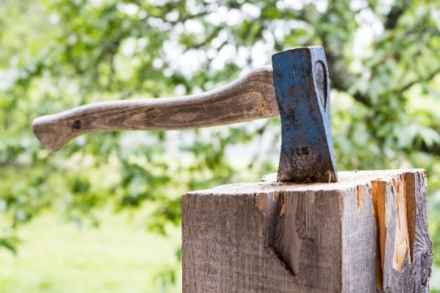
axe head
axe handle

Some children are discussing whether the axe head is made of metal. They use properties of materials to explain their answers.
Who do you agree with, and why?
Elsie: The axe head is not a metal because it is not shiny.
Freddie: The axe head is a metal because it is hard.

Logan: The axe head is a metal because it is sharp.

Isla: The axe head is a metal because it is heavy.

Cards for
Axe
Elsie: The axe head is not a metal because it is not shiny. | Freddie: The axe head is a metal because it is hard.
Logan: The axe head is a metal because it is sharp. | Isla: The axe head is a metal because it is heavy.

Cards for
Axe
Elsie: The axe head is not a metal because it is not shiny. | Freddie: The axe head is a metal because it is hard.
Logan: The axe head is a metal because it is sharp. | Isla: The axe head is a metal because it is heavy.

BEST> Properties of materials> Axe
Diagnostic question
Axe

Overview
Learning focus: | Properties can be used to classify types of material as metals or ceramics.
Observable learning outcome: | Use physical properties to identify that an object is made of metal.
Question type: | Talking heads
Key words: | Properties, materials, metal

P | PRIOR UNDERSTANDING  This diagnostic question probes understanding of ideas that are usually taught at age 5-11, to aid transition to later stages of learning.
Common preconceptions and misunderstandings
This diagnostic question targets the following misunderstandings that pupils might have:
- properties such as sharpness and mass should be used to classify a material as metal, however, these are properties of the object and not the material itself.
What to know more? Read What does the research say? towards the end of the Teacher Notes.
Ways to use this question
This task is intended for discussion in pairs or small groups. Children may wish to use a set of cards printed from the activity sheet to help them to focus on individual statements. They could sort them into piles using headings such as, agree, disagree, not sure. Children should be reassured that this question is designed to uncover their thinking and that ‘getting the answers right’ at this stage is not the most important thing.
Listening in to the conversations of each group will often give you insights into how different children are thinking. Each member of a group should be encouraged to report their final decision. This can be done formally as a pencil and paper exercise (using the activity sheet) or you could use the accompanying presentation with an electronic voting system or mini white boards and take additional verbal feedback from students for their reasons why. You should use probing questions, to reveal a clear description or explanation of children’s current scientific understanding.
Differentiation
You may choose to read the question to the class, so that everyone can focus on the science.
The quality of the discussions can be improved with a careful selection of groups; or by allocating specific roles to children in each group. For example, you may choose to select a child with strong prior knowledge as the scribe. They may question the others and only write down what they have been told. This strategy encourages contributions from more members of each group.
NB in any class, small group discussions typically improve over time and a persistence with this strategy is often very successful in the medium to long term.
Expected answers
Freddie gives the most scientifically correct answer: The axe head is a metal because it is hard.
How to respond - what next?
If there is a range of answers, an effective way to respond would be through structured class discussion. Ask one student to explain why they gave the answer they did; ask another student to explain why they agree with them; ask another to explain why they disagree, and so on until some sort of shared understanding has been reached. This sort of discussion gives students the opportunity to explore their thinking and for you to really understand their learning needs.
A child who agrees with Logan, Freddie and Isla can identify that the axe head is made of metal. Each of these responses begin with the phrase: it is a metal because …
However, Freddie is correct because hardness is an intensive property - it does not depend on the amount of matter that is present. Other intensive properties of materials include density, state, colour, odour, boiling and melting point. Intensive properties can help us to define the material from which an object is made.
Conversely, the answers given by Logan and Isla are both extensive properties that depend on the amount of matter that is present, for example mass, shape, volume, size, weight and length.
Logan’s response that the axe head is metal because it is sharp can be disputed because it has been shaped that way, not because it is made of metal. Children should be encouraged to think of other materials that can be made sharp but are not necessarily made of metal, such as a plastic golf tee or the edge of a piece of paper.
Isla’s response that the axe head is metal because it is heavy can be disputed that by the fact that mass is a property of the object and not the material itself. Children should be encouraged to think of other objects that can be heavy but not necessarily made of metal, such as a wooden table or a large rock.
A child who agrees with Elsie is correct that metals are shiny but this can be disputed because reflectivity is not a property exclusive to metals. Children should be encouraged to think of other materials that can be shiny but not necessarily made of metal, such as a glass mirror or new patent leather school shoes. You could point out that the axe head used in the image has been painted, as metal objects often are, to protect them from rusting. This would prevent the metal from appearing shiny.
If children have misunderstandings about properties of materials, ask them to think about the properties of a metal object. Then ask what the properties are if the object is broken into smaller pieces – do these properties remain or have they changed?
it is our intention to link each diagnostic question to a dedicated response activity relevant to primary. In the meantime, we refer you to the existing BEST 11-14 activity, which can be found in the ‘Classifying materials’ folder at www.stem.org.uk/best/chemistry-earth-science/big-idea-substances-and-properties, and ask you to use and adapt where you feel appropriate.
- Response activity: Broken chain
What does the research say?
According to research (Krnel, Watson and Glažar, 1998) metals have typical properties that enable them to be classified early. However, both extensive properties (e.g. sharpness and mass) as well as intensive properties (e.g. strength, hardness and lustre) are used by some pupils. Extensive properties are properties of the object and not the material itself.
Acknowledgments
Developed by Helen Harden (UYSEG) and Nicky Waller (CIEC).
Images by Robert Hell from Pixabay
References
Krnel, D., Watson, R. and Glažar, S. A. (1998). Survey of research related to the development of the concept of 'matter'. International Journal of Science Education, 20(3), 257-289.

