Day and night

Why do you think it gets dark at night?

Which diagram and statement do you agree with most?
I think it gets dark at night because the …
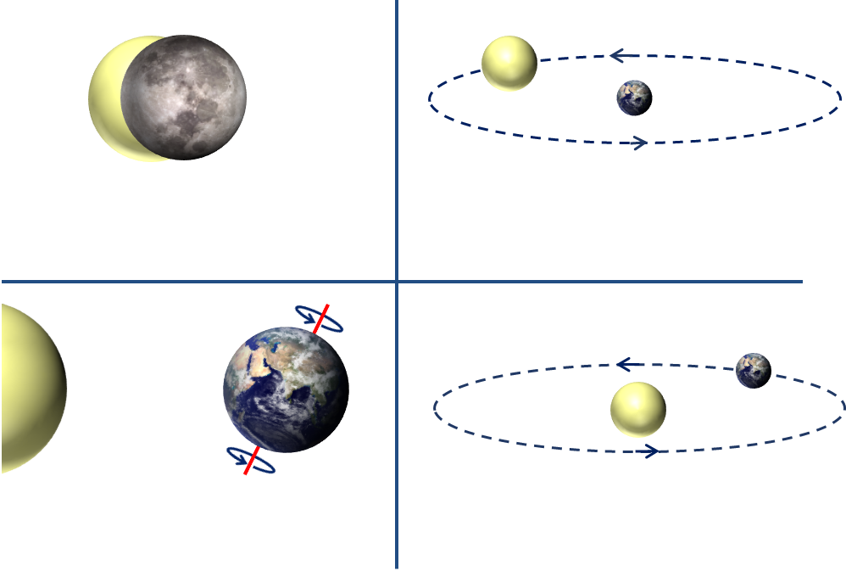
D Earth goes around the Sun
once a day
C Earth rotates on its axis
once a day
A Moon covers the Sun
once a day
B Sun goes behind the Earth
once a day

Can you explain why you think this?
BEST> Earth and space> Day and night
Diagnostic question
Day and night

Overview
Learning focus: | We live on the Earth where a day is the time it takes the Earth to rotate on its axis.
Observable learning outcome: | Describe how the Earth rotates on its axis and explain what a day is.
Question type: | Simple multiple choice
Key words: | Earth, Sun, Moon, axis, rotate

P | PRIOR UNDERSTANDING  This diagnostic question probes understanding of ideas that are usually taught at age 5-11, to aid transition to later stages of learning.
Common preconceptions and misunderstandings
This diagnostic question targets the following misunderstandings that pupils might have:
- The Sun’s ‘movement’ across the sky happens because the Sun is moving.
- The Earth is at the centre of our solar system.
What to know more? Read What does the research say? towards the end of the Teacher Notes.
Ways to use this question
Children should complete the questions individually in order to capture their current understanding. They should be reassured that the questions are designed to uncover their thinking and that ‘getting the answers right’ at this stage is not the most important thing. There will be time for them to share and discuss their ideas with others at a later stage.
Provide sufficient time for the children to think. They should look carefully at the diagrams and written statements provided and use both to help make their decisions.
Answers could be recorded formally as a pencil and paper exercise (using the activity sheet) or you could make a ‘card sort’ for them to place into piles; or play a game of ‘corners’ where children physically move to areas of the room displaying response options.
Alternatively, you could use the accompanying presentation with an electronic voting system or mini white boards and take additional verbal feedback from children in order for them to explain their reasoning. This might range from an uncertain, ‘I am not sure why,’ to a more confident and detailed response. The range of answers will show you whether children understand the concept sufficiently well to apply it correctly.

Differentiation
You may choose to read the questions to the class, so that everyone can focus on the science. In some situations, it may be more appropriate for a teaching assistant to read and/or scribe for a selected number of children.
Expected answers
Answer C gives the most scientifically correct response, indicating an understanding that we have day and night because the Earth rotates on its axis every 24 hours.
Age | Answer A  Moon covers the Sun once a day | Answer B  Sun goes behind the Earth once a day | Answer C  Earth rotates on its axis once a day | Answer D  Earth goes around the Sun once a day | Clouds cover the Sun
9-10 | 9% | 19% | 19% | 44% | 9%
11-12 | 22% | 20% | 22% | 29% | 7%
13-14 | 18% | 12% | 47% | 23% | -
15-16 | 22% | 19% | 33% | 26% | -
Results from a study (n=100) of 9- to 16-year-olds in the south-west of England (Baxter, 1989).
How to respond - what next?
If there is a range of answers, an effective way to respond is through structured class discussion. Ask one child to explain why they gave the answer they did; ask another child to explain why they agree with them; ask another to explain why they disagree, and so on until some sort of shared understanding has been reached. This sort of discussion gives children the opportunity to explore their thinking and for you to really understand their learning needs.
Answer D is most common and partially fits with the correct model of the Earth going around the Sun, rather than the misconception that the Sun travels around the Earth. Although the Earth does orbit the Sun, this takes 365 ¼ days and not one day as the response option states incorrectly. Although daylight hours are affected by the tilt of the Earth's axis and its path around the Sun, the Earth’s orbit of the Sun is not the reason for why we have day and night.
Answer B shows a more egocentric view that fits with pupils’ every day observations that the Sun appears to move around the Earth. This assumption might make perfect sense because we cannot see the Sun when it goes behind the Earth – as it ‘moves across the sky’ from the point of view of the observer. This view, however, is a common misunderstanding.
Answer A is related to the false idea that the moon only appears in the sky during the night-time. It is important for children to understand that the Moon is always there. It produces no light of its own but we see the Moon because the Sun's light reflects back to our eyes.

All of these misunderstandings about the cause of day and night show a lot of persistence, perhaps because the scientific view is a more complex and less obvious explanation. To help children to visualise day and night, use a globe in a darkened room and illuminate it on one side with a strong light. This will give a clear distinction between the lit-up part of the globe facing the light and shade on the part of the globe facing away from the light. A small piece of Blu-Tack placed on your location will show how day and night occur as the globe is spun (rotated) on its axis (once per day). The correct direction to rotate is anti-clockwise whilst looking down at the North Pole.
Plan for further opportunities to design and make physical models, act out the movement of the Earth, Sun and Moon in large open spaces, produce simple animations and record oral commentaries of drafted explanations. For answers A, B and D you could challenge children to explain how the phases of the Moon (a 28-day cycle) or, to extend even further, the seasons of a year can be explained using these techniques.
Responses often work best when the activities involve paired or small group discussions, which encourage social construction of new ideas (meaning making) through dialogue. Children could record their evolving ideas using the statement: I used to think this … because … and now I think this … because … This is an opportunity for them to evidence any progress in learning.
It is our intention to link each diagnostic question to a dedicated response activity relevant to primary. In the meantime, we refer you to the existing BEST 11-14 activity, which can be found in the ‘Planets and the solar system’ folder at www.stem.org.uk/best/physics/big-idea-earth-space, and ask you to use and adapt where you feel appropriate.
- Response activity: Modelling the Earth
What does the research say?
It can be tempting to keep work on the Solar System simple and descriptive when in fact it is conceptually demanding (Osborne, 2011). The scientific explanations for simple observations such as the Sun moving across the sky each day are not obvious and sometimes counter intuitive. The Sun’s ‘movement’ across the sky happens not because the Sun is moving, which is the most obvious explanation, but because the Earth is rotating on its axis.
A study of thirty-two Tasmanian pupils identified a progression in pupils’ thinking from a model with the Earth at the centre, which was held by about three-quarters of the 9- and 10-year-olds, to a model with the Sun at the centre that is understood by the majority of the 11- and 12-year-olds (Jones, Lynch and Reesink, 1987). To correctly explain observable phenomena that are caused by movement of the Earth, Sun and Moon pupils need to understand the correct scientific model. If they are using a model that is incorrect pupils are likely to form further misunderstandings and about a quarter of 11- and 12-year-olds are using incorrect models.
One of the key findings of Lelliott and Rollnick's (2009) review of astronomy education research (1974-2008) was the need for teachers to use physical models both to scaffold learning and to challenge misunderstanding.
Acknowledgments
Developed by Peter Fairhurst (UYSEG) and Nicky Waller (CIEC), based on illustrations in Making Sense of Secondary Science (Driver et al., 1994).
Images: Peter Fairhurst (UYSEG) using images of the Earth and Moon from CC0 Public Domain.
References
Allen, M. (2014). Misconceptions in Primary Science, Second edn Berkshire, UK: Open University Press.
Baxter, J. (1989). Children's understanding of familiar astronomical events. International Journal of Science Education, 11 (Special Issue), 502-13.
Driver, R., et al. (1994). Making Sense of Secondary Science: Research into Children's Ideas, London, UK: Routledge.
Jones, B. L., Lynch, P. P. and Reesink, C. (1987). Children's conception of the Earth, Sun and Moon. International Journal of Science Education, 9(1), 43-53.
Lelliott, A. and Rollnick, M. (2009). Big Ideas: A review of astronomy education research 1974-2008. International Journal of Science Education, 32:13, 1771-1799.
Osborne, J. (2011). Earth in Space. In Sang, D. (ed.) Teaching Secondary Physics. London: Hodder Education.

