Is it a magnet?
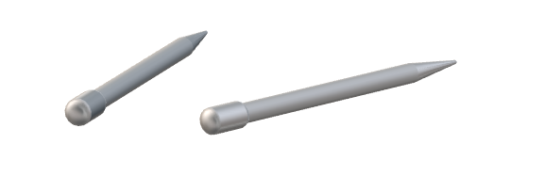
A steel nail can be made into a magnet.
One of these steel nails is a magnet and the other isn’t.

How can a magnet be used to work out which nail is a magnet?

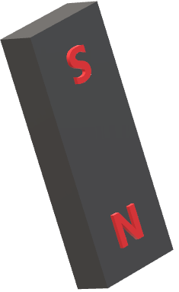
Apparatus and materials
- Two steel nails:
  - One made into a magnet
  - One not a magnet.
- Bar magnet

Procedure
Use the magnet to work out which nail is a magnet.

To answer
  - Describe how to use a magnet to identify another magnet.
  - Why can’t you work out which nail is a magnet, using just the nails?

Physics > Big idea PEM: Electricity and magnetism > Topic PEM3: Magnets and electromagnets > Key concept PEM3.1: Magnetic fields
Response activity
Is it a magnet?

Overview
Learning focus: | The magnetic field around a magnet can be represented by field lines, which indicate the size and direction of the force of the magnet on the north-seeking-pole of another magnet.
Observable learning outcome: | Describe the rules of attraction and repulsion between two magnets.
Activity type: | Application and practice - practical
Key words: | Magnetic, north-seeking-pole, south-seeking-pole, attract, repel, electric charge

This activity can help develop students’ understanding by addressing the sticking-points revealed by the following diagnostic question:
- Diagnostic question: Magnetic poles
P | PRIOR UNDERSTANDING  This activity explores ideas that are usually taught at age 5-11, to aid transition from earlier stages of learning.

What does the research say?
It is only possible to tell the difference between a magnetic material (that is attracted by a magnet) and a magnet if two magnets are used, because one magnet can repel part of another magnet, but not a magnetic material. The majority of students are unlikely to have experienced this repulsive force (Knight, 2004).
Ways to use this activity
This practical activity gives students the opportunity to practise applying their understanding and to clarify their thinking through discussion. To support this, students should complete the practical in pairs or small groups.
Listening to individual groups as they work often highlights any difficulties they might have. These can often be overcome, through a whole class clarification or redirection part way through the activity.
Asking students to report their findings at end of the practical work is a useful check. After a group has fed back, it might be helpful to model an even better answer. You could do this, for example, by asking another group to add to, or clarify, the first observation. Then ask another group to sum up the important part of the observation, and so on.

Differentiation
Providing suitable recording sheets can help some students organise their observations so they can more easily focus on the science. If some students are working with a teaching assistant, then a list of prompt questions for the TA could help to make this activity more purposeful. Some students may benefit from being challenged to plan and organise their own record keeping.
Equipment
For each student/pair/group:
- Two steel nails
  - One nail has been made into a magnet.
  - The other nail is not a magnet.
- Bar magnet
Technician notes
The students should not be able to tell which iron nail is the magnets by looking, or from where they collect it from.
A steel nail can be turned into a magnet by placing it inside a long solenoid and turning it on with a DC current. Solenoids in schools vary, and so will the current necessary to magnetise a steel nail. Care should be taken not to exceed the maximum recommended current for the solenoid used. Further information can be found in the CLEAPPS help sheet: GL301 - Magnets in science, which can be found at: http://science.cleapss.org.uk/Resource-Info/GL301-Magnets-in-science.aspx. This also includes information for making a solenoid capable of re-magnetising bar magnets that have lost some of their magnetism over time.
The steel nail needs to be magnetised sufficiently for it to be repelled by one end of a bar magnet.
Instead of nails, a small bar magnet and a similar looking piece or soft (pure) iron would work in the same way.
Health and safety
Safety issues are mainly linked to the preparation of magnetised nails in the prep room, as highlighted in the technician notes above.
Practical work should be carried out in accordance with local health and safety requirements, guidance from manufacturers and suppliers, and guidance available from CLEAPSS.
Expected answers
- One end of the nail that is a magnet will be attracted to the north-seeking-pole of the bar magnet. The other end of the nail will be repelled by the north-seeking-pole of the bar magnet. The same will be true for the south-seeking-pole of the bar magnet, but the opposite ends of the nail will be attracted and repelled.
Both ends of the nail that is not a magnet will be attracted to both the north- and south-seeking-poles of the bar magnet.
- The nail that is a magnet will attract the nail that is not magnetic in the same way as the bar magnet would. Both ends of each nail would attract, or be attracted to, both ends of the other nail. It is not possible to tell which is attracting and which is being attracted.

Acknowledgments
Developed by Peter Fairhurst (UYSEG).
Images: Peter Fairhurst (UYSEG).
References
Knight, R. D. (2004). Five Easy Lessons: Strategies for Successful Physics Teaching, San Francisco, U.S.A.: Addison Wesley.

