Is it a force?

A force is a push or a pull. It is sometimes difficult to spot when there is a force.
For each picture decide: force or no force

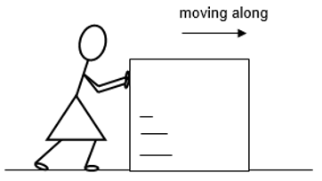
1. Karen is pushing a large box across the floor.
It is moving steadily.

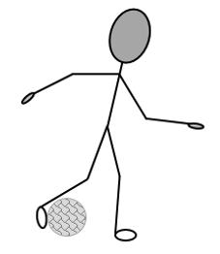
2. During a game of football, Shane kicks the ball.

3. During a game of netball,
Ann and Beth are both pushing on the ball.
It is not moving.

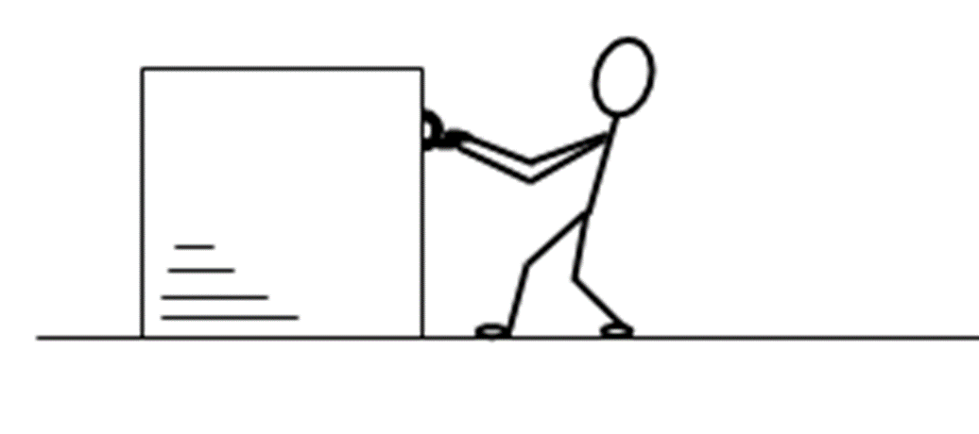
4. A workman is trying to pull a heavy box across the floor.
It is not moving.

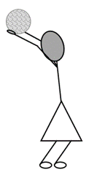
5. During a game of football,
Alice takes a throw in.

6. A spacecraft is drifting through space.
It is very far from all other objects.
There is no air in space, so there is no air resistance.
The spacecraft is moving in a straight line at a constant speed.

7. A heavy book is sitting on a table.
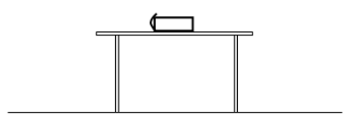

Physics > Big idea PFM: Forces and motion > Topic PFM1: Forces > Key concept PFM1.1: What forces do
Diagnostic question
Is it a force?

Overview
Learning focus: | A force makes things change: the speed, direction and/or shape of an object.
Observable learning outcome: | Identify situations in which a force (push or pull) is acting.
Question type: | Simple multiple choice
Key words: | Force, push, pull

P | PRIOR UNDERSTANDING  This diagnostic question probes understanding of ideas that are usually taught at age 5-11, to aid transition from earlier stages of learning.

What does the research say?
In earlier teaching students are likely to have described forces as pushes or pulls. Shevlin (1989) notes that students do not necessarily associate ‘kicks’ or ‘throws’ with a push. Force is a word that is used in a range of familiar contexts, and one that has a specific meaning in science.
Young students often associate the word ‘force’ with living things in the sense that some objects have the ‘power’ to make things move or can actively ‘try to’ bring about a particular action. For example they might describe a ball that is thrown upwards as ‘resisting’ the force of gravity (Driver et al, 1994).
Forces are often linked to ‘active’ objects like cars which can themselves make other things move.
More commonly forces are linked to movement and students see force as a property of something that is moving. A property that keeps it moving and which runs out when a moving object comes to rest (Gunstone and Watts, 1985, Driver et al, 1994).
Ways to use this question
Students should complete the question individually. This could be a pencil and paper exercise, or you could use an electronic ‘voting system’ or mini white boards and the PowerPoint presentation.
The answers to the question will show you whether students understood the concept sufficiently well to apply it correctly.
If there is a range of answers, you may choose to respond through structured class discussion. Ask one student to explain why they gave the answer they did; ask another student to explain why they agree with them; ask another to explain why they disagree, and so on. This sort of discussion gives students the opportunity to explore their thinking and for you to really understand their learning needs.

Differentiation
You may choose to read the questions to the class, so that everyone can focus on the science. In some situations it may be more appropriate for a teaching assistant to read for one or two students.
Expected answers
1. Force 2. Force 3. Force 4. Force
5. Force 6. No force 7. Force
How to respond - what next?
In Q1 the pushing causes the movement, as the kick also does in Q2. Some students think of a force as a steady push and do not think of the very short contact time of a kick as a force – but it still pushes the ball.
In Q3 and Q4 students can imagine themselves pushing or pulling and exerting a force, although there is no observable change.
Q5 As with a kick, some students do not think of a throw as a force. Here they may be concentrating on the instant of release, rather than the push on the ball during the time it is in contact with Alice’s hands.
Q6 will highlight which students think a force is necessary for steady motion. As the majority of students think this, it is likely to be a common (wrong) response. There is no force here to change the motion and to slow the spacecraft down.
Q7 has no moving objects. Although students may recognise gravity pushing the book down, only about half are likely to identify the table pushing on the book. (NB this reaction force of the table is considered much more fully later on in the suggested teaching sequence.)
If students have misunderstandings about identifying situations in which a force is acting, it may be helpful to focus their thinking on whether or not there is a push or a pull involved. Giving students the opportunity to observe the effects of a range of forces, in different situations, will allow them to become more familiar with this idea.
This may also be a good opportunity to introduce the measuring of forces with a force-meter and a top-pan balance.
Acknowledgments
Developed by Peter Fairhurst (UYSEG).
Images: EPSE (1, 3, 4, 6, 7), Peter Fairhurst UYSEG (2, 5)
References
Driver, R., Squires, A., Rushworth, P. and Wood-Robinson, V. (1994) Making sense of secondary science, research into children’s ideas, Routledge, London, England.
Gunstone, R. and Watts, M. (1985) ‘Force and Motion’ in Driver, R., Guesne, E. and Tiberghien, A. Children’s Ideas In Science, Open University Press, Milton Keynes, England.
Shevlin, J. (1989) ‘Children’s prior conceptions of forces aged 5-11 and their relevance to Attainment target 10 of the National Curriculum of Science’, Unpublished M.Ed. thesis, University of Leeds.

