Christmas paper chain fun
Stay safe
Whether you are a scientist researching a new medicine or an engineer solving climate change, safety always comes first. An adult must always be around and supervising when doing this activity. You are responsible for:
• ensuring that any equipment used for this activity is in good working condition
• behaving sensibly and following any safety instructions so as not to hurt or injure yourself or others
Please note that in the absence of any negligence or other breach of duty by us, this activity is carried out at your own risk. It is important to take extra care at the stages marked with this symbol: ⚠
Age range: 11-14-year-olds or younger with adult supervision  Approx. time: 45 minutes – 1 hour |  | Key words / Topics:  - maths  - Fibonacci  - sequence  - pattern  - golden ratio
Introduction
Paper chains are super easy to make and a great way to decorate a room or Christmas tree. In this activity learners are going to try to make the longest chain possible with three pieces of paper and then think about colour and number sequences.
Equipment ⚠
- Glue stick
- A ruler
- Two sheets of red paper
- Two sheets of green paper
- Two sheets of yellow paper - learners can choose their own colours, as long as they are different!
- Scissors

Instructions ⚠
Step 1 ⚠
Take one sheet of each colour. Use the scissors to cut the paper into thick strips, approximately 3cm wide. When all three sheets have been used, place the strips to one side.

Step 2 ⚠
Repeat step 1 with the other three sheets, but this time make the strips thinner (approximately 1cm wide).

Step 3
Learners should predict which set of strips will make the longest chain - will it be the thick strips or the thin strips? And why?
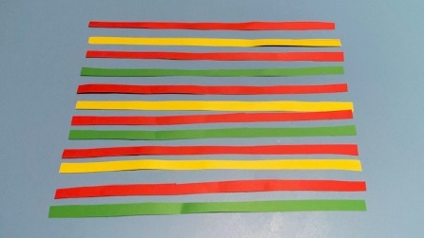
Step 4
Decide on a sequence to use to mix up the colours– a sequence is a pattern. Some examples of colour sequences are below, or learners could make up their own sequence. As learners are making two chains, they can have two different sequences or have the same for both thick and thin strips.
Red – Green – Yellow – Red – Green – Yellow – Red – Green – Yellow
Red – Red – Green – Green – Yellow – Yellow – Red – Red – Green – Green – Yellow – Yellow
Red – Yellow – Red – Green – Red – Yellow – Red – Green
Step 5
Use the glue stick to glue each strip into a loop, each one looping through the one before to make a chain.

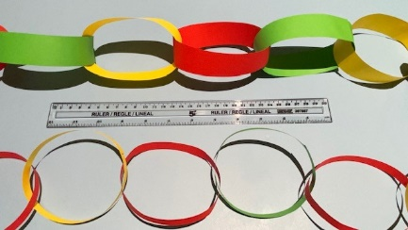
Step 6
Use a ruler to measure each chain to find out which one is the longest. Was the prediction correct?

Science and maths
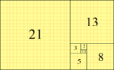
Learners might not realise that sequences are all around us. One of the most famous sequences is called the Fibonacci sequence. This is a series of numbers starting from 0 where every number is the sum of the two numbers preceding it. So, the sequence goes 0,1, 2, 3, 5, 8, and so on:
0+1=2 1+2=3 2+3=5 3+5=8 etc.
The sequence goes on forever! If we made a picture of the sequence with each of the squares representing the size of each number, it might look a bit like this:

This sequence is the basis of something mathematicians call the Golden Ratio. The sequence – and this shape – is found in many places in nature, such as a leaves or petals on a flower. For example, a sunflower head might have florets in an arrangement of 34 and 55. It’s also thought to be a sequence that makes buildings and other structures look attractive.
The Engineering Context
The Fibonacci sequence is widely used in engineering applications including computer data structures and sorting algorithms, financial engineering, audio compression, and architectural engineering.
Curriculum links
England: National Curriculum  - Maths: upper KS2  - Reason about the location of any number with up to 2 decimals places in the linear number system, including identifying the previous and next multiple of 1 and 0.1 and rounding to the nearest of each. |  | Northern Ireland Curriculum  - Primary: the world around us  - By interpreting statistical data and using it to solve problems using measurement, shape, space and estimation in the world around them.
Scotland: Curriculum for Excellence  - Maths third  - I have worked with others to research a famous mathematician and the work they are known for, or investigated a mathematical topic, and have prepared and delivered a short presentation. |  | Wales: National Curriculum  - Maths Year 5  - Show that a number is in the sequence and/or find the position number by continuing the sequence or otherwise.

