Activity title
Jingle bells density experiment
Stay safe
Whether you are a scientist researching a new medicine or an engineer solving climate change, safety always comes first. An adult must always be around and supervising when doing this activity. You are responsible for:

• ensuring that any equipment used for this activity is in good working condition
• behaving sensibly and following any safety instructions so as not to hurt or injure yourself or others

Please note that in the absence of any negligence or other breach of duty by us, this activity is carried out at your own risk. It is important to take extra care at the stages marked with this symbol: ⚠
Time required
Less than 30 minutes
Activity summary
“Jingle Bells” is a great carol and bells are part of Christmas celebrations – not to mention decorations! In this fun challenge, we see the effect that density has on objects and make some jingle bells dance!
What equipment will you need?
- A handful of bells – any size
- A can of clear fizzy pop or fizzy water
- A jam jar big enough to hold all your bells
And have an adult to help.
How to do it
Step 1
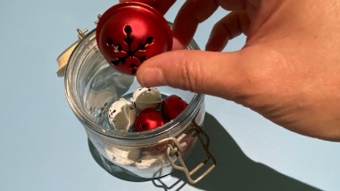
Put your bells in the jam jar. You don’t want to fill it up more than about one third of the way.

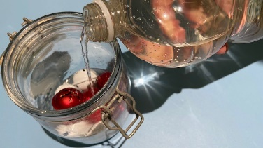
Step 2

Add the fizzy pop or fizzy water until the jar is full. This works best when the pop/water is at room temperature.

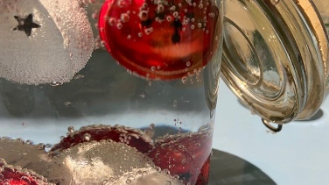
Step 3
Watch to see the bells begin to rise and fall carried by the bubbles in the pop.

Well done – you’ve cracked the Christmas challenge!

Here’s the science
The bells rise and fall due to the different density of the ingredients – so let’s dive in and find out what’s happening under the surface!
Dazzling density
Density is the name given to how compact the particles in an object or liquid are. The more closely packed they are, the more dense the object or liquid will be. Denser substances will sink, and less dense substances will rise.

In our experiment, the bells were more dense than the fizzy pop/water and so sank to the bottom. The air bubbles in the fizzy pop/water are less dense so they rise to the top. When the bubbles clung to the bells they were carried to the surface, but when they popped the bells returned to the bottom of the jar once again.

Bubble magic
So how DO bubbles get into fizzy drinks and why do the bubbles stick to the bells?
Liquids can contain gases – for example the water in the ocean contains oxygen for the fish to breathe. The gas in fizzy drinks is called carbon dioxide and it’s pushed into the drink at high pressure which makes it dissolve. Bottles we buy are filled at very high pressure and at low temperatures – this helps higher amounts of the gas to dissolve in the liquid. When you open the bottle, the pressure drops and the carbon dioxide escapes in the form of bubbles which rise to the surface where they pop and the gas leaves the drink. That’s why when you leave a fizzy drink without the lid on it will eventually lose all its bubbles and go flat. As the pressure will have dropped once the bottle is opened it’s easier to squeeze the bottle than when it was new.

And why do bubbles stick to the bells? Well, they may look like they have smooth surfaces but at a microscopic level the surface is actually quite rough – the tiny bumps give the bubbles something to cling on to. You can see the same thing happen when you put a straw in your drink.

