Activity title
Puzzling paperchains
Stay safe
Whether you are a scientist researching a new medicine or an engineer solving climate change, safety always comes first. An adult must always be around and supervising when doing this activity. You are responsible for:

• ensuring that any equipment used for this activity is in good working condition
• behaving sensibly and following any safety instructions so as not to hurt or injure yourself or others

Please note that in the absence of any negligence or other breach of duty by us, this activity is carried out at your own risk. It is important to take extra care at the stages marked with this symbol: ⚠
Time required
30 minutes to 1 hour
Activity summary
Paper chains are super easy to make and a great way to decorate a room, or your Christmas tree. In this challenge we’re going to try to make the longest chain we can with three pieces of paper and then we will think about colour and number sequences.
What equipment will you need?
• Scissors
• Glue stick
• A ruler
• Two sheets of red paper
• Two sheets of green paper
• Two sheets of yellow paper - You can choose your own colours, as long as they are different!

And have an adult to help.

How to do it
Method
Step 1 ⚠
Take one sheet of each colour. Use the scissors to cut the paper into thick strips (approximately 3cm wide).
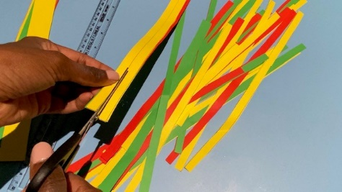
Step 2 ⚠
When you have used all three sheets place your strips to one side. We’re going to do the same thing with the other three sheets but this time make the strips thinner (approximately 1cm wide).
Step 3
Can you predict which set of strips will make the longest chain? Will it be the thick strips or the thin strips? And why? Write your prediction down here - (a prediction is a guess about what might happen):
I PREDICT:
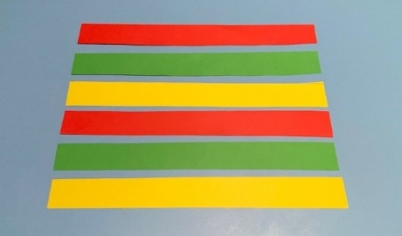
Step 4
Decide on a sequence to use to mix up the colours– a sequence is a pattern. Some examples of colour sequences are below. Because you are making two chains, you can have two different sequences or have the same for both thick and thin strips.
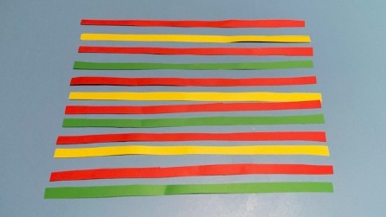
Red – Green – Yellow – Red – Green – Yellow – Red – Green – Yellow
Red – Red – Green – Green – Yellow – Yellow – Red – Red – Green – Green – Yellow – Yellow
Red – Yellow – Red – Green – Red – Yellow – Red – Green
Or you can make up your own sequence!
What are your sequences going to be? Write them below:
MY THICK CHAIN SEQUENCE:
MY THIN CHAIN SEQUENCE:
Step 5
It’s time to make your chains! Use the glue stick to glue each strip into a loop, each one looping through the one before to make a chain.
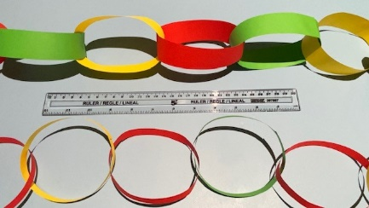
Step 6
Use your ruler to measure each chain to find out which one is the longest.
THICK CHAIN LENGTH:
THIN CHAIN LENGTH:
Step 7
Was your prediction correct?
Well done – you’ve cracked the Christmas challenge!
Sequences
In the experiment you designed a sequence to order the colours of your paperchain loops. Sequences – or number patterns are everywhere! Sequences are helpful because when we have discovered a pattern, we can make predictions. For example, if you get a leaflet saying the recycling truck will collect refuse every Friday, we can make sure we have placed the bin out in time because we can accurately predict the truck will come.
Sequence steppingstones
Number sequences can be fun to solve! Can you fill in the gaps on the sequence stepping stones below?
19, 18, --- 16, 15, ---, ---
2, 4, ---, ---,10, 12, ---, ---
10, ---, 30, ---, 50, ---, ---
---, 29, ---, ---, 26, ---
15, ---, 25, ---, 35, ---
Fantastic Fibonacci
You might not realise, but sequences are all around us. One of the most famous sequences is called the Fibonacci sequence.
The Fibonacci sequence is a series of numbers starting from 0 where every number is the sum of the two numbers preceding it. So, the sequence goes 0,1, 2, 3, 5, 8, and so on.
0+1 =2
1+2=3
2+3=5
3+5=8
Can you work out the next five numbers in the sequence?
The sequence goes on forever! If we made a picture of the sequence with each of the squares representing the size of each number it might look a bit like this:
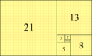
And this is the basis of something mathematicians call the Golden Ratio. The sequence – and this shape is found in many places in nature such as a leaves or petals on a flower. For example, a sunflower head might have florets in an arrangement of 34 and 55. It’s also thought to be a sequence that makes buildings and other structures look attractive.

