Trees and Carbon Capture session plan
Brief overview of session ‘logic’ | Mathematical opportunities offered
- Why trees are good  - How much carbon do trees capture and store?  - How does the amount of carbon captured and stored by a tree change during its lifecycle? | - Interpretation of data, statistics, graphs, infographics in context  - Critiquing graphs  - Analysing and comparing data in order to develop and present a conclusion  - Making assumptions  - Making predictions  - Reading scales  - Plotting graphs

Time for session: 30 minutes.
Time | Slide | What to do… | Aims, additional info and comments
0 | 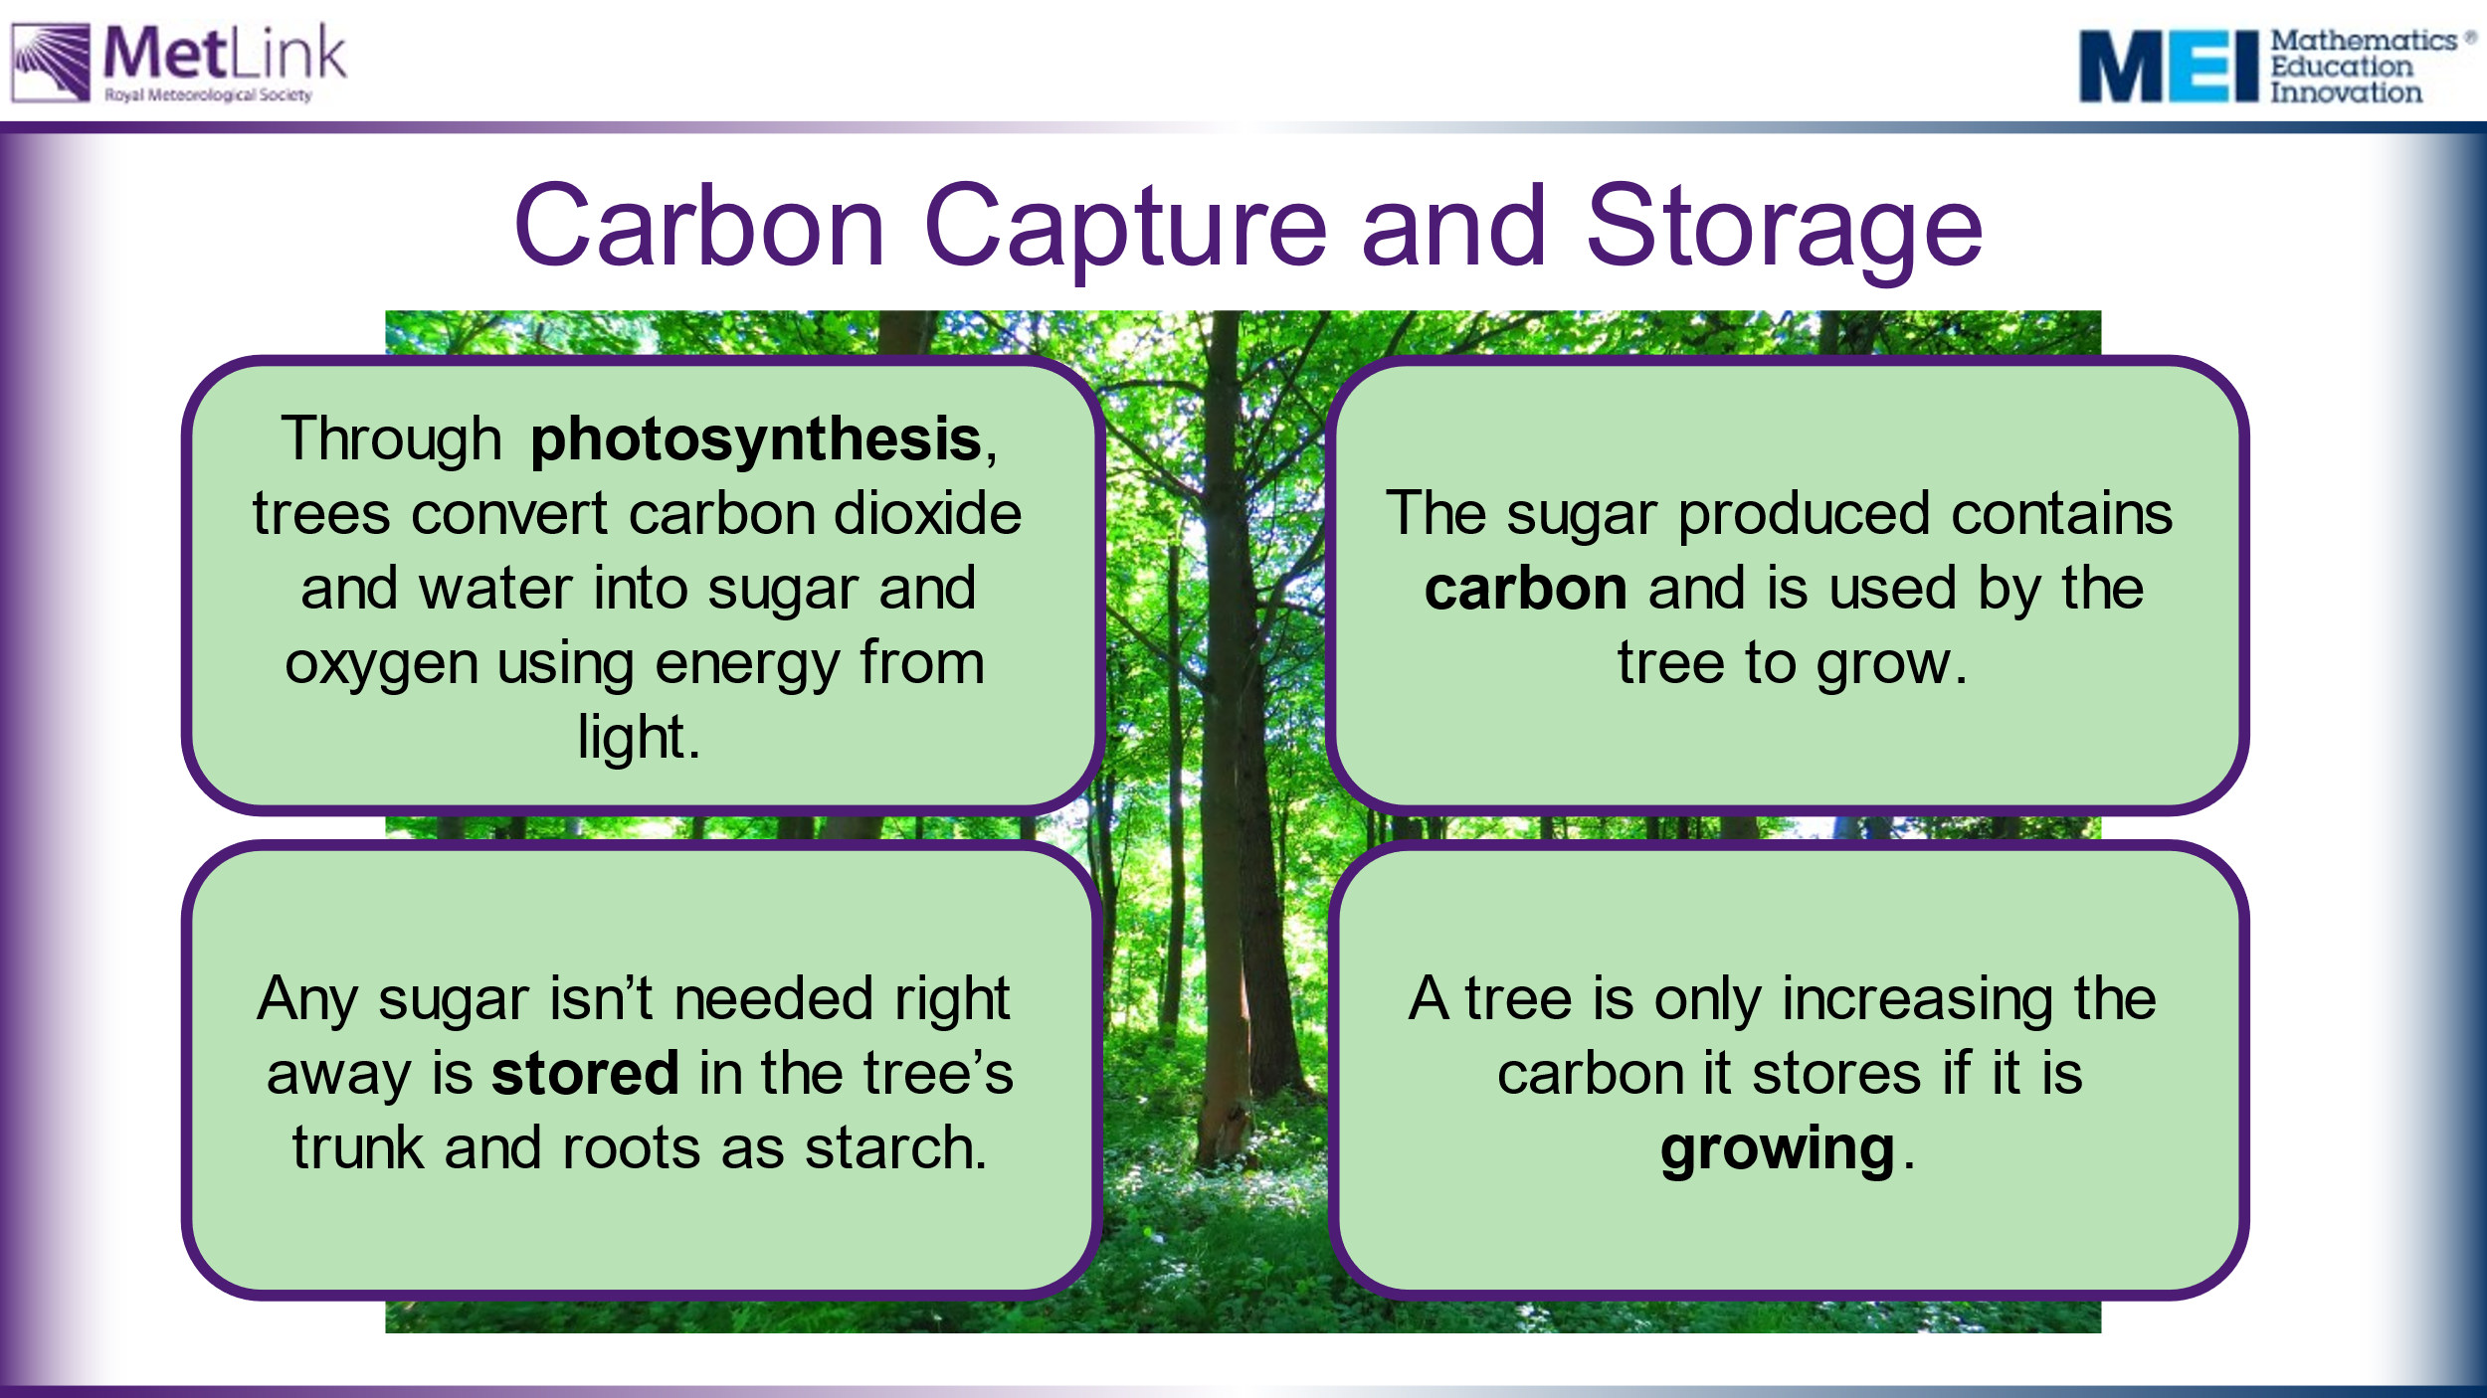 | Emphasise that trees only capture and store carbon from the atmosphere when they are actively growing.  Mature trees, which are no longer growing, shed as much carbon as they absorb from the atmosphere.  What are the implications of this?
5 | 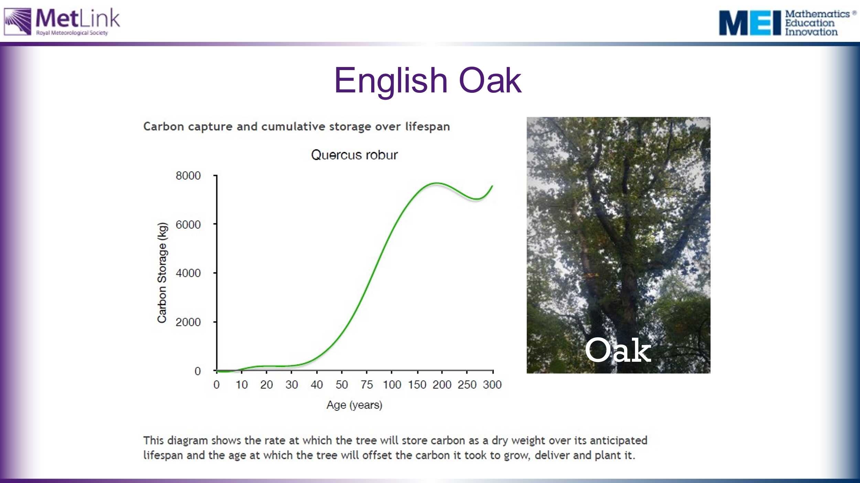 | Main activity:  We are going to look at data showing how much CO₂ different species of tree absorb from the atmosphere.  This will allow us to address some of the issues and questions raised in the session so far, including:  - How many trees need to be planted to offset a flight from London to New York  - What kinds of trees and woodlands would it be best for us to plant?  Task 1: Provide students, in groups, with the three graphs and ask them to write down three things that they notice. Collect these points and any questions or issues raised. Show slide with all three graphs together on the board when collecting their views.  Emphasise that it is very difficult to compare the three graphs in their current form. Can your students say why? | The aim of task 1 is to draw attention to some of the issues with the data as presented. Some questions that might emerge include:  - What do the graphs actually show?  - What does it mean for a cumulative frequency graph to go down? (as it does for the English Oak graph)  - Can you work out which trees are best to plant from this data? (It is very difficult to compare these graphs in their current form)  Draw attention to the scales on the graphs – not only are the scales different for the different species, the scales for Age are not linear – the intervals on the x-axes vary. Why do they change? How is this misleading? (or is it not?)  Information about how this data was collected is available here: https://www.treeconomics.co.uk/projects/barchamcarbonperformanceproject/ and here: https://www.barcham.co.uk/store/. Each tree in the Barcham shop has a certificate.  The negative carbon storage in the first few years of each graph are explained by taking into account the carbon emissions in driving to collect the tree before planting it.  The Norway Spruce is a common variety of Christmas Tree.
 | 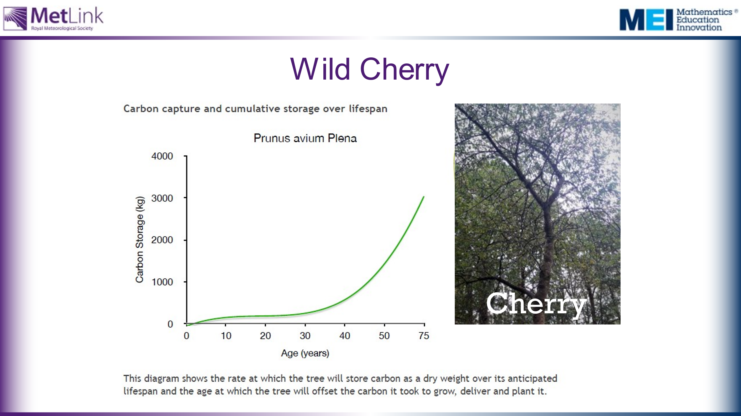
 | 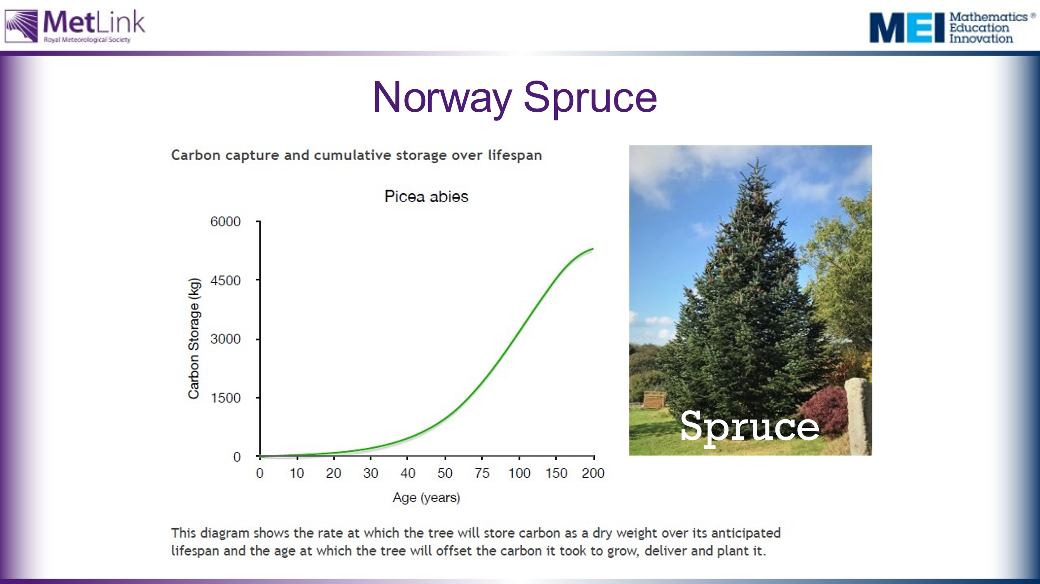
 | 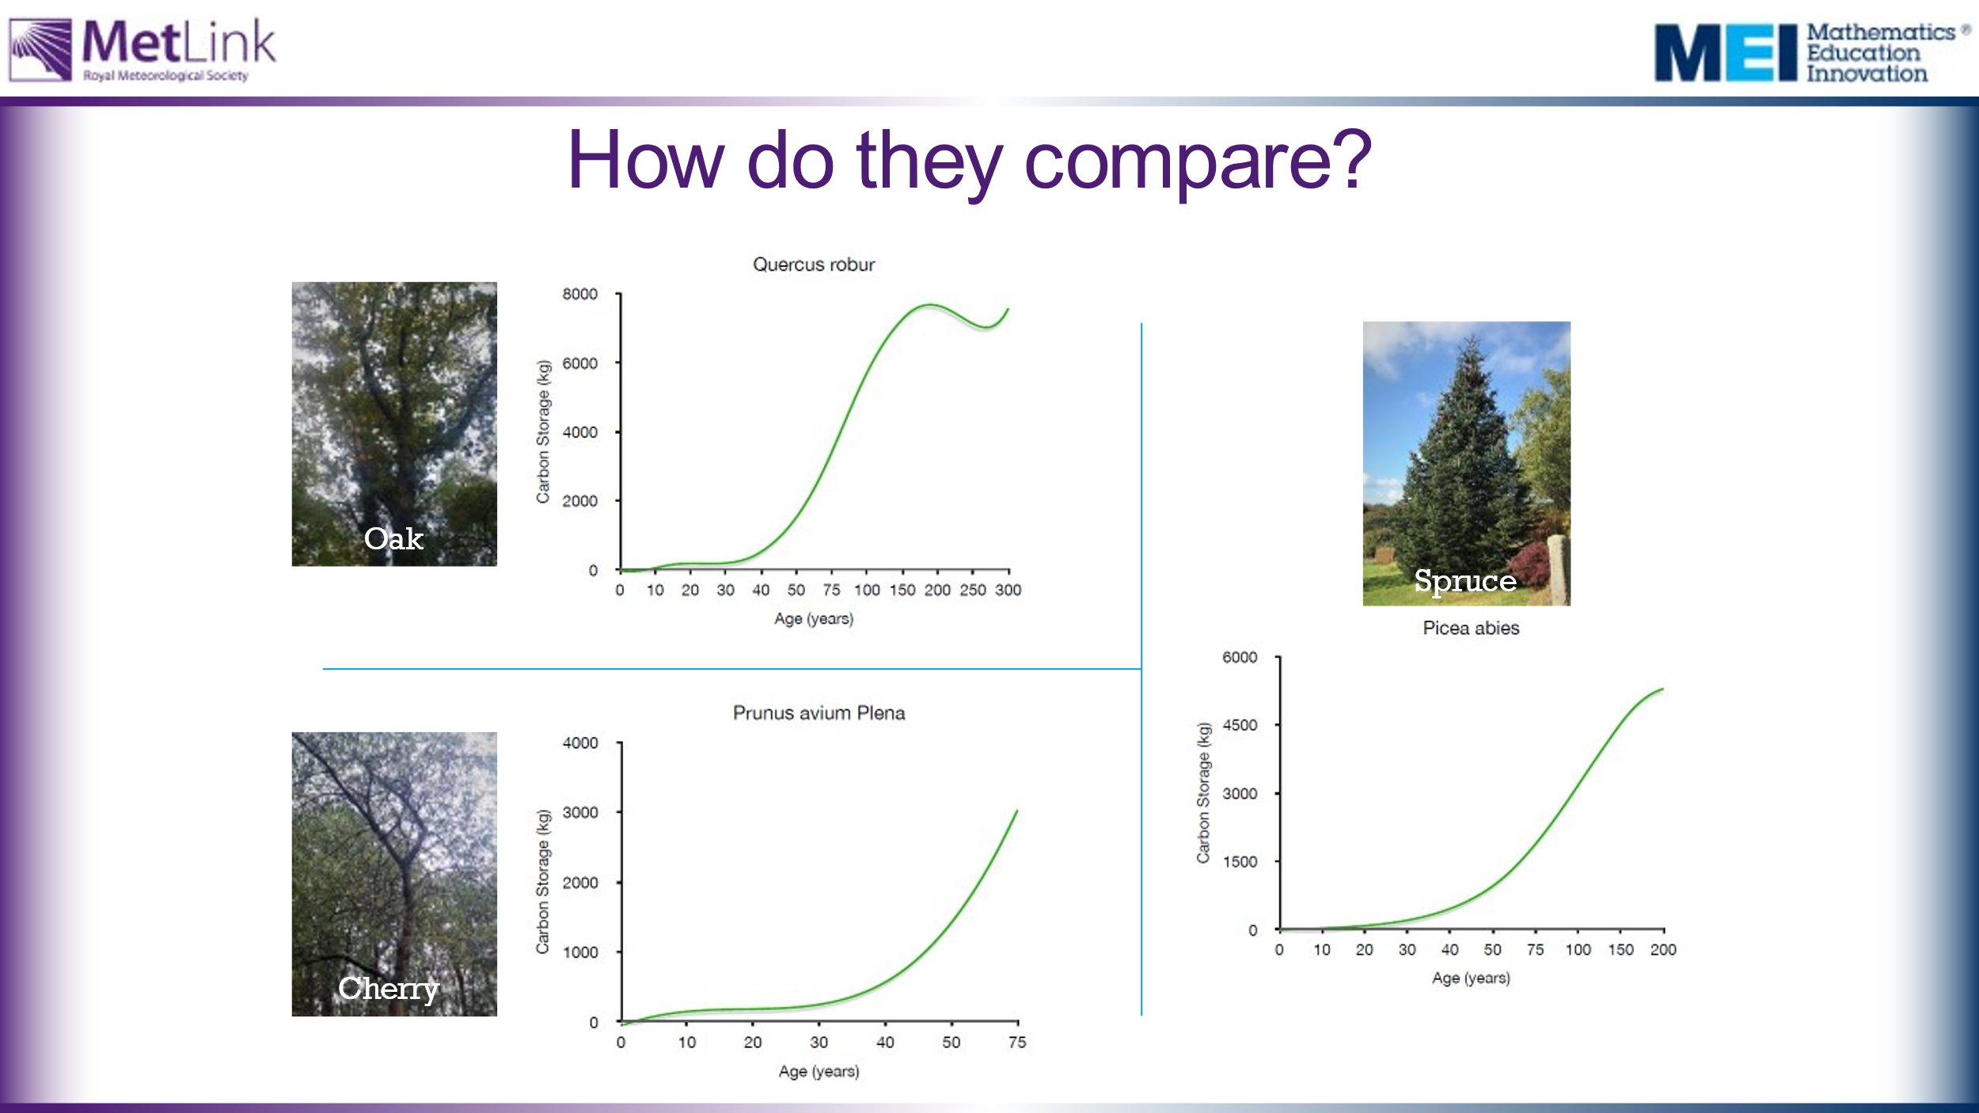
15 | 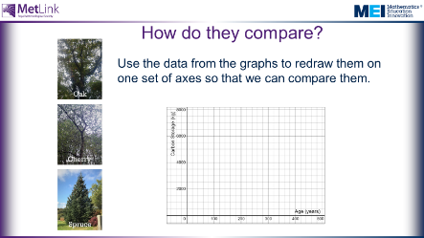 | Task 2: Provide students with blank axes and data take from the graphs. Students should plot the data from each tree on the same axes to allow for effective comparisons to be made between the trees. | Warning: It is quite fiddly to read information accurately from the graphs. Students will need a ruler and pencil, and careful attention needs to be paid to the varying scales on the graphs.  It may be worth showing students the following hidden slide to give them an idea of a possible approach.
 | 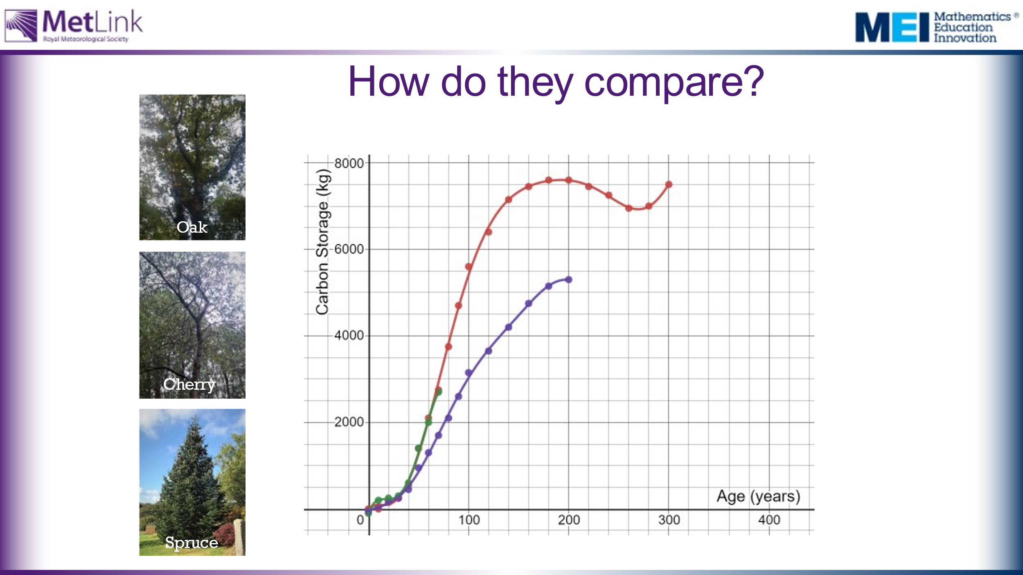 | What conclusions can we draw?  Here are the three sets of data plotted on the same set of axes, in Desmos: https://www.desmos.com/calculator/rci87lp05w  After 15 minutes they need to present their argument for which trees they would choose to plant and why. | It’s worth noting that it takes around 200 years for Oak and Spruce trees to store their maximum amount of carbon.
30 | 