Graph of carbon storage of three species of tree
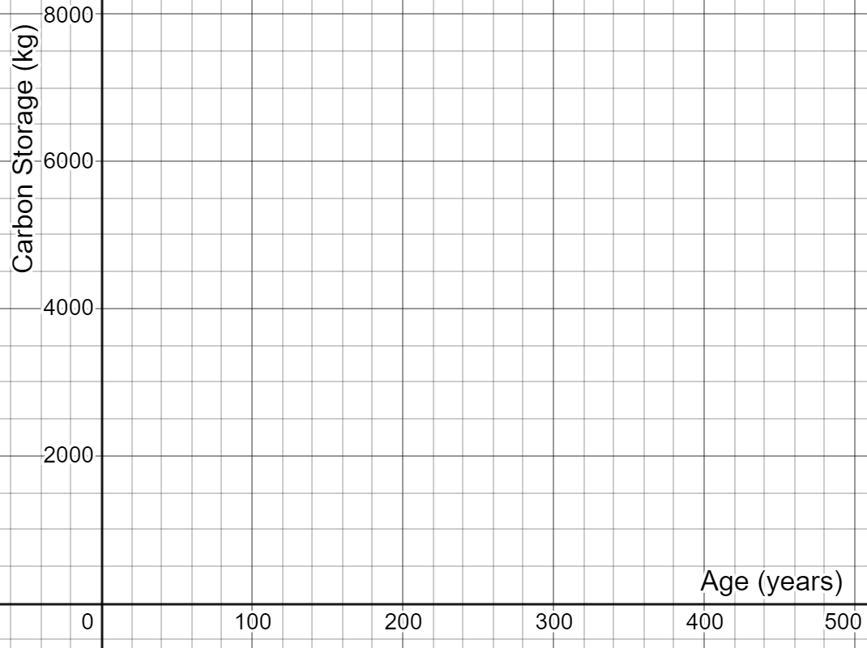
Graph of carbon storage of three species of tree
