Volcanoes presentation – Key Stage 2/3

Key concepts:
- To understand how a volcano forms through the rising up of magma
- To understand the structure of a volcano and be able to recognize and label key parts
- To understand that volcanoes are usually found at plate boundaries either constructive or destructive boundaries but also above hotspots
- To be able to name and locate some of major volcanoes on Earth
- To understand that volcanoes are natural hazards
- To understand some of the positive and negative impacts volcanic eruptions can have on populations

Presenter notes

Some suggested notes for each slide and information for the presenter. Questions the presenter could ask students are highlighted in bold. The Geological Society gives permission for presentations and notes to be adapted to suit the presenter’s needs.

Volcanoes Overview

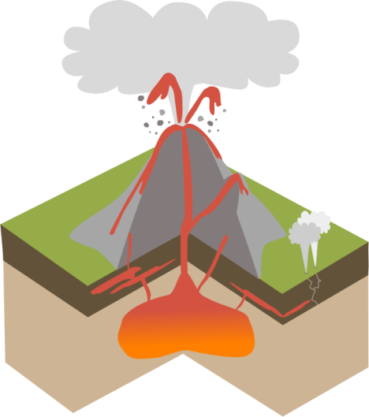
Volcanoes are openings in the Earth’s rocky surface which allow hot molten rock, ash and gas to escape from below the surface. When molten rock is below the surface of the Earth it is known as magma but when it is on the surface it is called lava. The UK has any extinct volcanoes or parts of volcanoes including Helvellyn in the Lake District, Arthurs Seat in Edinburgh, Ben Nevis in Fort William and Snowdon in north Wales.
Ash, steam & gas
Lava
Volcanic bombs
Magma chamber
Geyser
Conduit
Main vent
Secondary vent
Sill
Dykee

Magma deep underground collects in a magma chamber beneath a volcano. As more and more magma is added to the magma chamber, the pressure increases and causes the rock around the magma chamber to crack. The hot liquid magma, which is lighter than the surrounding rock, rises upwards through conduits or cracks in the crust and erupts on land through a volcanic vent. Sometimes when a volcano erupts it can blow the top off the volcano creating a bowl shaped crater. As a volcano erupts over days, weeks and even thousands of years, each eruption of lava and ash adds layers onto the volcano so that over time it grows into a huge landform.

Volcanoes can erupt effusively (gently) when magma is runny and contains little gas (e.g. in Hawaii) or explosively causing a huge ash columns and potentially pyroclastic flows - flows of hot gas and ash (up to 800°C) that races down the side of a volcano when an ash column (e.g. Mount St Helens in Washington, USA). Explosive eruptions are a bit like fizzy drinks - these contain carbon dioxide gas under pressure, and when a bottle of fizzy drink is shaken, extra bubbles of carbon dioxide gas are created. These extra bubbles explode out of the bottle taking the fizzy drink with it. This is what happens in explosive eruptions – the bubbles of gas trapped within the magma explode out of the volcano taking rock fragments, lava and ash with it. Effusive eruptions can also sometimes form lava lakes – a good example is Nyiragongo Volcano in Democratic Republic of Congo, these are lakes of molten lava contained in the crater of volcano and are very rare on Earth.

There are two main types of lava that come out of a volcano during an effusive eruption, Pahoehoe pronounced ‘pah-hoey-hoey’ and ´A´a pronounced ‘ah-ah’ (both Hawaiian words). Pahoehoe forms from slowly flowing lava and has a smooth or ropey surface when it hardens into rock. ’A’a forms from fast flowing lava and has a rough, rubbly surface with jagged blocks when it hardens into rock.

Where and why do we get volcanoes?
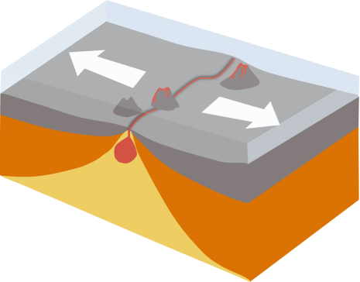
The Earth’s crust and outer mantle are together known as the lithosphere - this is the rigid outer layer of the Earth. The lithosphere is split up into tectonic plates which can be oceanic – made from ocean crust (basalt), continental - made from continental crust (granite) or a mixture of the two. Oceanic crust is denser and forms the ocean basins, continental crust is less dense and forms the elevated landmasses. Tectonic plates move around above the mantle below which can flow but is still solid rock. Tectonic plates meet at plate boundaries which can be constructive (moving away from each other), destructive (moving towards each other, with one plate being forced under or subducted beneath the other) or conservative (sliding past each other – causes lots of earthquakes). Volcanoes form at both constructive and destructive plate boundaries. Most volcanoes on Earth occur around the edge of the Pacific plate a region known as the ‘Pacific Ring of Fire’.
Constructive plate boundary: when plates pull apart the mantle below melts (as it is under less pressure) and forms pockets of hot liquid magma. This magma, which is lighter than the surrounding rock, rises up to fill in the gap and erupts on the sea floor as underwater volcanoes. The Mid Atlantic Ridge is an example of a constructive plate boundary on Earth.

Constructive

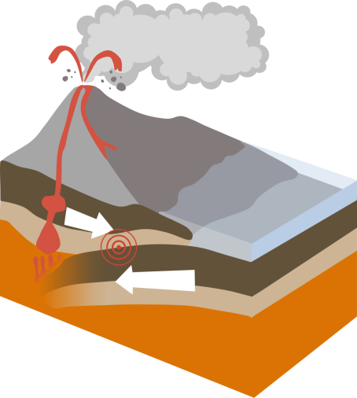
Destructive plate boundary: when two plates (either one continental and one oceanic, or two oceanic plates) are moving towards each other a subduction zone forms. This is a place where the cold, old, oceanic plate is pulled down into the Earth’s mantle where it melts to form magma. This magma then rises and erupts explosively on land as lava and forms volcanoes. The Andes mountain chain in South America is formed from a chain of volcanoes above a subduction zone. As well as having lots of volcanic activity, earthquakes are also very common at subduction zones, generated by the two plates grinding against each other.

Destructive
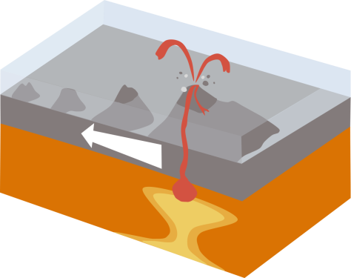

Volcanoes can also form above hotspots – these are areas of superheated rock in the mantle which cause magma to rise and erupt as lava on the ocean floor. Hotspots can be far away from any plate boundary – for example the Hawaiian Islands in the middle of the Pacific plate are formed due to a mantle hotspot.
Hotspot

There are two main types of volcano – shield volcanoes and composite or stratovolcanoes. Shield volcanoes form from gentle (effusive) eruptions of runny lava. Because it’s so runny, this lava can travel a long way before it solidifies into rock and creates wide, sloping volcanoes in the shape of a shield. Mauna Loa in Hawaii is a good example of a shield volcano, Olympus Mons on Mars is also a shield volcano. Composite volcanoes are formed from layers of alternating lava and ash, usually at destructive plate boundaries. The lava that erupts to form composite volcanoes is much thicker and flows more slowly than basalt lava. This means that it cannot spread out very far before it solidifies so forms cone-shaped volcanoes with steep sides. Because of the thicker, stickier lava, composite volcanoes tend to erupt explosively.

Volcanoes as natural hazards
- Lava flows - can burn down and cover any buildings/roads that happen to be in their path (e.g. in the Kilauea eruption in Hawaii 2018). If a volcano has an ice cap the heat from erupted lava can melt the snow and ice causing floods – a particular problem in Iceland.
- Volcanic ash - made from tiny fragments of rock and glass which can get inside aeroplane engines and clog them up causing the engines to fail; it can also poison water supplies and
farmland and cause breathing problems in humans and other animals. Large ash clouds can block out the sun, when Mount Pinatubo erupted in 1991 ash in the atmosphere lowered the Earth’s temperature by 0.5°C for a whole year!
- Pyroclastic flows - mixtures of hot ash, gas and rock fragments which race down the sides of a volcano at speeds of up to 1000kmph and temperatures more than 800°C instantly boiling and crushing anything in their path including people, animals and plants.
- Volcanic gas - most of the gas in magma is water vapour which is generally harmless however other gases such as carbon dioxide, fluorine, chlorine and hydrogen sulfide, can be extremely harmful to humans and other animals.
- Lahars are a type of mud flow caused when volcanic ash and other volcanic debris mixes with water. Lahars flow like water, have a similar texture to wet concrete, and can be 60-70°C . They may not be as hot as pyroclastic flows however they are extremely destructive and can bulldoze and bury anything in their path.
- Volcanic eruptions can also cause rock falls, landslides, earthquakes and tsunamis so they can be extremely dangerous natural hazards.

Hundreds of millions of people choose to live very near and even on the slopes of active volcanoes. Some major cities (e.g. Mexico City population 9 million) have even been built close to active volcanoes (Popocatepetl). People choose to live near volcanoes because for them the positives outweigh the negatives. Volcanic ash and lava are rich in minerals so over time (hundreds of years) they break down to provide valuable nutrients for the soil. The regions around Mount Vesuvius in Italy are particularly well-known for growing grapes, tomatoes and other vegetables in the rich volcanic soils. Volcanoes create beautiful landscapes so are important tourist attractions for many countries. Volcanic areas can be sources of geothermal energy - heat energy from the Earth - which is used to drive turbines and produce electricity, or to heat water supplies. In Iceland 85% buildings are heated by geothermal energy and 25% of the nation’s electricity is generated from geothermal energy. Important minerals such as zinc, lead, tin, copper, silver and gold can be found in volcanic rocks. Hot gasses escaping through vents of active volcanoes also bring minerals to the surface, particularly the mineral sulfur.

Monitoring volcanoes: Geologists can monitor volcanoes to see whether they might be close to erupting by looking at the volcanic gases that come out. Because gas is less dense than magma, it rises quickly and can be detected at the surface of the Earth through vents called fumaroles. An increase in the amount of gas given off, the appearance of new gas vents, or a change in the chemical makeup of the gas can be some of the first aboveground signs of increased volcanic activity.

Magma, gas, and other fluids moving underground before a volcanic eruption can cause swelling, sinking, or cracking in the ground surface. Tiltmeters are used to continuously measure the tilt of the ground surface – if magma is collecting beneath a volcano it will usually cause the surface above to inflate and tiltmeters can measure these changes. Another way land surface changes are monitored is to use satellite data. To do this, multiple receivers are placed around a volcano, satellites travelling around the Earth can then detect whether any of these receivers have moved over time which might indicate that the volcano is bulging with magma and ready to erupt. As magma and volcanic gases rise to the surface from depth they can also cause earthquakes. Seismometers detect the amount of shaking form an earthquake to work out its location, how strong it is (magnitude) and how frequent earthquakes are occurring to determine whether or not an eruption may occur.

Volcanos quiz answers

Questions | Answers
What are the arrows on the diagram pointing towards? | B: Magma chamber and conduit
What is a dormant volcano? | B: One that hasn’t erupted recently (in the last 10,000 years)
Where can volcanoes occur? (2 answers) | A + B: Above hotspots in the mantle, At destructive plate boundaries
What type of eruption is happening here? | B: Explosive eruption
What is this geologist sampling? | C: Pahoehoe lava
Which of these describes a composite volcano? | B: Steep slopes, cone shaped
What sometimes forms inside a volcano crater? | C: Lava lake
Which of these are not natural hazards that can be caused by volcanoes? | C: Hurricanes
Which of these is NOT a positive reason for living near a volcano? | A: Volcanic ash can disrupt air travel
What instrument is used to monitor ground surface changes? | B: Tiltmeter

Useful video links (links are contained within the PowerPoint presentation)
- National Geographic video on Volcano Lava (1min 11secs) https://www.youtube.com/watch?v=xExdEXOaA9A
- Effusive eruption in Hawaii (recommend to watch for about 1 minute) https://www.youtube.com/watch?v=vt3eiaduSnw
- Explosive eruption from Eyjafjalljokull, Iceland (recommend to start at 1:30) https://www.youtube.com/watch?v=e-TMtRh8AIs)
- Nyriagongo lava lake
https://www.youtube.com/watch?v=_2th8dY03Wo

Other resources:
Volcanoes factsheet: https://www.geolsoc.org.uk/factsheets
Lava flow activity: https://www.geolsoc.org.uk/Education-and-Careers/Resources/Activity-Sheets-And-Presentations
Build a volcano activity: https://www.geolsoc.org.uk/Education-and-Careers/Resources/Activity-Sheets-And-Presentations
Classroom tiltmeter: http://www.earthlearningidea.com/PDF/Tiltmeter_English.pdf

