Chinese Zodiac Animal Wheel Activity Sheet
Instructions
- Cut out the outer and inner wheel templates
- Make a hole with a sharp pencil and eraser through the centres
- Join the wheels together with a brass paper fastener
- Start spinning and matching the years.

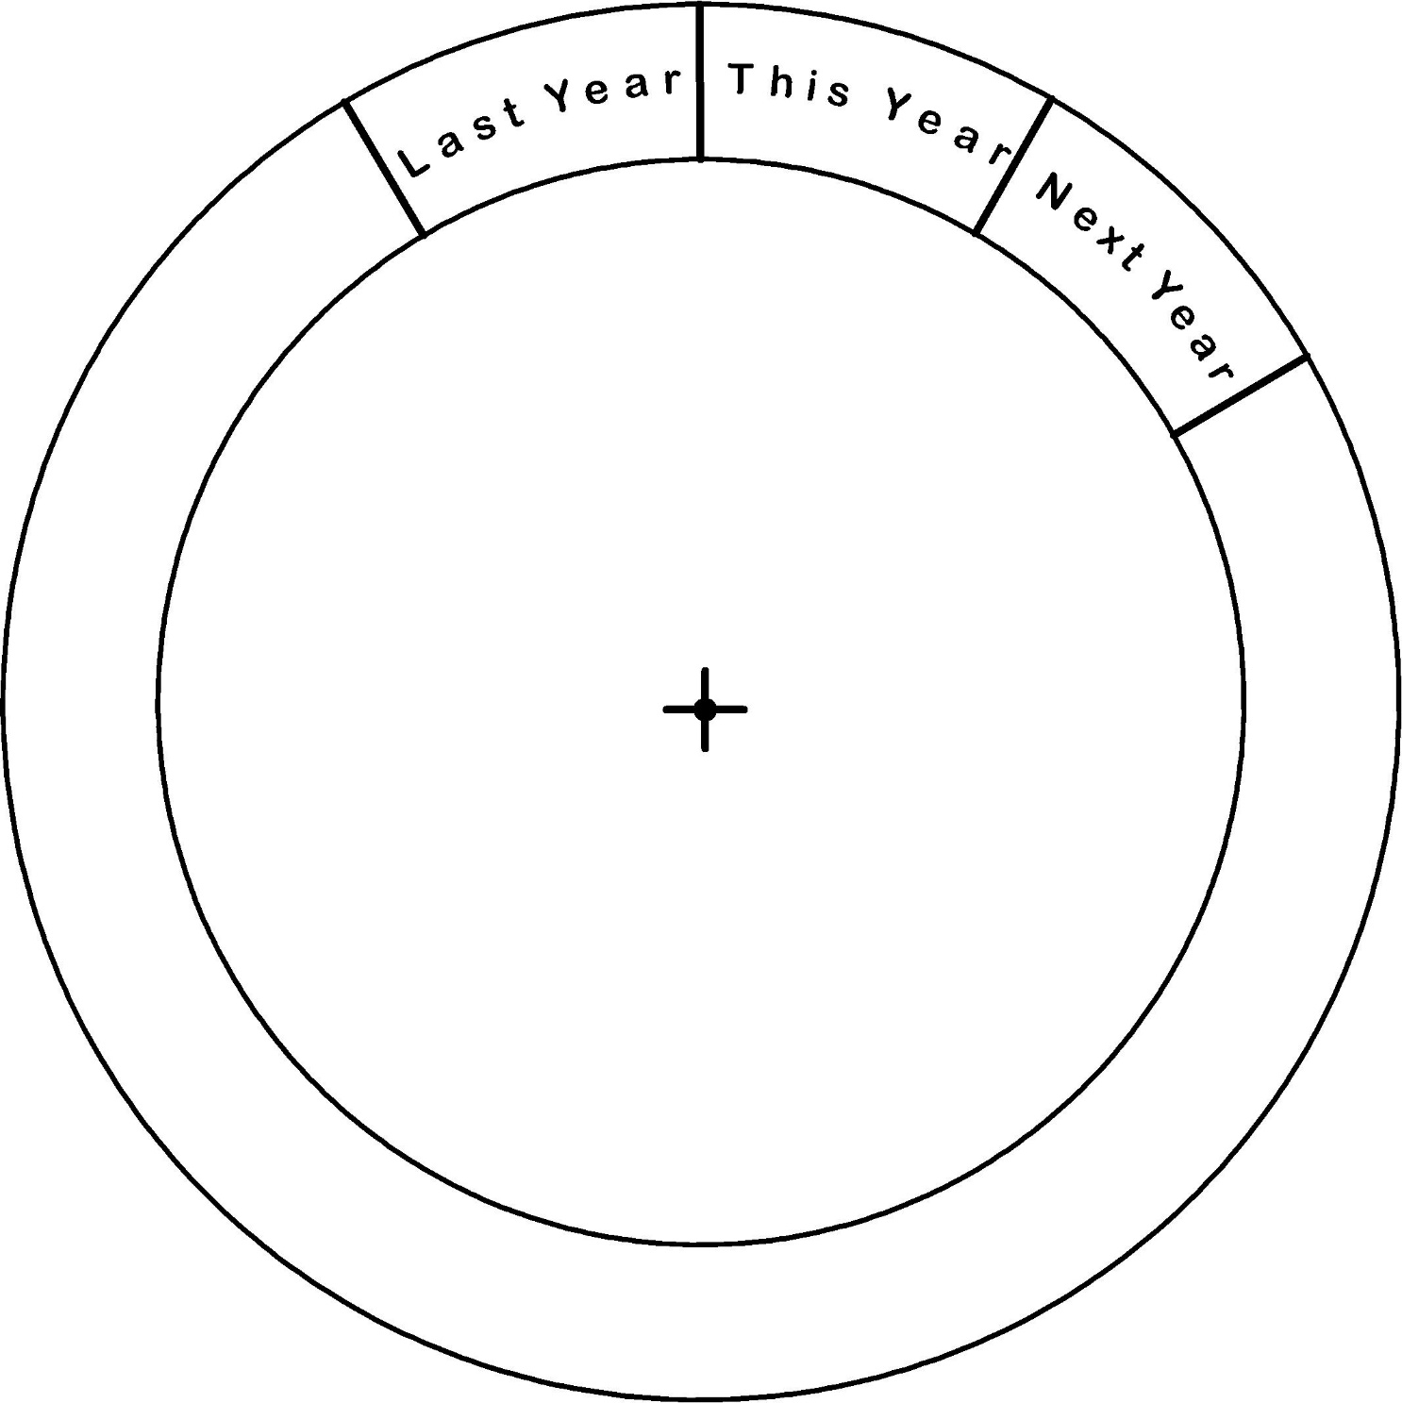

Cut

Outer Wheel

Chinese New Year Animal Wheel Activity Sheet

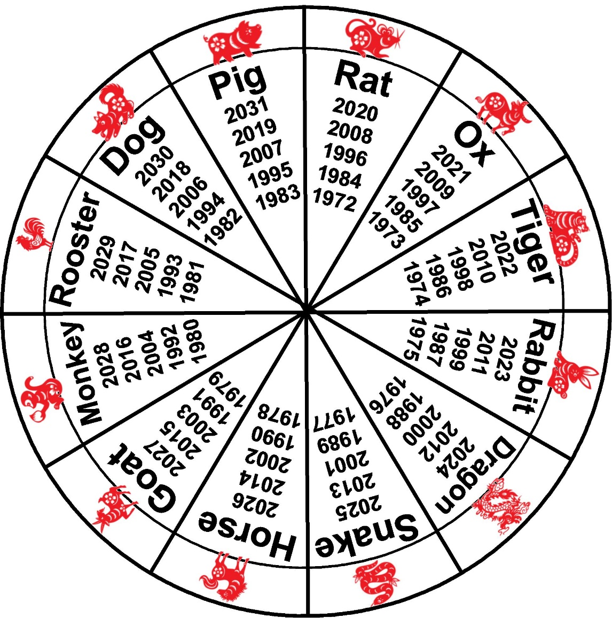
Cut
Inner Wheel

