Activity title
Fastest freeze
Stay safe
Whether you are a scientist researching a new medicine or an engineer solving climate change, safety always comes first. An adult must always be around and supervising when doing this activity. You are responsible for:

• ensuring that any equipment used for this activity is in good working condition
• behaving sensibly and following any safety instructions so as not to hurt or injure yourself or others

Please note that in the absence of any negligence or other breach of duty by us, this activity is carried out at your own risk. It is important to take extra care at the stages marked with this symbol: ⚠
Time required
30 minutes
Activity summary
When it’s snowy outside you might see lorries spreading salt on the roads and people shovelling salt onto pavements. Do you know why they do it? It’s to melt the ice to make the roads safer for the traffic and less slippery for pedestrians. In this challenge we find out how and why it works!
By the end of this activity, you will be able to:
Understand what is meant by freezing points and how salt can cause change.
What equipment will you need?
- Two jam jars
- Something to mark one jar such as a permanent marker or sticker
- Water
- Table salt (about 2oz)
And have an adult to help.

How to do it
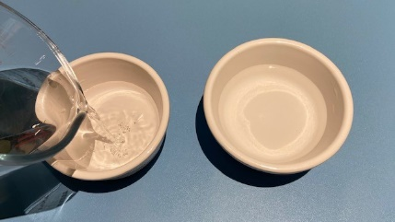
Step 1

Pour the water into both jam jars until they are about half full.

Step 2
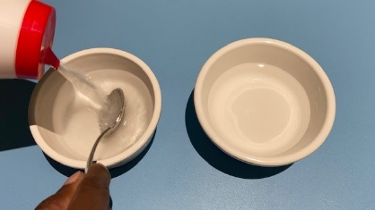
In one jar add salt to make a saturated solution. A saturated saltwater solution is one where you keep adding salt to the
water until it stops dissolving.

Step 3

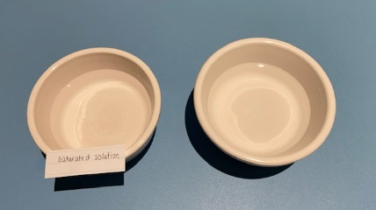
Mark your saltwater solution with the permanent marker or a sticker so you don’t get the jars mixed up!

Step 4

Place both jam jars in the freezer and close the door.

Step 5

Check each hour to see if either jar has frozen.

Step 6

You should find that the plain water freezes faster than the saltwater solution.

Step 7

When both have frozen remove from the fridge and leave to thaw. You should find the salt water similarly thaws more quickly than the plain water.
Well done – you’ve cracked the Christmas challenge!
So we have proved that salt water doesn’t freeze as quickly as plain water but will thaw more quickly. And we know that adding salt to icy roads and paths means that the ice will thaw more quickly than it otherwise would to keep us from slipping and sliding – but what’s going on to make this happen?

Here’s the science
Fastest Freeze!
It’s all to do with freezing points – these are the temperatures at which substances turn from a liquid to a solid – for example when water turns into ice.
Water has a freezing point of 0 degrees Celsius. Salt water has a lower freezing point around -2 degrees Celsius. So saltwater needs to be COLDER than plain water in order to freeze which is why the jam jar with the plain water froze first.
Fastest Thaw!
In our road example the salt mixed with the surface water of the ice – this made the ice need to be colder than 0 degrees in order to remain as a solid, otherwise it will return to liquid form. This is why ice will thaw when salt is spread on it as long as the temperature is not below the freezing point of salt water – in which case the ice would remain.
But HOW does the salt change the freezing point?
Salt contains particles called ions which are atoms or molecules with an electrical charge. The two ions in salt are called Na+ (Sodium) and Cl- (Chlorine).
When salt dissolves into the water the ions spread themselves throughout the water and block the water molecules from getting close enough together and in the right orientation to organise into the solid form of ice.
Did you know?
Adding any impurity to a liquid lowers its freezing point. What you put in doesn’t matter, but the number of particles it breaks into in the liquid is important. The more particles that are produced, the greater the freezing point depression.
Sugar simply dissolves into single sugar molecules, so its effect on the freezing point is less than you would get adding an equal amount of salt, which as we have found, breaks into two particles. Salts that break into more particles, like magnesium chloride (MgCl2) – which generates three ions - have an even greater effect on lowering the freezing point of water.
Freezing seas
Seas are made up of saltwater and that’s why we still get watery waves even when its zero degrees and far too cold for a swim – brrr! However, at the North and South Poles the temperatures are so low that the salty water will freeze, making oceans of ice and slow-moving glaciers. Global warming has raised the temperatures in every part of the world including the poles – this means that the icy oceans are at risk of melting.

