Activity title
Make marshmallow snowflakes
Stay safe
Whether you are a scientist researching a new medicine or an engineer solving climate change, safety always comes first. An adult must always be around and supervising when doing this activity. You are responsible for:

• ensuring that any equipment used for this activity is in good working condition
• behaving sensibly and following any safety instructions so as not to hurt or injure yourself or others

Please note that in the absence of any negligence or other breach of duty by us, this activity is carried out at your own risk. It is important to take extra care at the stages marked with this symbol: ⚠
Time required
Less than 30 minutes
Activity summary
Snowflakes are a sign that the wintery weather has arrived and in this fun activity we will make our very own snowflakes which you can use as decorations, or that you can simply eat as a delicious snack! We will also learn more about how snowflakes get their shape.
What equipment will you need?
- One large marshmallow per snowflake
- A large pack of small marshmallows
- A packet of toothpicks or dried spaghetti
- Ribbon or string
And have an adult to help.

How to do it
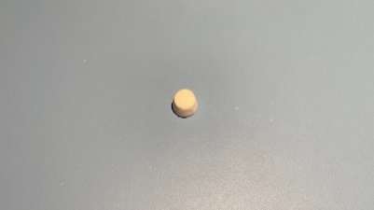
Step 1
Take one large marshmallow to be the centre of your snowflake.

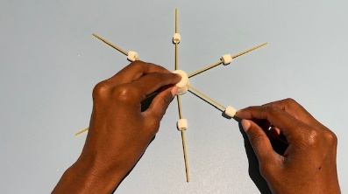
Step 2
Stick 6 toothpicks or dried spaghetti evenly around the edge.

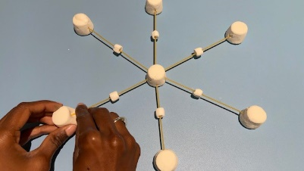
Step 3
Use the smaller marshmallows to connect more toothpicks together in a symmetrical pattern. Symmetrical means that the pattern is a mirror image both horizontally and vertically.

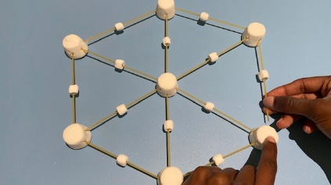
Step 4
You can use your imagination to create your snowflake shape or use one of our suggested patterns. You can build the snowflakes out to make bigger structures – as long as you haven’t run out of marshmallows!
Step 5
Attach a loop of ribbon or string if you want to hang them as decorations, otherwise you can enjoy them as a delicious snack – just be careful if you used toothpicks!
Well done – you’ve cracked the Christmas challenge!

Different snowflakes
If you’ve ever looked at a snowflake before it melted or have seen them under a magnifying glass, you’ll know that they are very beautiful and come in a multitude of different patterns.
Have you ever wondered how this happens, and why each one seems to be different?
Snowflake science
A tiny droplet of water in the atmosphere will be circular in shape. As the temperature drops the droplet will begin to freeze and in doing so will begin to change shape into a hexagon. A hexagon is a shape with six sides – all snowflakes begin this way.

So why a hexagon shape? This is because water molecules each contain two hydrogen atoms and one oxygen atom. (This is why water is called H2O). The most efficient way for the molecules to attach together is in a hexagon shape.

More water droplets and vapour will combine with the tiny hexagon to create crystalline spines that come from those six sides to create the variety of beautiful patterns we see. They will always be symmetrical because when water freezes the molecules bond in a symmetrical way.

Snowflakes can only form when the temperature is very cold – and the colder the air the more complex the snowflake structure will be.

What happens when a snowflake melts?
It’s always a pity that snowflakes seem to melt before we have had a chance to really look at them but that is because of something called the changing states of matter.
What’s the matter?
Substances come in three main states of matter: solid, liquid and gas. There’s actually a fourth state called Plasma but that’s quite rare. A substance will change between these states depending on the temperature, and things like air pressure.

Water is the liquid form of the chemical H2. Can you think what the solid form might be? It’s ice! The matter changes state when the temperature reaches 0 degrees Celsius. When the temperature reaches 100 degrees Celsius the liquid will turn into a gas – like the steam from a kettle.

When snowflakes are falling through the icy sky the temperature around them is below zero so they remain in a solid state. On a warm mitten the temperature will be higher and so the ice will tun into water – a liquid.

