Hieroglyphics Instruction Sheet
- For each letter of your name, identify the Hieroglyph.
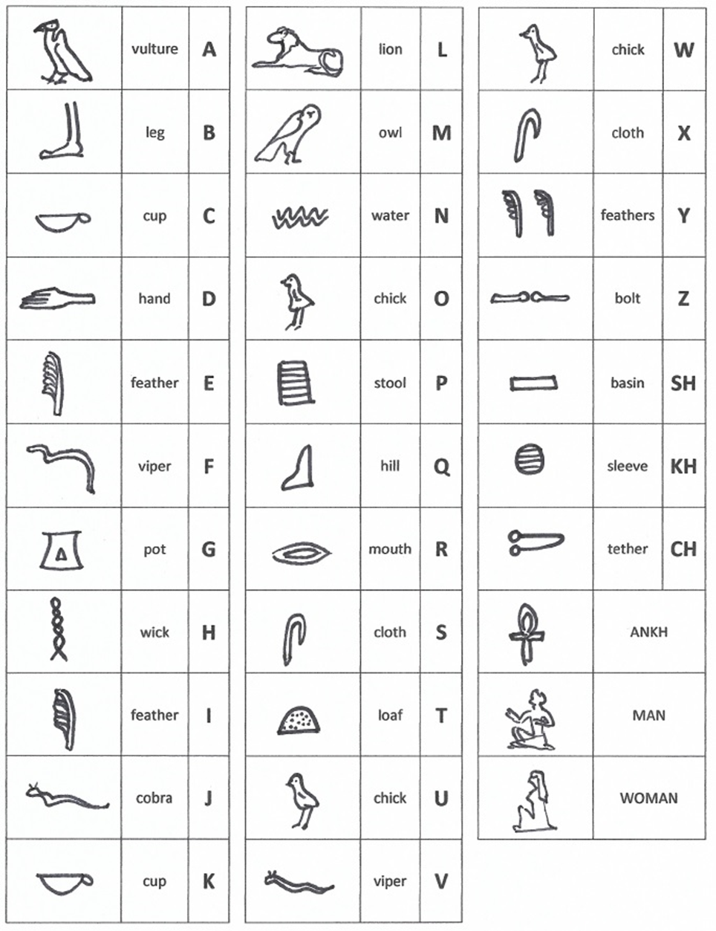
- Draw or copy and paste each Hieroglyph onto your papyrus.

