Base camp

Base camp

Base camp

Base camp

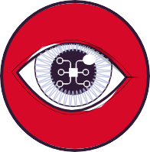Setting up the relay
Future of flight
Drone relay cards
Drone relay card one
Drone relay card three
Drone relay card two
Drone relay card four
- Divide students into groups of 3–5.
- Have each group queue up relay-style.
- Place an identical ‘Drone relay card’ at the other side of the room and a blank piece of paper at the other side of the room.
- Have the first student in line dash over to the image, review it, run to the blank piece of paper and write down the first line of the program.
- The student then runs back and tags the next person in line, then goes to the back of the queue.
- The next person in line dashes to the image, and repeats this process until the group have a complete program.
- First group to finish is the winner!
- Each group swaps their program with another group and tests it out. Can they recreate the grid map?

