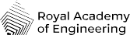
Future of flight
Ground control cards

House
Medal
Fish
Tree
Swan
Dancer

Cut out the cards. One person from each team acts as ‘Ground control’ and explains to the other team members how to create the shape using the puzzle pieces.
Create new ground control cards for your classmates to try and recreate.

