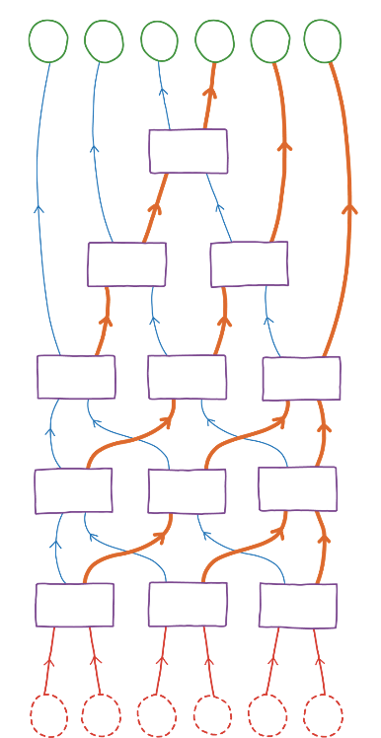**Counters – set 1**



Future of flight

Sorting machine

−7

−4

−1

3

1

0

**Counters – set 2**

14

21

36

47

66

91

**Counters – set 3**

1

8

1

4

1

3

1

2

5

8

5

6

**Counters – blank**

**Teacher note:** change the difficulty of this challenge by using different numbers to order such as fractions, decimals or algebraic terms.