Power and current

An electric circuit is a device for doing work of some kind.
In this circuit a bulb is transferring energy to the surroundings.
The rate of energy transfer is the power of the circuit.
The unit of power is a watt (W).
One watt is equal to one joule per second.
a. Which electric circuit has the most power?
Put a tick () next to the best answer.
A | B  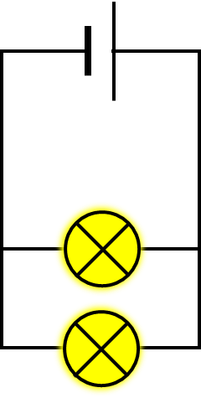 | C  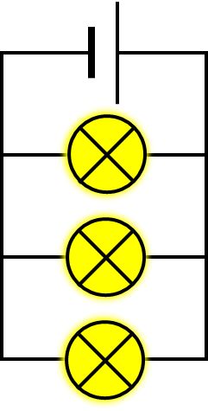 | D  All the same
b. What is the best reason for your answer to part a?
Put a tick () in the box next to the best answer.
A | Current from the battery is the same in all the circuits.
B | Current from the battery is biggest in this circuit.
C | Current through each bulb is the same in all the circuits.
D | Current through each bulb is biggest in this circuit.

Physics > Big idea PEM: Electricity and magnetism > Topic PEM8: Mains electricity > Key concept PEM8.2: Paying for electricity
Diagnostic question
Power and current

Overview
Learning focus: | The amount of energy that an electrical appliance transfers is proportional to time; and its power is proportional to the potential difference across it and the current through it.
Observable learning outcome: | Describe how the power of an electric circuit depends on current through it.
Question type: | Two-tier multiple choice
Key words: | Power, current, parallel circuit

P | PRIOR UNDERSTANDING  This diagnostic question probes understanding of ideas that are usually taught at age 11-14, to aid transition from earlier stages of learning.

What does the research say?
Novice learners typically lack a scientific understanding of how a circuit works and rely on memorising equations and procedures. They may be able to solve routine circuit calculations correctly, but often cannot predict or explain the behaviour of a circuit (Liu et al., 2022).
Some common misunderstandings that students may continue to hold, which are relevant to understanding how electrical power is proportional to current, are:
- that most students do not discriminate sufficiently between current, voltage, energy and power (Gott, 1984; Shipstone, 1985; Driver et al., 1994; Engelhardt and Beichner, 2004)
- the amount of current provided by a battery is always the same no matter what circuit it is connected to (Driver et al., 1994; Engelhardt and Beichner, 2004)
- and a circuit can be analysed sequentially moving around a circuit in one direction, so changes to components ‘further around a circuit’ do not affect earlier parts of the circuit (Driver et al., 1994; Stocklmayer and Treagust, 1996; Duit and von Rhoneck, 1997)
Ways to use this question
Students should complete the questions individually. This could be a pencil and paper exercise, or you could use an electronic ‘voting system’ or mini white boards and the PowerPoint presentation. The follow-on question will give you insights into how they are thinking and highlight specific misconceptions that some may hold.
If there is a range of answers, you may choose to respond through structured class discussion. Ask one student to explain why they gave the answer they did; ask another student to explain why they agree with them; ask another to explain why they disagree, and so on. This sort of discussion gives students the opportunity to explore their thinking and for you to really understand their learning needs.
Differentiation
You may choose to read the questions to the class, so that everyone can focus on the science. In some situations, it may be more appropriate for a teaching assistant to read for one or two students.
Expected answers
a. C b. B
How to respond - what next?
It is likely that most students will correctly recognise that circuit C, in part a, has the most power because the bulbs are emitting most light.
Part b requires them to use earlier circuit understanding, rather than simple observation, to explain why this is so. Whilst applying understanding to a new situation, some students may revert to earlier misunderstandings that may be revealed by this question.
A The misunderstanding that a particular battery causes the same sized current, no matter what circuit it is connected to, is common and may be reinforced by the misunderstanding that changes to ‘later parts’ of a circuit do not affect ‘earlier parts’ of it.
C The statement for this option is correct and explains why all the bulbs in the third circuit have the same power as each other, but it does not explain this circuit as a whole has the most power.
D A few students may recall that current is bigger in a parallel circuit when there are more bulbs, and misapply this fact because they do not fully understand the factors that affect the size of current in different parts of a parallel circuit.
If students have misunderstandings about how the power of an electric circuit depends on current through it, it can help to provide students with an opportunity to review their understanding of current in parallel circuits and to compare measurements of current to the total brightness of bulbs in each circuit. The BEST key concept: PEM5.2 Analysing parallel circuits includes resources for developing understanding of what happens as extra components are added to a parallel circuit.
The following BEST ‘response activity’ could be used in follow-up to this diagnostic question:
- Response activity: Rope power
Acknowledgments
Developed by Peter Fairhurst (UYSEG).
Images by Peter Fairhurst (UYSEG).
References
Driver, R., et al. (1994). Making Sense of Secondary Science: Research into Children's Ideas, London, UK: Routledge.
Duit, R. and von Rhoneck, C. (1997). Learning and understanding key concepts of electricity. In Tiberghien, A., Jossem, E. L. & Barojas, J. (eds.) Connecting Research in Physics Education with Teacher Education. International Commision on Physics Education.
Engelhardt, P. V. and Beichner, R. J. (2004). Students' understanding of direct current resistive electrical circuits. American Journal of Physics, 72(1), 98-115.
Gott, R. (1984). Electricity at age 15: a report on the performance of pupils at age 15 on questions in electricity. London: Department of Education and Science, Welsh Office, Department of Education for Northern Ireland.
Liu, Z., et al. (2022). Assessment of knowledge integration in student learning of simple electric circuits. Physical Review Physics Education Research, 18(2), 020102.
Shipstone, D. M. (1985). Electricity in simple circuits. In Driver, R., Guesne, E. & Tiberghien, A. (eds.) Children's Ideas In Science. Milton Keynes: Open University Press.
Stocklmayer, S. M. and Treagust, D. F. (1996). Images of electrcity: How do novices and experts model electric current? International Journal of Science Education, 18(2), 163-178.

