**Hot line**

A big current flows through power lines.

The bigger the current, the hotter the wires.

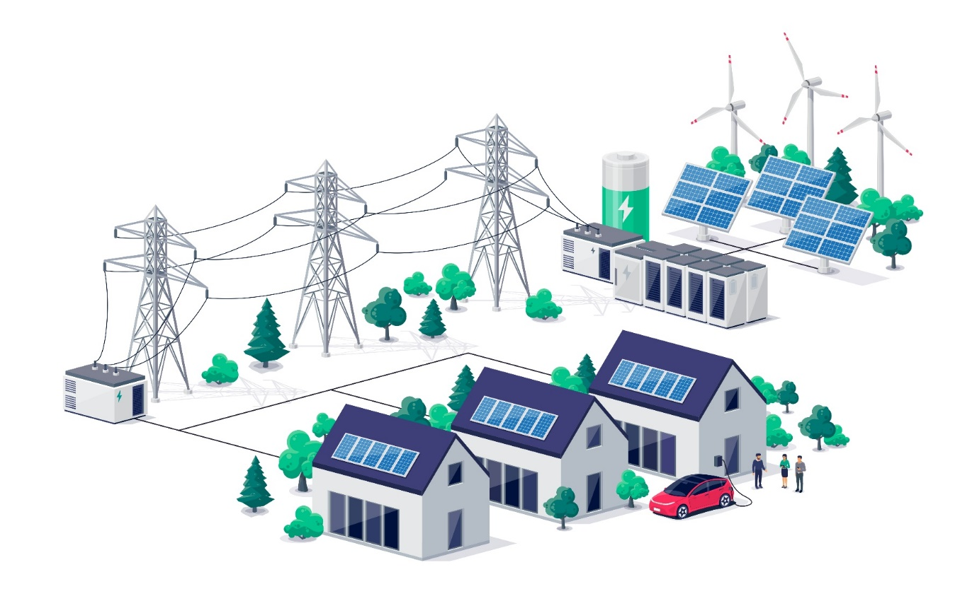When the wires are hotter, they **dissipate** more power.

Why does a bigger current heat up the power lines?

|  |  |  |  |  |  |
| --- | --- | --- | --- | --- | --- |
| For each statement, tick (✓) **one** column to show what you think. | | I am **sure** this is right | I think this is right | I think this is wrong | I am **sure** this is wrong |
| **A** | Electrons are causing metal ions to vibrate faster. |  |  |  |  |
| **B** | Electrons are moving along the wire more quickly. |  |  |  |  |
| **C** | More electrons are moving through the wire. |  |  |  |  |

*Physics > Big idea PEM: Electricity and magnetism > Topic PEM8: Mains electricity > Key concept PEM8.3: Transmitting electricity*

|  |
| --- |
| **Diagnostic question** |
| **Hot line** |

**Overview**

|  |  |
| --- | --- |
| Learning focus: | Transmission lines dissipate less power when they transfer power with a higher transmission voltage and lower current. When current is lower there is a smaller drop in voltage along their length. |
| Observable learning outcome: | Describe the heating effect of current on a conducting wire. |
| Question type: | Confidence grid |
| Key words: | Power, dissipation, current, electrons, ions |

|  |  |
| --- | --- |
| **P** | **PRIOR UNDERSTANDING**  This diagnostic question probes understanding of ideas that are usually taught at age 11-14, to aid transition from earlier stages of learning. |

**What does the research say?**

A simple mechanical model is helpful in explaining resistance and why electric current in a metal conductor causes heating. In this model, resistance can be thought of as the friction between moving electrons and ions in a conductor or resistor (Chasseigne et al., 2011).

The explanation for a metal conductor increasing in temperature with the size of current, is that the bigger the current, the greater the friction between moving electrons and ions because more electrons move past a fixed point every second and the more quickly the ions at that point are caused to vibrate. More accurately, the ions are held in a fixed lattice that vibrates as one. The faster they vibrate, the higher the temperature. (Hartley, Fairhurst and Norris, 2021)

**Ways to use this question**

Students should complete the confidence grid individually. This could be a pencil and paper exercise, or you could use an electronic ‘voting system’ or mini white boards and the PowerPoint presentation.

If there is a range of answers, you may choose to respond through structured class discussion. Ask one student to explain why they gave the answer they did; ask another student to explain why they agree with them; ask another to explain why they disagree, and so on. This sort of discussion gives students the opportunity to explore their thinking and for you to really understand their learning needs.

*Differentiation*

You may choose to read the questions to the class, so that everyone can focus on the science. In some situations, it may be more appropriate for a teaching assistant to read for one or two students.

**Expected answers**

Statements A and B are right; and statement C is wrong.

**How to respond - what next?**

With a bigger current more electrons move past a point in the wire each second because they are moving more quickly, but the total number of electrons in the wire does not change. As more electrons pass each point more quickly, there is greater friction on the metal ion (lattice) and the ions are caused to vibrate more quickly, which increases the temperature of the wire.

A Some students may not understand the mechanism for current heating a wire, or they may not understand what ions are or why they are found in metals.

B, C Some students may have the misunderstanding that electrons flow from the generator and a bigger current is caused by there being more electrons moving through the wire, rather than the same number moving more quickly.

This follows from a misunderstanding that a ‘battery’ has a store of electrons that it provides to a circuit.

If students have misunderstandings about describing the heating effect of current on a conducting wire, it can help to provide students with an opportunity to review their understanding, perhaps using resources from the BEST key concept: *PEM6.1 Components with changing resistance*.

**Acknowledgments**

Developed by Peter Fairhurst (UYSEG).

Image from Shutterstock.

**References**

Chasseigne, G., et al. (2011). Improving students' ability to intuitively infer resistance from magnitude of current and potential difference information: A functional learning approach. *European Journal of Psychology of Education,* 26(1)**,** 1-19.

Hartley, R., Fairhurst, P. and Norris, T. (2021). Electricity and magnetism. In de Winter, J. & Hardman, M. (eds.) *Teaching secondary physics.* 3rd ed. London: Hodder Education.