Power dissipation

The power an electrical device has is calculated using P = I x V.
V
I
The resistance of the device is calculated using R = .

Rearranging the resistance equation:
Substituting this into the power equation:
Which gives:
V = I x R
P = I x (I x R)
P = I² x R
V is the voltage across the device.
I is the current through the device.
R is the resistance of the device.
P is the power of the device.

A transmission line has a resistance and is heated by current.
It is warmer than its surroundings and dissipates power.

1. What happens to the amount of power dissipated if the current through a transmission line is tripled?
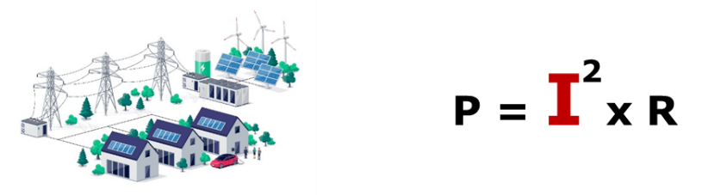
Put a tick () in the box next to the best answer.
A | Three times more power is dissipated.
B | Six times more power is dissipated.
C | Nine times more power is dissipated.

2. What happens to the amount of power dissipated if the current through a transmission line is halved?
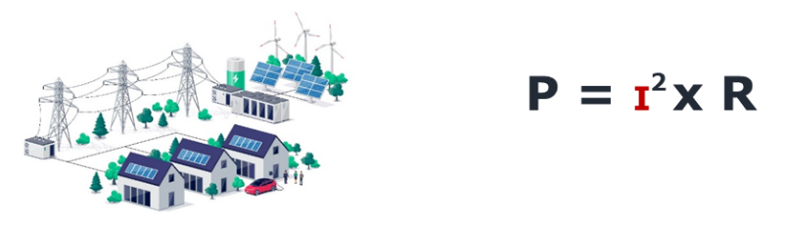
Put a tick () in the box next to the best answer.
A | Four times more power is dissipated.
B | Two times more power is dissipated.
C | Two times less power is dissipated.

Physics > Big idea PEM: Electricity and magnetism > Topic PEM8: Mains electricity > Key concept PEM8.3: Transmitting electricity
Diagnostic question
Power dissipation

Overview
Learning focus: | Transmission lines dissipate less power when they transfer power with a higher transmission voltage and lower current. When current is lower there is a smaller drop in voltage along their length.
Observable learning outcome: | Calculate power dissipated by a wire using P = I² x R.
Question type: | Simple multiple choice
Key words: | Power, dissipation, current, resistance, voltage, energy

What does the research say?
In physics each symbol in an equation is connected to a physical variable. Students are required to perform mathematical operations with the equation and then connect the mathematical operations and the results of calculations to their implications in the physical world (Redish and Kuo, 2015). To show mastery in physics students should be able to explain their equations in words, however at age 14-16 students often hide an incomplete understanding as they can calculate correct answers by treating equations just as mathematical operations without a good understanding of the physics that may be necessary for their future studies.
Redish and Kuo (2015) suggest for many students, the first step in physics calculations needs to be highlighting the physical meaning, which can later be tied to the formal mathematical laws. This can help students by giving meaning to equations, so analysis of problems is no longer a ‘brittle rote procedure’. It can also lead to conceptual short cuts that enable students to access more challenging problems. For many experienced physicists, physical meaning is gained by beginning with the mathematical relations that come easily to them, but their strategy is less effective for many learners.
In this question, there needs to be clarity in understanding that the variables in the equations all refer to the transmission line (as a ‘device’ with resistance) rather than to the power the transmission line is transferring to the next stage of the national grid (Bissell, 2021).
Ways to use this question
Students should complete the questions individually. This could be a pencil and paper exercise, or you could use an electronic ‘voting system’ or mini white boards and the PowerPoint presentation.
The answers to the questions will show you whether students understood the concept sufficiently well to apply it correctly.
If there is a range of answers, you may choose to respond through structured class discussion. Ask one student to explain why they gave the answer they did; ask another student to explain why they agree with them; ask another to explain why they disagree, and so on. This sort of discussion gives students the opportunity to explore their thinking and for you to really understand their learning needs.
Differentiation
You may choose to read the questions to the class, so that everyone can focus on the science. In some situations, it may be more appropriate for a teaching assistant to read for one or two students.
Expected answers
1. C 2. C
How to respond - what next?
The power dissipated is proportional to the square of the current through the transmission line, which means that small changes in current can have a big effect on the heating of the wire and the resulting power dissipation. Doubling or halving current increases or decreases power dissipated by a factor of four – which assumes that the resistance of the wire is constant.
These questions are checking students’ understanding of the squared relationship between power and current.
In question 1, students choosing option A have not applied the squared relationship, and those choosing option B have misunderstood the squared relationship to mean a doubling of the effect.
In question 2, some students may wrongly interpret the reduction of current with an increase in power dissipation – an increase to compensate for a decrease. These students are likely to choose option A. Those choosing option B are likely to think that the power transferred is fixed and that resistance increases to compensate for a change to the current.
Strictly speaking, with a smaller current, the resistance of a wire will decrease.
If students have misunderstandings about calculating power dissipated by a wire using P = I² x R, it can help to show them what happens with a transmission line demonstration in the laboratory, set up to show the power dissipated by observing the transmitted power (brightness of a bulb) for different currents through the transmission line.
The following BEST ‘response activity’ could be used in follow-up to this diagnostic question:
- Response activity: Transmission lines
Acknowledgments
Developed by Peter Fairhurst (UYSEG).
Image from Shutterstock.
References
Bissell, J. (2021). Clarifying misconceptions about Ohm’s law and power dissipation in grid electricity transmission. Physics Education, 56(3), 033009.
Redish, E. F. and Kuo, E. (2015). Language of physics, language of math: Disciplinary culture and dynamic epistemology. Science and Education, 24, 561-590.

