The right power

The power an electrical device has is calculated using P = I x V.
V
I
The resistance of the device is calculated using R = .
Rearranging the resistance equation:
Substituting this into the power equation:
Which gives:
I =
P = x V
P =
V
R
V
R
V²
R

V²
R
How do the variables in P = relate to a transmission line?
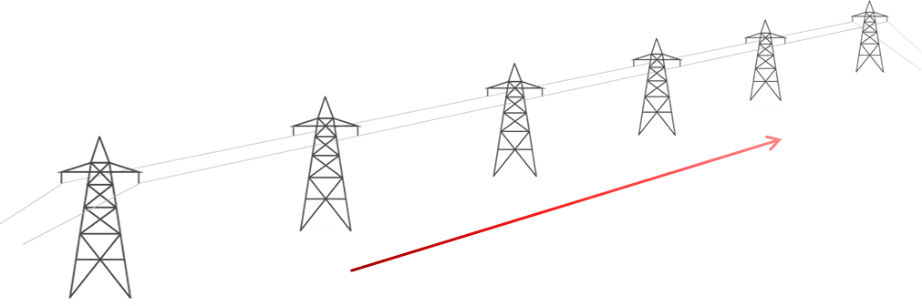
Step-up transformer
Step-down transformer
400 kV

For each statement, tick () one column to show what you think. |  | I am sure this is right | I think this is right | I think this is wrong | I am sure this is wrong
A | P = power transferred along a wire.
B | V = voltage drop across the length of a wire.
C | R = resistance of the whole length of a wire.

Physics > Big idea PEM: Electricity and magnetism > Topic PEM8: Mains electricity > Key concept PEM8.3: Transmitting electricity
Diagnostic question
The right power

Overview
Learning focus: | Transmission lines dissipate less power when they transfer power with a higher transmission voltage and lower current. When current is lower there is a smaller drop in voltage along their length.
Observable learning outcome: | Explain how the equation P = V²/R applies to transmission lines.
Question type: | Confidence grid
Key words: | Power dissipation, transmission voltage, voltage drop, resistance, current

B | BRIDGING  This diagnostic question probes understanding of ideas that are usually taught at age 16-19, to build a bridge to later stages of learning.

What does the research say?
Many students (and many experienced practitioners) are quickly confused when they are shown that applying Ohm’s law also gives P = V²/R, which seems to suggest power dissipation also increases rapidly with voltage. The confusion is caused by a misunderstanding that the voltage in the power dissipation equations is the transmission voltage – it isn’t. For power dissipation from a transmission line, the voltage in P = V²/R refers to the voltage drop along the length of the wire (Bissell, 2021).
An additional confusion derives from the fact that the transmission voltage is inversely proportional to current, which seems to violate Ohm’s law. It is easy to think that a higher transmission voltage gives current a bigger push through a transmission line, but when the transmission voltage is higher a smaller current is pushed through the wire, by a transformer, and the voltage drop along its length is smaller. To overcome these misunderstandings, the difference between transmission voltage and the voltage drop along transmission wires needs to be clearly understood (Bissell, 2021).
Ways to use this question
Students should complete the confidence grid individually. This could be a pencil and paper exercise, or you could use an electronic ‘voting system’ or mini white boards and the PowerPoint presentation.
If there is a range of answers, you may choose to respond through structured class discussion. Ask one student to explain why they gave the answer they did; ask another student to explain why they agree with them; ask another to explain why they disagree, and so on. This sort of discussion gives students the opportunity to explore their thinking and for you to really understand their learning needs.

Differentiation
You may choose to read the questions to the class, so that everyone can focus on the science. In some situations, it may be more appropriate for a teaching assistant to read for one or two students.
Expected answers
Statements B and C are right; and statement A is wrong.
How to respond - what next?
The equation P = V²/R refers to the power dissipated by the transmission line. V is the voltage drop across the length of the wire and R is the resistance of the wire.
A It is common for students to confuse the power dissipated by a transmission wire with the power transferred along it – especially in relation to the appropriate values for a particular equation.
B It is also common for students to think wrongly that the transmission voltage can be used, with this equation, to calculate power dissipation.
C Most students are likely to think correctly that this statement is correct because the resistance of the wire is the only obvious resistance to consider.
If students have misunderstandings about explaining how the equation P = V²/R applies to transmission lines, it can help to provide opportunity to apply their understanding of each voltage to a practical example. The following BEST ‘response activity’ could be used in follow-up to this diagnostic question, in order to do this:
- Response activity: Talking volts
Acknowledgments
Developed by Peter Fairhurst (UYSEG).
Images by Peter Fairhurst (UYSEG).
References
Bissell, J. (2021). Clarifying misconceptions about Ohm’s law and power dissipation in grid electricity transmission. Physics Education, 56(3), 033009.

