**The right voltage**

The transmission voltage at the start of these power lines is 400 kV.

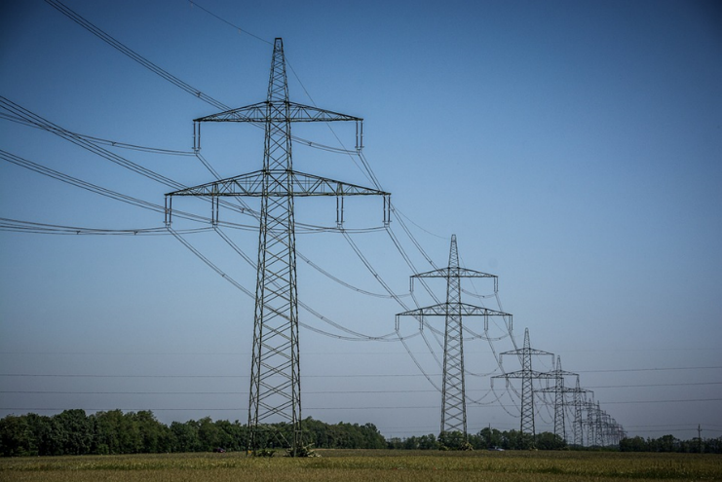

*(400 kV = 400 000 V)*

What is the transmission voltage at the end of the transmission lines?

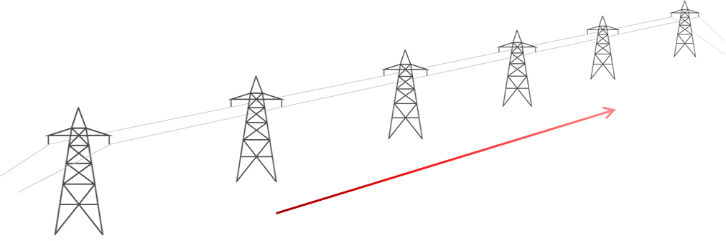

Step-up transformer

Step-down transformer

**400 kV**

**?**

*Put a tick (✓) in the box next to the best answer.*

|  |  |  |
| --- | --- | --- |
| **A** | Exactly 400 kV. |  |
|  |  |  |
| **B** | A little less than 400 kV. |  |
|  |  |  |
| **C** | About 200 kV. |  |
|  |  |  |
| **D** | Exactly 0 kV. |  |

*Physics > Big idea PEM: Electricity and magnetism > Topic PEM8: Mains electricity > Key concept PEM8.3: Transmitting electricity*

|  |
| --- |
| **Diagnostic question** |
| **The right voltage** |

**Overview**

|  |  |
| --- | --- |
| Learning focus: | Transmission lines dissipate less power when they transfer power with a higher transmission voltage and lower current. When current is lower there is a smaller drop in voltage along their length. |
| Observable learning outcome: | Explain the difference between transmission voltage and voltage drop along a wire. |
| Question type: | Simple multiple choice |
| Key words: | Transmission voltage, power dissipation, kilovolt, step-up transformer, step-down transformer |

**What does the research say?**

Many students (and many experienced practitioners) are quickly confused when they are shown that applying Ohm’s law also gives P = V2/R, which seems to suggest power dissipation also increases rapidly with voltage. The confusion is caused by a misunderstanding that the voltage in the power dissipation equations is the transmission voltage – it isn’t. For power dissipation from a transmission line, the voltage in P = V2/R refers to the voltage drop along the length of the wire (Bissell, 2021).

An additional confusion derives from the fact that the transmission voltage is inversely proportional to current, which seems to violate Ohm’s law. It is easy to think that a higher transmission voltage gives current a bigger push through a transmission line, but when the transmission voltage is higher a smaller current is pushed through the wire, by a transformer, and the voltage drop along its length is smaller. To overcome these misunderstandings, the difference between transmission voltage and the voltage drop along transmission wires needs to be clearly understood (Bissell, 2021).

**Ways to use this question**

Students should complete the question individually. This could be a pencil and paper exercise, or you could use an electronic ‘voting system’ or mini white boards and the PowerPoint presentation.

The answers to the question will show you whether students understood the concept sufficiently well to apply it correctly.

If there is a range of answers, you may choose to respond through structured class discussion. Ask one student to explain why they gave the answer they did; ask another student to explain why they agree with them; ask another to explain why they disagree, and so on. This sort of discussion gives students the opportunity to explore their thinking and for you to really understand their learning needs.

*Differentiation*

You may choose to read the question to the class, so that everyone can focus on the science. In some situations, it may be more appropriate for a teaching assistant to read for one or two students.

**Expected answer**

B

**How to respond - what next?**

Transmission lines dissipate power, which means that the transmission voltage reduces along their length. The very high voltage and relatively low current minimise the power dissipated and so the transmission voltage at the far end of a transmission line is only a little lower than it is at the start (in the order of a few percent).

A Text books typically show the voltage at both ends of transmission lines to be the same size and ignore the small drop in transmission voltage. Some students may hold the misunderstanding that they are the same, but still be comfortable with the idea that the transmission lines dissipate power. These students are likely to have a fragmented understanding.

C If students treat transmission lines as resistive components, they may consider there to be a complete circuit formed by a pair of wires along the length of the transmission lines, and that the far end is in the middle of a circuit of resisting wires, so the voltage is half-way between 400 kV and 0 V (the wires act as a potential divider).

D Some students may treat the transmission voltage as the voltage across the length of the transmission lines, in which case they may think the transmission voltage at the far end is equal to zero.

If students have misunderstandings about explaining the difference between transmission voltage and voltage drop along a wire, it can help to provide opportunity to apply their understanding of each voltage to a practical example. The following BEST ‘response activity’ could be used in follow-up to this diagnostic question, in order to do this:

* Response activity: Talking volts

**Acknowledgments**

Developed by Peter Fairhurst (UYSEG).

Photograph by Silberfuchs from Pixabay, other images by Peter Fairhurst (UYSEG).

**References**

Bissell, J. (2021). Clarifying misconceptions about Ohm’s law and power dissipation in grid electricity transmission. *Physics Education,* 56(3)**,** 033009.