Talking volts

Two different voltage measurements relate to transmission lines:
- transmission voltage
- voltage drop along the length of a transmission line.
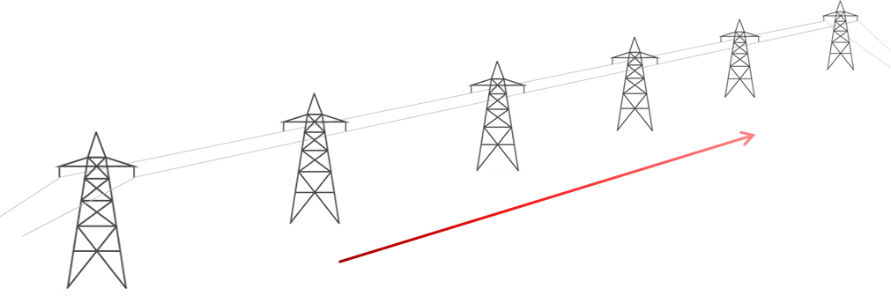
Step-up transformer
Step-down transformer
400 kV
390 kV
1 kA through each line
3

(1 kA = 1000 A)
Some students are talking about calculations they can make for the transmission lines using different voltage measurements.
Jasper: The power transmitted is about 400 000 x 1000.
Leon: The resistance of a transmission line can be calculated using R = P/I².
Keeley: The power dissipated is about 1000 A x 10 000 V.
Mya: Resistance of a transmission line is about 10 Ω.

To answer
- Who is right about the calculations?
  - Explain your answer
- Who is wrong about the calculations?
  - What would you say to help them understand?

Cards for
Talking volts
Jasper: The power transmitted is about 400 000 x 1000. | Keeley: The power dissipated is about 1000 A x 10 000 V.
Leon: The resistance of a transmission line can be calculated using R = P/I². | Mya: Resistance of a transmission line is about 10 Ω.

Cards for
Talking volts
Jasper: The power transmitted is about 400 000 x 1000. | Keeley: The power dissipated is about 1000 A x 10 000 V.
Leon: The resistance of a transmission line can be calculated using R = P/I². | Mya: Resistance of a transmission line is about 10 Ω.

Physics > Big idea PEM: Electricity and magnetism > Topic PEM8: Mains electricity > Key concept PEM8.3: Transmitting electricity
Response activity
Mains power

Overview
Learning focus: | Transmission lines dissipate less power when they transfer power with a higher transmission voltage and lower current. When current is lower there is a smaller drop in voltage along their length.
Observable learning outcome: | Explain the difference between transmission voltage and voltage drop along a wire.  Explain how the equation P = V²/R applies to transmission lines.
Activity type: | Talking heads
Key words: | Power dissipation, transmission voltage, voltage drop, resistance, current, kilovolt, kiloamp, megawatt

This activity can help develop students’ understanding by addressing the sticking-points revealed by the following diagnostic questions:
- Diagnostic question: The right voltage
- Diagnostic question: The right power
What does the research say?
Many students (and many experienced practitioners) are quickly confused when they are shown that applying Ohm’s law also gives P = V²/R, which seems to suggest power dissipation also increases rapidly with voltage. The confusion is caused by a misunderstanding that the voltage in the power dissipation equations is the transmission voltage – it isn’t. For power dissipation from a transmission line, the voltage in P = V²/R refers to the voltage drop along the length of the wire (Bissell, 2021).
An additional confusion derives from the fact that the transmission voltage is inversely proportional to current, which seems to violate Ohm’s law. It is easy to think that a higher transmission voltage gives current a bigger push through a transmission line, but when the transmission voltage is higher a smaller current is pushed through the wire, by a transformer, and the voltage drop along its length is smaller. To overcome these misunderstandings, the difference between transmission voltage and the voltage drop along transmission wires needs to be clearly understood (Bissell, 2021).
Ways to use this activity
This task is intended for discussion in pairs or small groups. It can be done as a pencil and paper exercise or projected onto a screen.
Students should read the statements and follow the instructions on either the worksheet or the PowerPoint. Listening in to the conversations of each group will often give you insights into how your students are thinking. Each member of a group should be able to report back to the class.
Feedback from each group can be used, with careful teacher questioning, to bring out a clear description or explanation of the science.
Differentiation
The quality of the discussions can be improved with a careful selection of groups; or by allocating specific roles to students in each group. For example, you may choose to select a student with strong prior knowledge as the scribe, and forbid them from contributing any of their own answers. They may question the others and only write down what they have been told. This strategy encourages contributions from more members of each group.
NB in any class, small group discussions typically improve over time and a persistence with this strategy is often very successful in the medium to long term.
Expected answers
1. All four students are right
Jasper: the power transmitted, P = IV = 1000 A x 400 000 V = 400 000 000 W = 400 MW. (Jasper could improve his answer by including units.) The voltage used is the transmission voltage.
Keeley: the power dissipated, P = IV = 1000 A x 10 000 V = 10 000 000 W = 10 MW. The voltage used is the voltage drop across the length of the transmission line.
Leon: the power dissipated, P = I²R, which rearranges to give R = I²/P.
Mya: resistance of the transmission line, R = I²/P = (1000 A x 1000 A) / 10 000 000 W = 0.1 Ω. The power is the power dissipated by the transmission line.
2. None of the statements are wrong.
Extra information for teachers
400 kV transmission lines typically have a resistance of about 0.03 Ω per km, so the figures in the question could relate to transmission lines that are in the order of 3 km (2 miles) long.
Acknowledgments
Developed by Peter Fairhurst (UYSEG).
Images: Peter Fairhurst (UYSEG).
References
Bissell, J. (2021). Clarifying misconceptions about Ohm’s law and power dissipation in grid electricity transmission. Physics Education, 56(3), 033009.

