Transmission lines

In this model, transformers make the transmission voltage high and the current low.
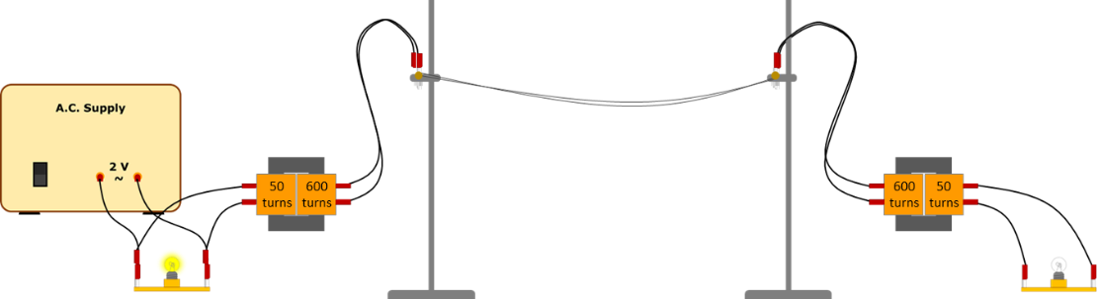
The model is safe because:
- It uses a low voltage a.c. supply of no more than 2 V
- The voltage in the transmission lines is no more than about 28 V
- The step-down transformer is connected the right way around.
Predict
How bright the second bulb will be:
- with the transformers …………………………………………………………………………………………………………..
- without the transformers ……………………………………………………………………………………………………..
Explain
In each case, why do you think the bulb will be this bright?

Watch a demonstration of the transmission lines.

Observe
The brightness of the second bulb:
- with the transformers …………………………………………………………………………………………………………..
- without the transformers ……………………………………………………………………………………………………..
Explain
Were your prediction and explanation correct?
Try to improve your first explanation to explain what happens more clearly.

Physics > Big idea PEM: Electricity and magnetism > Topic PEM8: Mains electricity > Key concept PEM8.3: Transmitting electricity
Response activity
Transmission lines

Overview
Learning focus: | Transmission lines dissipate less power when they transfer power with a higher transmission voltage and lower current. When current is lower there is a smaller drop in voltage along their length.
Observable learning outcome: | Predict changes to current through transmission lines using P = I x V.  Calculate power dissipated by a wire using P = I² x R.
Activity type: | Predict, explain; observe, explain (PEOE)
Key words: | Power, transmission voltage, current, transformer, step-up, step-down

This activity can help develop students’ understanding by addressing the sticking-points revealed by the following diagnostic questions:
- Diagnostic question: Transmission current
- Diagnostic question: Power dissipation
What does the research say?
Students often readily accept that power dissipation from electricity transmission lines is reduced when transmission voltage is high and transmission current is low. There may however be confusion because transmission voltage is inversely proportional to current, which seems to violate Ohm’s law.
It is easy to think that a higher transmission voltage gives current a bigger push through a transmission line, but when the transmission voltage is higher a smaller current is pushed through the wire, by a transformer, and the voltage drop along its length is smaller. To overcome these misunderstandings, the difference between transmission voltage and the voltage drop along transmission wires needs to be clearly understood (Bissell, 2021).
Ways to use this activity
Students should complete this activity in pairs or small groups, and the focus should be on the discussions. It is through the discussions that students can check their understanding and rehearse their explanations.
To begin, each group should discuss the activity and use their scientific understanding, firstly to predict what they think will happen, and then to explain why they think they are going to be right. If students in any group cannot agree, you may be able to direct them with some careful questioning.
Students now watch a demonstration.
After the practical each group should be given the opportunity to change, or improve their explanation. A good way to review your students’ thinking might be through a structured class discussion. You could ask several groups for their explanations and put these on the whiteboard. Then ask other groups to suggest which explanation is the most accurate and the most clearly expressed, and through careful questioning work up a clear ‘class explanation’.
A useful follow up is for individual students to then write down explanations in their own words – without reference to the class explanation on the board (i.e. cover it up).
Differentiation
The quality of the discussions can be improved with a careful selection of groups; or by allocating specific roles to students in each group. For example, you may choose to select a student with strong prior knowledge as a scribe, and forbid them from contributing any of their own answers. They may question the others and only write down what they have been told. This strategy encourages contributions from more members of each group.
Equipment
For the class:
- Perspex safety screens
- 2 V fixed a.c. power supply
- Two 1.5V bulbs in holders
- Two transformers, each with a coil ratio of about 1:10
- Long connecting leads
- Two stands and clamps
- Transmission line demonstration kit (wires)
Technician notes
Ready made transmission line kits are readily available to purchase, or instructions for making a demonstration model can be obtained from organisations such as CLEAPSS.
Health and safety
It is very important to follow the safety precautions for this demonstration.
There is a risk of serious electric shock if safety precautions are not followed.
To avoid any part of the equipment having a dangerous potential difference:
- Used a fixed a.c. source of no more than 2 V
- Do not step-up the voltage to more than 28 V
- Make certain that the step-down transformer is connected the right way around.
The coil on each transformer that has the largest number of turns is connected directly to the transmission lines.
Place Perspex safety screens in front of the demonstration to prevent any student from touching any part of the apparatus.
All teachers or technicians carrying out this demonstration need to be fully trained by an expert, and should strictly follow guidance available from CLEAPSS.
Practical work should be carried out in accordance with local health and safety requirements, guidance from manufacturers and suppliers, and guidance available from CLEAPSS.

Expected answers
With transformers, the second bulb is bright.
Without transformers, the second bulb is dim (or unlit).
Without transformers, the current through the transmission wires is quite large, it warms the wires and power is dissipated, heating the air rather than making the second bulb light.
With transformers, the transmission voltage is higher and the current much lower. The wires heat up less and more energy is transferred to the second bulb.
Acknowledgments
Developed by Peter Fairhurst (UYSEG).
Images: Peter Fairhurst (UYSEG).
References
Bissell, J. (2021). Clarifying misconceptions about Ohm’s law and power dissipation in grid electricity transmission. Physics Education, 56(3), 033009.

