Beyond violet

The Sun emits more than just light and infrared radiation.
Ultraviolet radiation is also given off by the Sun.
Ultraviolet radiation can be detected next to violet light.
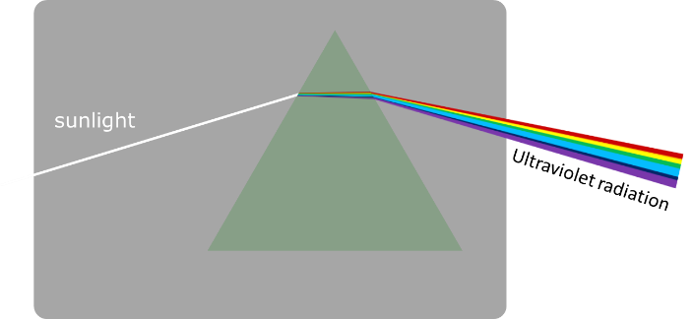

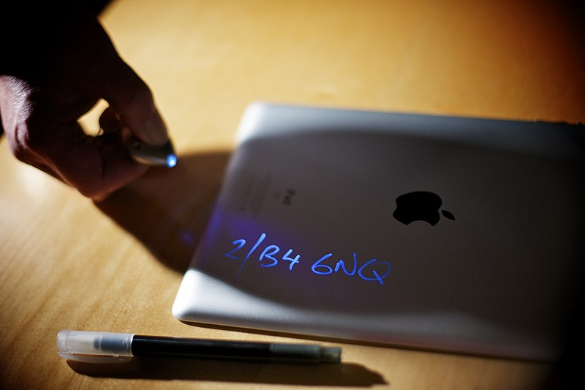
Ultraviolet marker with ultraviolet led lamp

An ultraviolet marker can add invisible
identification marks to belongings.
Ultraviolet radiation makes them visible.

What makes the identification marks visible?
Put a tick () in the box next to the best answer.
A | The ink reflects ultraviolet radiation.
B | The ink reflects ultraviolet light.
C | The ink uses energy from ultraviolet radiation to make light.

Physics > Big idea PSL: Sound, light and waves > Topic PSL7: Electromagnetic waves > Key concept PSL7.1: More than light
Diagnostic question
Beyond violet

Overview
Learning focus: | Electromagnetic radiation is made of vibrating electric and magnetic fields that can travel through a vacuum. Light and other types of EM radiation are organised in order of frequency across the EM spectrum.
Observable learning outcome: | Compare ultraviolet radiation and light.
Question type: | Simple multiple choice
Key words: | Ultraviolet radiation, ultraviolet marker, fluorescence

What does the research say?
Students tend to be aware of ultraviolet (UV) radiation, but the majority of those aged 11-18 (n=283) were found to have the misunderstanding that the Sun is the only source of ultraviolet radiation (Libarkin et al., 2011), which suggests their knowledge of UV is perhaps linked to tanning and to the risk of sunburn. In Neumann and Hopf’s study (2012), 40% (n=50) of 14- to 16-year-olds had the misunderstanding that UV was visible. These students may have observed UV lamps that emit a visible violet glow in addition to UV, or think that the light emitted from fluorescent paint seen under UV lamps is ‘UV light’ (Neumann, 2014). In the latter case, fluorescent paint is able to emit visible light because of the energy transferred to it by UV radiation it absorbs. In the study by Libarkin et al. (2011), about 80% of students were found to have the misunderstanding that it is possible to see objects in the presence of UV radiation alone, and some considered UV to be both invisible and either blue or violet in colour.
Ways to use this question
Students should complete the question individually. This could be a pencil and paper exercise, or you could use an electronic ‘voting system’ or mini white boards and the PowerPoint presentation.
The answers to the question will show you whether students understood the concept sufficiently well to apply it correctly.
If there is a range of answers, you may choose to respond through structured class discussion. Ask one student to explain why they gave the answer they did; ask another student to explain why they agree with them; ask another to explain why they disagree, and so on. This sort of discussion gives students the opportunity to explore their thinking and for you to really understand their learning needs.
Differentiation
You may choose to read the questions to the class, so that everyone can focus on the science. In some situations, it may be more appropriate for a teaching assistant to read for one or two students.

Expected answer
C
How to respond - what next?
Ultraviolet light is invisible and the ink is visible because it absorbs (photons of) ultraviolet radiation and reemits light radiation. This process is called fluorescence.
A It is common for students to think that ultraviolet radiation is visible and that we see non-luminous objects because of reflected light. However, in this instance, the ultraviolet light is making the ink luminous and the ink is not reflecting visible light. This is often because ultraviolet lamps typically emit visible light in addition to ultraviolet radiation.
B Students may choose this option for the same reason as option A, and they may distinguish between ultraviolet radiation and ultraviolet light. It is a surprisingly common misunderstanding that ultraviolet radiation is both invisible and a blue or violet colour.
If students have misunderstandings about whether ultraviolet radiation is visible, it can help to discuss why the security ink does not reflect visible light that includes violet – why it can’t be seen in sunlight.
Ultra- is a Latin prefix meaning ‘beyond’, so ultraviolet is beyond violet in the spectrum.
The following BEST ‘response activity’ could be used in follow-up to this diagnostic question:
- Response activity: Ultraviolet lamp
Acknowledgments
Developed by Peter Fairhurst (UYSEG).
Image by Peter Fairhurst (UYSEG) and photograph by West Midlands Police from Wikimedia Commons.
References
Libarkin, J. C., et al. (2011). Invisible misconceptions: Student understanding of ultraviolet and infrared radiation. Astronomy Education Review, 10(1).
Neumann, S. (2014). Three misconceptions about radiation—and what we teachers can do to confront them. The Physics Teacher, 52(6), 357-359.
Neumann, S. and Hopf, M. (2012). Students’ conceptions about ‘radiation’: Results from an explorative interview study of 9th grade students. Journal of Science Education and Technology, 21, 826-834.

