Detecting infrared

A thermal imaging camera can detect infrared radiation.
The camera shows infrared radiation as different colours so that we can ‘see’ it.
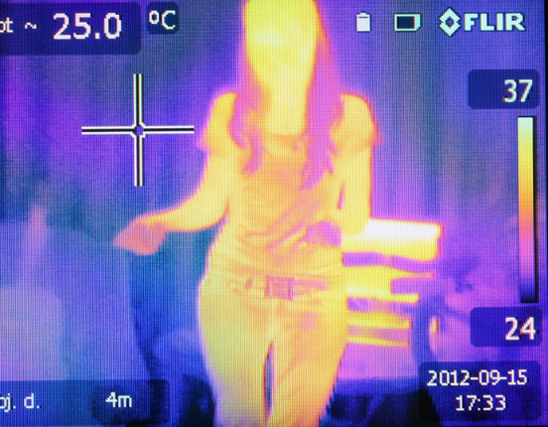
A thermal image showing the temperature of objects between 24 ºC and 37 ºC.

Which of these objects are emitting infrared radiation?
Choose all the correct answers.
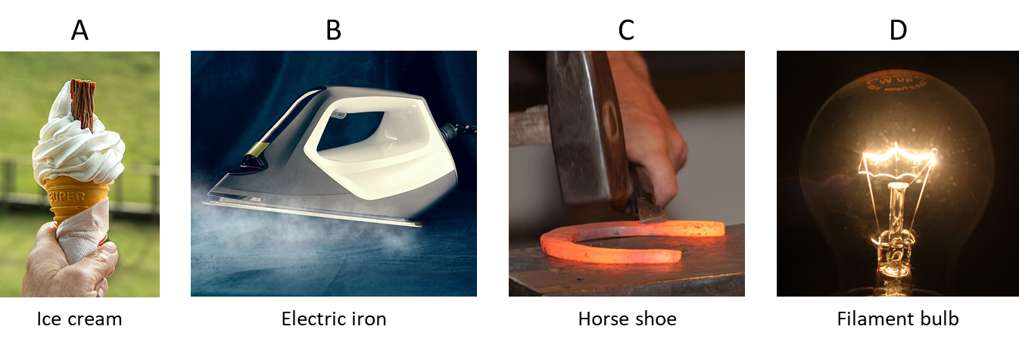
Physics > Big idea PSL: Sound, light and waves > Topic PSL7: Electromagnetic waves > Key concept PSL7.1: More than light
Diagnostic question
Detecting infrared

Overview
Learning focus: | Electromagnetic radiation is made of vibrating electric and magnetic fields that can travel through a vacuum. Light and other types of EM radiation are organised in order of frequency across the EM spectrum.
Observable learning outcome: | Compare infrared radiation and light.
Question type: | Simple multiple choice
Key words: | Infrared radiation, thermal image, thermal imaging camera

What does the research say?
Most students, age 12-18, do not consider light to be radiation (Rego and Peralta, 2006; Neumann and Hopf, 2012). The BEST key concept: PSL6.1 Refraction and dispersion develops understanding of the wave model of light, which can be extended by considering what can be observed beyond either end of the visible spectrum, which is recommended by Neumann (2014).
Libarkin et al. (2011) found that, prior to teaching, very few students were familiar with infrared (IR) radiation, found a little beyond the red end of the visible spectrum, and most were unable to explain what it was or describe its characteristics. In a separate study 15% (n=50) of 14- to 16-year olds had the misunderstanding that IR radiation was visible, perhaps because they had observed some visible light emitted by heat lamps, or IR emitted by filament bulbs (Neumann and Hopf, 2012).
Ways to use this question
Students should complete the question individually. This could be a pencil and paper exercise, or you could use an electronic ‘voting system’ or mini white boards and the PowerPoint presentation.
The answers to the question will show you whether students understood the concept sufficiently well to apply it correctly.
If there is a range of answers, you may choose to respond through structured class discussion. Ask one student to explain why they gave the answer they did; ask another student to explain why they agree with them; ask another to explain why they disagree, and so on. This sort of discussion gives students the opportunity to explore their thinking and for you to really understand their learning needs.
Differentiation
You may choose to read the questions to the class, so that everyone can focus on the science. In some situations, it may be more appropriate for a teaching assistant to read for one or two students.
Expected answers
All of the objects are emitting infrared radiation.
How to respond - what next?
Infrared radiation is emitted from objects because of vibrations between particles, and the resultant vibrations of charged particles that results in electromagnetic waves (strictly speaking photons).
A It is common for students to think that cold objects do not emit infrared radiation.
B, C and D It is likely that most students will think the iron, horseshoe and bulb are all emitters of infrared because they are all warm or hot.
B A few students may think that only B emits infrared because it is emitting energy that can cause heating and no light. Students may think that objects can each emit only one type of radiation.
C A few students may think that only C emits infrared because it is emitting a reddish light.
If students have misunderstandings about comparing infrared radiation and light, and in particular with which objects emit infrared radiation, it can help to demonstrate what can be seen using a thermal imaging camera, which should show that even ice cubes emit infrared radiation.
If a thermal imaging camera is not available, pictures can be found on the internet by searching for ‘thermal images’.
The following BEST ‘response activity’ could be used in follow-up to this diagnostic question:
- Response activity: Emitting infrared
Acknowledgments
Developed by Peter Fairhurst (UYSEG).
Images by byrev (thermal image), stevepb (icecream), ThomasWolter (electric iron), cyremille (horse shoe) and dengri (filament bulb) - all from Pixabay.
References
Libarkin, J. C., et al. (2011). Invisible misconceptions: Student understanding of ultraviolet and infrared radiation. Astronomy Education Review, 10(1).
Neumann, S. (2014). Three misconceptions about radiation—and what we teachers can do to confront them. The Physics Teacher, 52(6), 357-359.
Neumann, S. and Hopf, M. (2012). Students’ conceptions about ‘radiation’: Results from an explorative interview study of 9th grade students. Journal of Science Education and Technology, 21, 826-834.
Rego, F. and Peralta, L. (2006). Portuguese students' knowledge of radiation physics. Physics Education, 41(3), 259.

