Different colours

Red and blue light are refracted differently by a glass prism.
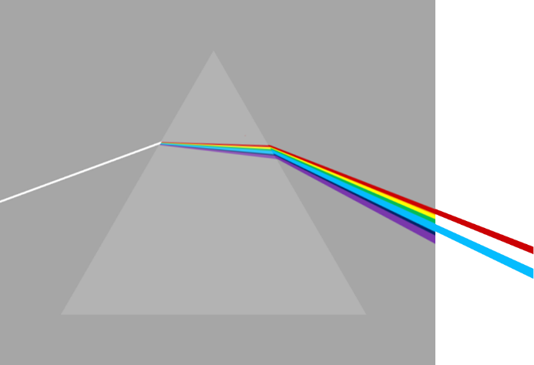
v = f x λ
A light wave crosses the boundary between air and glass.

How do red and blue light waves compare?
For each statement, tick () one column to show what you think.
 |  | I am sure this is right | I think this is right | I think this is wrong | I am sure this is wrong
A | In glass, blue travels slower than red.
B | Blue always has a higher frequency than red.
C | The frequency of blue light does not change.

Physics > Big idea PSL: Sound, light and waves > Topic PSL7: Electromagnetic waves > Key concept PSL7.1: More than light
Diagnostic question
Different colours

Overview
Learning focus: | Electromagnetic radiation is made of vibrating electric and magnetic fields that can travel through a vacuum. Light and other types of EM radiation are organised in order of frequency across the EM spectrum.
Observable learning outcome: | Describe the relationships between speed, frequency and wavelength for light waves.
Question type: | Confidence grid
Key words: | Speed, frequency, wavelength
What does the research say?
In 2017, Plotz completed a review of research literature on students’ comprehension of electromagnetic (EM) radiation (1980 to 2017), from which he identified four concepts that he thought were necessary for a good understanding of the topic. He also identified understanding of wavelength, frequency and the propagation velocity of waves as prerequisites for learning.
Ways to use this question
Students should complete the confidence grid individually. This could be a pencil and paper exercise, or you could use an electronic ‘voting system’ or mini white boards and the PowerPoint presentation.
If there is a range of answers, you may choose to respond through structured class discussion. Ask one student to explain why they gave the answer they did; ask another student to explain why they agree with them; ask another to explain why they disagree, and so on. This sort of discussion gives students the opportunity to explore their thinking and for you to really understand their learning needs.
Differentiation
You may choose to read the questions to the class, so that everyone can focus on the science. In some situations, it may be more appropriate for a teaching assistant to read for one or two students.
Expected answers
Statements A, B and C are all right.
How to respond - what next?
Moving through the glass prism, blue light is bent most because it is slowed down the most by glass. This is because blue light has a higher frequency than red light. The time between each wave-front of blue (or red) light does not alter as the wave passes into glass and so the frequency of blue (or red) light is constant.
For the enthusiast:
In 1865, James Clerk Maxwell showed that light was an electromagnetic wave and that the speed of any electromagnetic wave in a vacuum is constant. This is the speed of light: 299 792 458 m/s (3.0 x 10⁸ m/s).
Maxwell also showed that the speed of any electromagnetic wave passing through matter (solid, liquid, gas or plasma) is less than the speed of light and depends on matter and the frequency of the EM wave.
A Some students may think that light travels at the same speed in glass as in air because they are aware that ‘all electromagnetic waves travel at the same speed, which is the speed of light’ and that ‘the speed of light and is fixed at 3.00 x 10⁸ m/s’.
However, light and electromagnetic waves only travel at their fastest speed in a vacuum. In glass or in water the speed of light falls by about a quarter and a third respectively.
B & C Some students may understand that the wavelength of (a particular frequency of) light is shorter in glass than in air and assume that its frequency is higher. However, its frequency is constant and its speed is reduced.
If they have this misunderstanding, they may consequentially think that there are situations in which blue light (in glass) can have the same or lower frequency than red (in a vacuum).
Or they may simply think wrongly that red has a higher frequency than blue light.
If students have misunderstandings about describing the relationships between speed, frequency and wavelength for light waves, it can help to review understanding of the relationship between the variables for other types of wave that are more easily observed.
It can also help to consolidate understanding by providing students with a series of calculations, in which they are required to use the wave equation with examples using light waves. These could perhaps highlight the ideas that all light waves travel at the same speed in a vacuum, but at different speeds through matter, and the frequency of a particular colour of light wave does not change as the wave moves through different materials.
Acknowledgments
Developed by Peter Fairhurst (UYSEG).
Images: Peter Fairhurst (UYSEG).
References
Plotz, T. (2017). Students' conceptions of radiation and what to do about them. Physics Education, 52(1), 014004.

