Red light

Red light is shone through a glass prism.
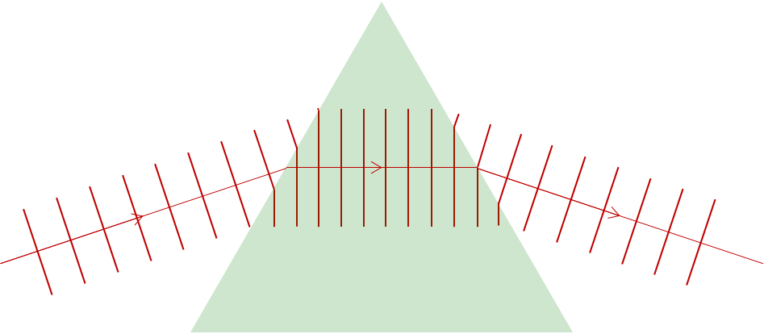
v = f x λ

The red light wave is refracted as it enters a glass prism, and again when it leaves.

What property of red light stays the same as it moves through a glass prism?
Put a tick () in the box next to the best answer.
A | Its speed (v) is constant.
B | Its frequency (f) is constant.
C | Its wavelength (λ) is constant.
D | None – its speed, frequency and wavelength all change.

Physics > Big idea PSL: Sound, light and waves > Topic PSL7: Electromagnetic waves > Key concept PSL7.1: More than light
Diagnostic question
Red light

Overview
Learning focus: | Electromagnetic radiation is made of vibrating electric and magnetic fields that can travel through a vacuum. Light and other types of EM radiation are organised in order of frequency across the EM spectrum.
Observable learning outcome: | Describe the relationships between speed, frequency and wavelength for light waves.
Question type: | Simple multiple choice
Key words: | Speed, frequency, wavelength

What does the research say?
In 2017, Plotz completed a review of research literature on students’ comprehension of electromagnetic (EM) radiation (1980 to 2017), from which he identified four concepts that he thought were necessary for a good understanding of the topic. He also identified understanding of wavelength, frequency and the propagation velocity of waves as prerequisites for learning.
Ways to use this question
Students should complete the question individually. This could be a pencil and paper exercise, or you could use an electronic ‘voting system’ or mini white boards and the PowerPoint presentation.
The answers to the question will show you whether students understood the concept sufficiently well to apply it correctly.
If there is a range of answers, you may choose to respond through structured class discussion. Ask one student to explain why they gave the answer they did; ask another student to explain why they agree with them; ask another to explain why they disagree, and so on. This sort of discussion gives students the opportunity to explore their thinking and for you to really understand their learning needs.
Differentiation
You may choose to read the questions to the class, so that everyone can focus on the science. In some situations, it may be more appropriate for a teaching assistant to read for one or two students.
Expected answer
B
How to respond - what next?
Red light travels slower in glass than in air and its wave-fronts (crests) bunch up so that it also has a shorter wavelength in glass. The time between each wave-front does not alter as the wave passes into the glass and so the frequency of the wave remains constant.
For the enthusiast:
In 1865, James Clerk Maxwell showed that light was an electromagnetic wave and that the speed of any electromagnetic wave in a vacuum is constant. This is the speed of light: 299 792 458 m/s (3.0 x 10⁸ m/s).
Maxwell also showed that the speed of any electromagnetic wave passing through matter (solid, liquid, gas or plasma) is less than the speed of light and depends on the matter and the frequency of the EM wave.
A Some students may have the misunderstanding that light always travels at the speed of light (3.0 x 10⁸ m/s). More accurately the speed of light should be called the speed of light in a vacuum (or the maximum possible speed of light).
C It is unlikely that students will think wavelength remains constant, unless they misinterpret the diagram provided.
D It is common for students to treat physics equations in the same way as mathematics equations in which all three terms are interdependent variables. They may therefore believe that a change in wavelength can cause a change in frequency.
If students have misunderstandings about describing the relationships between speed, frequency and wavelength for light waves, it can help to review understanding of the relationship between the variables for other types of wave that are more easily observed.
It can also help to consolidate understanding by providing students with a series of calculations, in which they are required to use the wave equation with examples using light waves. These could perhaps highlight the ideas that all light waves travel at the same speed in a vacuum, but at different speeds through matter, and the frequency of a particular colour of light wave does not change as the wave moves through different materials.
Acknowledgments
Developed by Peter Fairhurst (UYSEG).
Images: Peter Fairhurst (UYSEG).
References
Plotz, T. (2017). Students' conceptions of radiation and what to do about them. Physics Education, 52(1), 014004.

