Under red

The Sun emits more than just light.
Infrared radiation is also given off by the Sun.
Infrared can be detected next to red light.
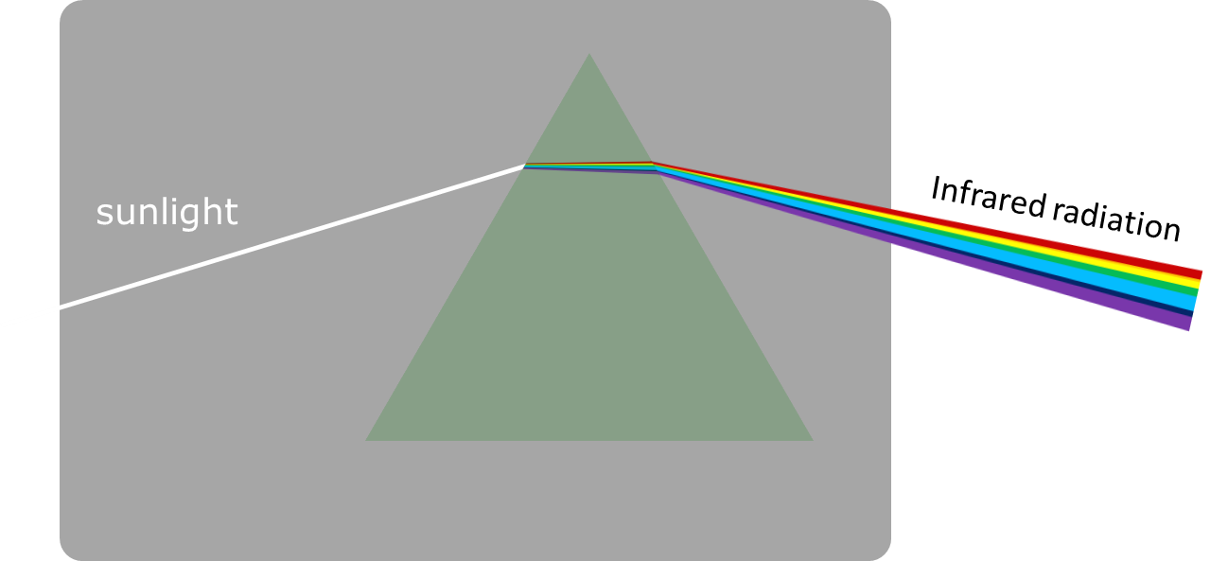
To do: fill in the gaps to compare infrared radiation and light.
You should only use the words infrared, light or infrared and light.
Infrared radiation and light
There are several types of electromagnetic radiation that include __________________.
Blue light has a higher frequency than __________________.
We can see __________________ with our eyes.
The visible spectrum includes __________________.
The electromagnetic spectrum includes __________________.

Physics > Big idea PSL: Sound, light and waves > Topic PSL7: Electromagnetic waves > Key concept PSL7.1: More than light
Diagnostic question
Under red

Overview
Learning focus: | Electromagnetic radiation is made of vibrating electric and magnetic fields that can travel through a vacuum. Light and other types of EM radiation are organised in order of frequency across the EM spectrum.
Observable learning outcome: | Compare infrared radiation and light.
Question type: | Focused cloze
Key words: | Infrared radiation, electromagnetic radiation, visible spectrum, electromagnetic spectrum

What does the research say?
Most students, age 12-18, do not consider light to be radiation (Rego and Peralta, 2006; Neumann and Hopf, 2012). The BEST key concept: PSL6.1 Refraction and dispersion develops understanding of the wave model of light, which can be extended by considering what can be observed beyond either end of the visible spectrum, which is recommended by Neumann (2014).
Libarkin et al. (2011) found that, prior to teaching, very few students were familiar with infrared (IR) radiation, found a little beyond the red end of the visible spectrum, and most were unable to explain what it was or describe its characteristics. In a separate study 15% (n=50) of 14- to 16-year olds had the misunderstanding that IR radiation was visible, perhaps because they had observed some visible light emitted by heat lamps, or IR emitted by filament bulbs (Neumann and Hopf, 2012).
Ways to use this question
Students should complete the activity individually as a pencil and paper exercise. The large text on the worksheet allows it to be copied A5 size, which fits a standard exercise book.
How students fill in the gaps will show you whether they understood the concept sufficiently well to apply it correctly.
If there is a range of answers, you may choose to respond through structured class discussion. Ask one student to explain why they gave the answer they did; ask another student to explain why they agree with them; ask another to explain why they disagree, and so on. This sort of discussion gives students the opportunity to explore their thinking and for you to really understand their learning needs.
Differentiation
You may choose to read the sentences to the class, so that everyone can focus on the science. In some situations, it may be more appropriate for a teaching assistant to read for one or two students.

Expected answers
There are several types of electromagnetic radiation that include infrared and light.
Blue light has a higher frequency than infrared and light.
We can see light with our eyes.
The visible spectrum includes light.
The electromagnetic spectrum includes infrared and light.
How to respond - what next?
This exercise may reveal students with the following misunderstandings:
- Light is not a type of electromagnetic radiation
- Infrared radiation is visible.
It can also reveal students understanding of what the visible spectrum (of light) and the electromagnetic spectrum (of which the visible spectrum is one part) are.
If students have misunderstandings about comparing infrared radiation and light, it can help to demonstrate infrared radiation as part of the electromagnetic spectrum:
- Use a prism to form a visible spectrum of sunlight onto a screen – perhaps using a crack of sunlight from between blinds or curtains.
- With an infrared detector, show that invisible radiation can be detected just beyond the red end of the visible spectrum.
- Show what happens to the infrared detector reading when the sunlight is blocked.
Infra- is a Latin prefix meaning ‘under’, so infrared is under-red in the spectrum.
The following BEST ‘response activity’ could be used in follow-up to this diagnostic question:
- Response activity: Emitting infrared
Acknowledgments
Developed by Peter Fairhurst (UYSEG).
Images: Peter Fairhurst (UYSEG).
References
Libarkin, J. C., et al. (2011). Invisible misconceptions: Student understanding of ultraviolet and infrared radiation. Astronomy Education Review, 10(1).
Neumann, S. (2014). Three misconceptions about radiation—and what we teachers can do to confront them. The Physics Teacher, 52(6), 357-359.
Neumann, S. and Hopf, M. (2012). Students’ conceptions about ‘radiation’: Results from an explorative interview study of 9th grade students. Journal of Science Education and Technology, 21, 826-834.
Rego, F. and Peralta, L. (2006). Portuguese students' knowledge of radiation physics. Physics Education, 41(3), 259.

