Physics > Big idea PSL: Sound, light and waves > Topic PSL7: Electromagnetic waves
Key concept (age 14-16)
PSL7.1: More than light

What’s the big idea?
A big idea in physics is waves because it is the key to explaining how energy can be transferred from one object to another object by radiation, even when the objects are not touching. Waves carry information that can be detected by humans or manufactured detectors. Understanding waves helps us to communicate, explore the universe, and transfer energy to where we want it.
How does this key concept develop understanding of the big idea?
This key concept helps to develop the big idea by building on an understanding of what light is, in order to develop understanding of light as one type of electromagnetic (EM) radiation in a continuous electromagnetic spectrum.
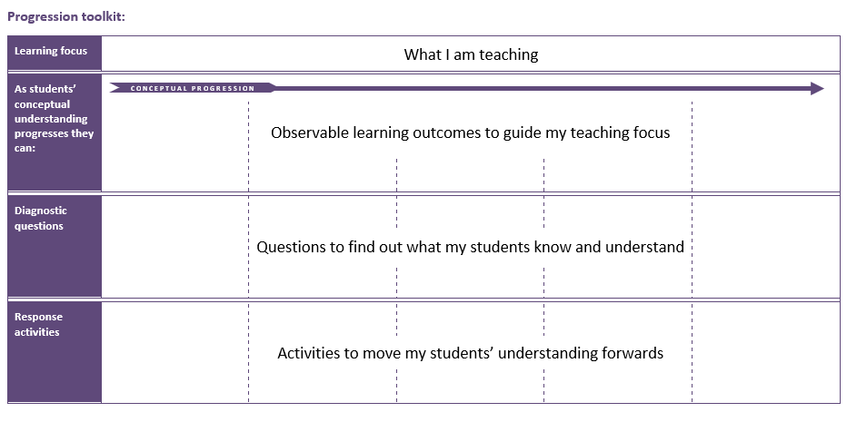
The conceptual progression starts by checking recall of some properties of red light, comparing it to those of blue light. It then supports the development of an understanding of light as a type of EM radiation, in order to enable understanding that infrared radiation and ultraviolet radiation are found beyond the ends of the visible spectrum and all three are part of a continuous EM spectrum that includes further types of EM radiation.
Using the progression toolkit to support student learning
Use diagnostic questions to identify quickly where your students are in their conceptual progression. Then decide how to best focus and sequence your teaching. Use further diagnostic questions and response activities to move student understanding forwards.
Progression toolkit: More than light
Learning focus | Electromagnetic radiation is made of vibrating electric and magnetic fields that can travel through a vacuum. Light and other types of EM radiation are organised in order of frequency across the EM spectrum.
As students’ conceptual understanding progresses they can: | C o n c e p t u a l p r o g r e s s I o n
 | Describe the relationships between speed, frequency and wavelength for light waves. | Describe the nature of light as a form of electromagnetic radiation. | Compare infrared radiation and light. | Compare ultraviolet radiation and light. | Explain why there is a spectrum of electromagnetic radiation.
Diagnostic questions | Red light | What’s light? | Under red | Beyond violet | Beyond ‘beyond’
 | Different colours |  | Detecting infrared
Response  activities |  |  | Emitting infrared | Ultraviolet lamp

Key:
P | Prior understanding from earlier stages of learning | B | Bridge to later stages of learning

Red light | Different colours | What’s light? | Under red | Detecting infrared
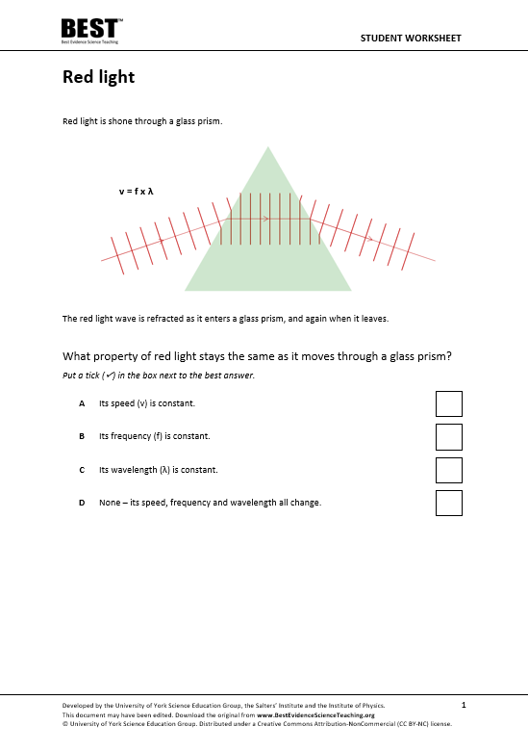 | 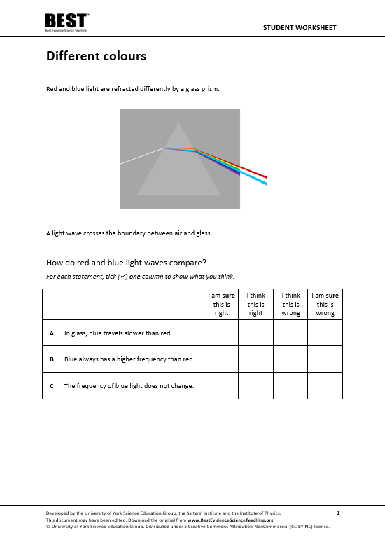 | 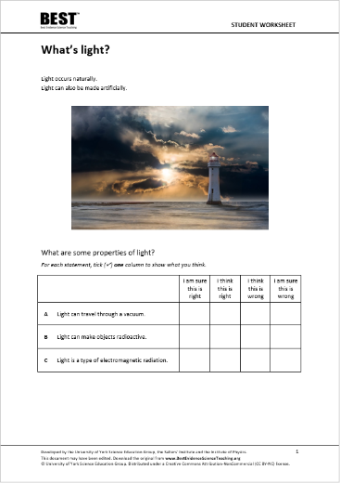 | 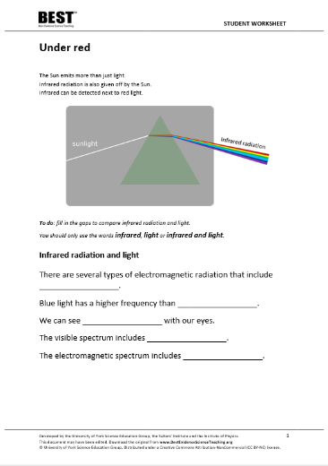 | 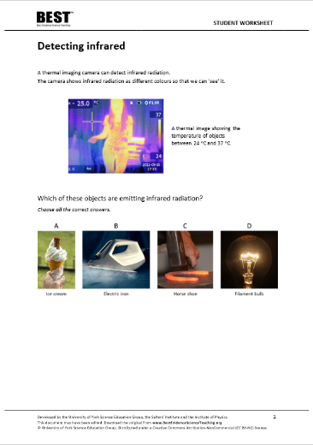
Simple multiple choice | Confidence grid | Confidence grid | Focused cloze | Simple multiple choice
Beyond violet | Beyond ‘beyond’ | Emitting infrared | Ultraviolet lamp
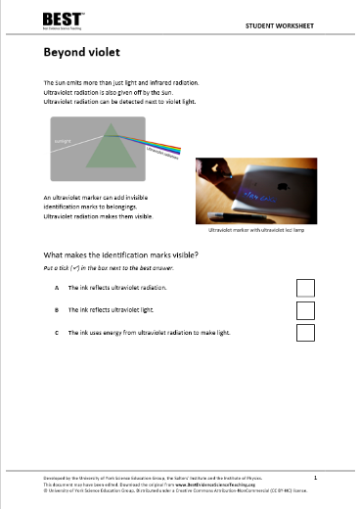 | 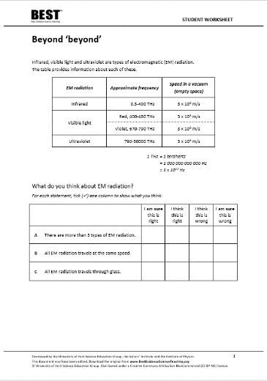 | 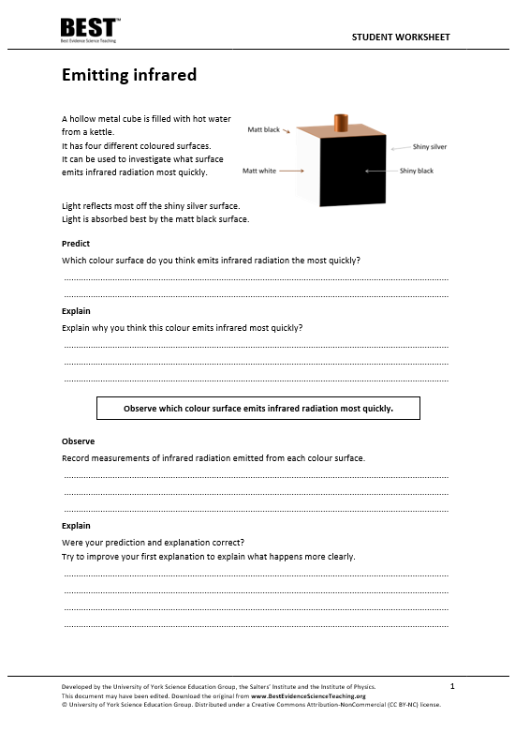 | 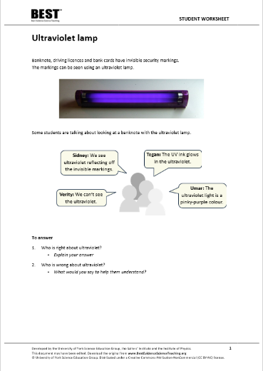
Simple multiple choice | Confidence grid | Predict, explain; observe, explain  PEOE | Talking heads

What’s the science story?
An electromagnetic wave is made of vibrating electric and magnetic fields, which can travel through a vacuum. Light is one example of an electromagnetic wave that we can detect with our eyes. In space all electromagnetic waves have the same velocity, and they all transfer energy from source to absorber.
The main groupings of the electromagnetic spectrum are: radio, microwave, infra-red, visible (red to violet), ultraviolet, X-rays and gamma-rays. Radio waves have the longest wavelength and lowest frequency, and gamma-rays the shortest wavelength and highest frequency.
Each grouping has a set of distinct properties that allow it to be detected and used in a particular way. The higher the frequency of an electromagnetic wave, the more energy it has and the more dangerous it can be to humans.
Earlier development of understanding (BEST 11-14)
When applying their understanding to novel situations, students of all ages often revert to earlier misunderstandings. Before moving forward, it is worthwhile using diagnostic questions from earlier topics to check that students do not have any persistent misunderstandings that can form barriers to learning. Time spent consolidating the scientific understanding of earlier key concepts before moving forward can accelerate progression later.
Key concept PSL4.1: Waves on water and ropes
Learning focus: A transverse wave travelling across the surface of water (or along a rope) transfers energy, as particles of water (or rope) are successively made to vibrate at right angles to the direction in which the wave travels.
This key concept:
- Consolidates understanding that the medium through which a transverse wave is travelling does not move forward with the wave.
- Develops the understanding of how particles move in a transverse wave in order to propagate the wave.
- Develops an understanding that amplitude and frequency do not affect the speed of a transverse wave, and of why they do affect the rate at which transverse waves can transfer energy.

What does the research say?
In 2017, Plotz completed a review of research literature on students’ comprehension of electromagnetic (EM) radiation (1980 to 2017), from which he identified four concepts that he thought were necessary for a good understanding of the topic. He also identified understanding of wavelength, frequency and the propagation velocity of waves as prerequisites for learning.
The most important concept, he suggested, is the idea of how EM radiation is classified by frequency and ordered across the spectrum. His second concept complements this, which is that all EM radiation types have properties in common, including their speed in a vacuum. The third concept is that EM radiation is omnipresent, with all types in differing intensities surrounding us. The fourth is that EM radiation transfers energy and interacts with matter in different ways, depending on the frequency and matter, and encompasses understanding of how each EM radiation type can be both helpful and harmful (Plotz, 2017).
Beyond the visible spectrum
Most students, age 12-18, do not consider light to be radiation (Rego and Peralta, 2006; Neumann and Hopf, 2012). The BEST key concept: PSL6.1 Refraction and dispersion develops understanding of the wave model of light, which can be extended by considering what can be observed beyond either end of the visible spectrum, which is recommended by Neumann (2014).
Libarkin et al. (2011) found that, prior to teaching, very few students were familiar with infrared (IR) radiation, found a little beyond the red end of the visible spectrum, and most were unable to explain what it was or describe its characteristics. In a separate study 15% (n=50) of 14- to 16-year-olds had the misunderstanding that IR radiation was visible, perhaps because they had observed some visible light emitted by heat lamps, or IR emitted by filament bulbs (Neumann and Hopf, 2012).
Students tend to be more aware of ultraviolet (UV) radiation, but the majority of those aged 11-18 (n=283) were found to have the misunderstanding that the Sun is the only source of UV radiation (Libarkin et al., 2011), which suggests their knowledge of UV is perhaps linked to tanning and to the risk of sunburn. In Neumann and Hopf’s study (2012), 40% (n=50) of 14- to 16-year-olds had the misunderstanding that UV was visible. These students may have observed UV lamps that emit a visible violet glow in addition to UV, or think that the light emitted from fluorescent paint seen under UV lamps is ‘UV light’ (Neumann, 2014). In the latter case, fluorescent paint is able to emit visible light because of the energy transferred to it by UV radiation it absorbs. In the study by Libarkin et al. (2011), about 80% of students were found to have the misunderstanding that it is possible to see objects in the presence of UV radiation alone, and some considered UV to be both invisible and either blue or violet in colour.
Students often confuse EM radiation with particle radiation, which includes alpha or beta particles (Plotz, 2017). The majority of students aged 12-18 (n=1246) also find it hard to distinguish between ionising and non-ionising radiation (Rego and Peralta, 2006). Ionising EM radiation can cause outer electrons to be forced out of atoms, by attraction or repulsion between the electric field of an electron and that of the radiation, in turn affecting bonds and interactions between atoms. Some types of EM radiation are ionising and other types are not.
It is common for students to think that when an object is exposed to radiation it becomes radioactive. However, this is only true for high-energy gamma radiation that may excite atomic nuclei (Plotz, 2017).
Radiation is often naturally occurring
One of the most common misunderstandings about radiation is that it is artificial and a result of technological progress. Often students think that living far from urban or industrial areas reduces or even eliminates exposure to radiation (Neumann, 2014). It is therefore important to discuss natural occurrences of radiation (Neumann and Hopf, 2012), perhaps using an IR camera (or images taken by IR cameras) to demonstrate that even cold objects such as ice cubes emit IR radiation (Neumann, 2014).
In a study by Plotz and Fitzgerald (2021) most students (n=141) age 15-17 thought light and UV were both naturally occurring in the Sun. Most students also thought radio waves and X-rays were artificially produced, but for IR radiation, microwaves and gamma radiation there was no clear bias in opinion either way, probably because these EM radiation types were less familiar.
It is helpful perhaps, to notice that natural, as in naturally occurring, is a term that is often related to the idea of ‘not dangerous’ (Plotz, 2017).
References
Libarkin, J. C., et al. (2011). Invisible misconceptions: Student understanding of ultraviolet and infrared radiation. Astronomy Education Review, 10(1).
Neumann, S. (2014). Three misconceptions about radiation—and what we teachers can do to confront them. The Physics Teacher, 52(6), 357-359.
Neumann, S. and Hopf, M. (2012). Students’ conceptions about ‘radiation’: Results from an explorative interview study of 9th grade students. Journal of Science Education and Technology, 21, 826-834.
Plotz, T. (2017). Students' conceptions of radiation and what to do about them. Physics Education, 52(1), 014004.
Plotz, T. and Fitzgerald, B. W. (2021). Superheroes of the Electromagnetic Spectrum: A Non-Traditional Way of Teaching Ionising Radiation. EURASIA Journal of Mathematics, Science and Technology Education, 17(6).
Rego, F. and Peralta, L. (2006). Portuguese students' knowledge of radiation physics. Physics Education, 41(3), 259.

