Emitting infrared

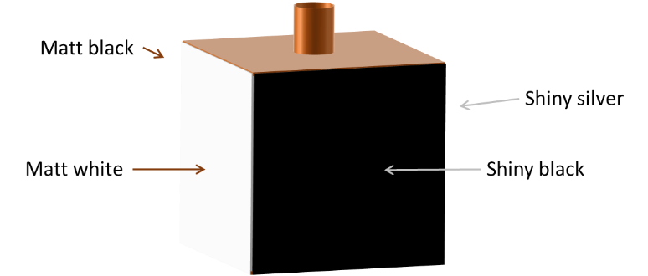
A hollow metal cube is filled with hot water from a kettle.
It has four different coloured surfaces.
It can be used to investigate what surface emits infrared radiation most quickly.

Light reflects most off the shiny silver surface.
Light is absorbed best by the matt black surface.
Predict
Which colour surface do you think emits infrared radiation the most quickly?

Explain
Explain why you think this colour emits infrared most quickly?

Observe which colour surface emits infrared radiation most quickly.

Observe
Record measurements of infrared radiation emitted from each colour surface.

Explain
Were your prediction and explanation correct?
Try to improve your first explanation to explain what happens more clearly.

Physics > Big idea PSL: Sound, light and waves > Topic PSL7: Electromagnetic waves > Key concept PSL7.1: More than light
Response activity
Emitting infrared

Overview
Learning focus: | Electromagnetic radiation is made of vibrating electric and magnetic fields that can travel through a vacuum. Light and other types of EM radiation are organised in order of frequency across the EM spectrum.
Observable learning outcome: | Compare infrared radiation and light.
Activity type: | Predict, explain; observe, explain (PEOE)
Key words: | Infrared radiation, emit, absorb, reflect, matt, shiny

This activity can help develop students’ understanding by addressing the sticking-points revealed by the following diagnostic questions:
- Diagnostic question: Under red
- Diagnostic question: Detecting infrared
What does the research say?
Most students, age 12-18, do not consider light to be radiation (Rego and Peralta, 2006; Neumann and Hopf, 2012). The BEST key concept: PSL6.1 Refraction and dispersion develops understanding of the wave model of light, which can be extended by considering what can be observed beyond either end of the visible spectrum, which is recommended by Neumann (2014).
Libarkin et al. (2011) found that, prior to teaching, very few students were familiar with infrared (IR) radiation, found a little beyond the red end of the visible spectrum, and most were unable to explain what it was or describe its characteristics. In a separate study 15% (n=50) of 14- to 16-year olds had the misunderstanding that IR radiation was visible, perhaps because they had observed some visible light emitted by heat lamps, or IR emitted by filament bulbs (Neumann and Hopf, 2012).
Ways to use this activity
Students should complete this activity in pairs or small groups, and the focus should be on the discussions. It is through the discussions that students can check their understanding and rehearse their explanations.
To begin, each group should discuss the activity and use their scientific understanding, firstly to predict what they think will happen, and then to explain why they think they are going to be right. If students in any group cannot agree, you may be able to direct them with some careful questioning.
Students now carry out the practical, or watch a demonstration. You will need to decide whether it is better for each group to carry out the practical and risk some unexpected observations, or to demonstrate the activity so that everyone observes the same thing.
After the practical each group should be given the opportunity to change, or improve their explanation. A good way to review your students’ thinking might be through a structured class discussion. You could ask several groups for their explanations and put these on the whiteboard. Then ask other groups to suggest which explanation is the most accurate and the most clearly expressed, and through careful questioning work up a clear ‘class explanation’.
A useful follow up is for individual students to then write down explanations in their own words – without reference to the class explanation on the board (i.e. cover it up).
Differentiation
The quality of the discussions can be improved with a careful selection of groups; or by allocating specific roles to students in each group. For example, you may choose to select a student with strong prior knowledge as a scribe, and forbid them from contributing any of their own answers. They may question the others and only write down what they have been told. This strategy encourages contributions from more members of each group.
Equipment
For a demonstration or for each pair/group:
- Leslie cube
- Electric kettle for hot water
- Infrared detector, or thermal imaging camera, or hands.
Technician notes
The Leslie cube needs to be filled almost full with hot water, so that the whole of each face is at the same temperature.
It needs to be placed on a surface that can withstand 100 ºC for a period of time, or on a heat resistant mat.
Health and safety
Touching the Leslie cube before it has cooled can cause burns.
Picking up a hot Leslie cube can cause spillages of scolding-hot water.
Practical work should be carried out in accordance with local health and safety requirements, guidance from manufacturers and suppliers, and guidance available from CLEAPSS.
Expected answers
The matt black surface emits infrared the most quickly. It is the best colour for absorbing energy from light, and because infrared is very similar to light it is also the best colour for absorbing energy from infrared.
The best absorbers of radiation are also the best emitters. Other colours better reflect infrared radiation from the hot water back into the cube so that it is emitted less quickly.
Acknowledgments
Developed by Peter Fairhurst (UYSEG).
Images: Peter Fairhurst (UYSEG).

References
Libarkin, J. C., et al. (2011). Invisible misconceptions: Student understanding of ultraviolet and infrared radiation. Astronomy Education Review, 10(1).
Neumann, S. (2014). Three misconceptions about radiation—and what we teachers can do to confront them. The Physics Teacher, 52(6), 357-359.
Neumann, S. and Hopf, M. (2012). Students’ conceptions about ‘radiation’: Results from an explorative interview study of 9th grade students. Journal of Science Education and Technology, 21, 826-834.
Rego, F. and Peralta, L. (2006). Portuguese students' knowledge of radiation physics. Physics Education, 41(3), 259.

