Ultraviolet lamp

Banknote, driving licences and bank cards have invisible security markings.
The markings can be seen using an ultraviolet lamp.
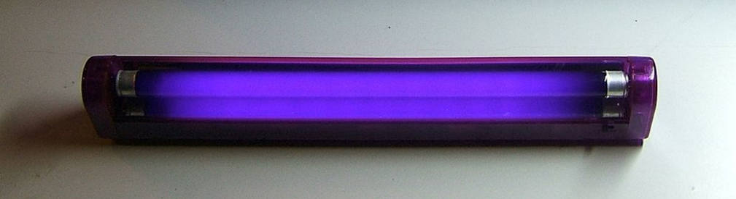
Some students are talking about looking at a banknote with the ultraviolet lamp.
Sidney: We see ultraviolet reflecting off the invisible markings.
Tegan: The UV ink glows in the ultraviolet.

Umar: The ultraviolet is a pinky-purple colour.
Verity: We can’t see the ultraviolet.

To answer
- Who is right about ultraviolet?
  - Explain your answer
- Who is wrong about ultraviolet?
  - What would you say to help them understand?

Cards for
Ultraviolet lamp
Sidney: We see ultraviolet reflecting off the invisible markings. | Tegan: The UV ink glows in the ultraviolet.
Umar: The ultraviolet is a pinky-purple colour. | Verity: We can’t see the ultraviolet.

Cards for
Ultraviolet lamp
Sidney: We see ultraviolet reflecting off the invisible markings. | Tegan: The UV ink glows in the ultraviolet.
Umar: The ultraviolet is a pinky-purple colour. | Verity: We can’t see the ultraviolet.

Physics > Big idea PSL: Sound, light and waves > Topic PSL7: Electromagnetic waves > Key concept PSL7.1: More than light
Response activity
Ultraviolet lamp

Overview
Learning focus: | Electromagnetic radiation is made of vibrating electric and magnetic fields that can travel through a vacuum. Light and other types of EM radiation are organised in order of frequency across the EM spectrum.
Observable learning outcome: | Compare ultraviolet radiation and light.
Activity type: | Talking heads
Key words: | Ultraviolet radiation, ultraviolet ink, fluorescence

This activity can help develop students’ understanding by addressing the sticking-points revealed by the following diagnostic question:
- Diagnostic question: Beyond violet
What does the research say?
Students tend to be aware of ultraviolet (UV) radiation, but the majority of those aged 11-18 (n=283) were found to have the misunderstanding that the Sun is the only source of ultraviolet radiation (Libarkin et al., 2011), which suggests their knowledge of UV is perhaps linked to tanning and to the risk of sunburn. In Neumann and Hopf’s study (2012), 40% (n=50) of 14- to 16-year-olds had the misunderstanding that UV was visible. These students may have observed UV lamps that emit a visible violet glow in addition to UV, or think that the light emitted from fluorescent paint seen under UV lamps is ‘UV light’ (Neumann, 2014). In the latter case, fluorescent paint is able to emit visible light because of the energy transferred to it by UV radiation it absorbs. In the study by Libarkin et al. (2011), about 80% of students were found to have the misunderstanding that it is possible to see objects in the presence of UV radiation alone, and some considered UV to be both invisible and either blue or violet in colour.
Ways to use this activity
This task is intended for discussion in pairs or small groups. It can be done as a pencil and paper exercise or projected onto a screen.
Students should read the statements and follow the instructions on either the worksheet or the PowerPoint. Listening in to the conversations of each group will often give you insights into how your students are thinking. Each member of a group should be able to report back to the class.
Feedback from each group can be used, with careful teacher questioning, to bring out a clear description or explanation of the science.
Differentiation
The quality of the discussions can be improved with a careful selection of groups; or by allocating specific roles to students in each group. For example, you may choose to select a student with strong prior knowledge as the scribe, and forbid them from contributing any of their own answers. They may question the others and only write down what they have been told. This strategy encourages contributions from more members of each group.
NB in any class, small group discussions typically improve over time and a persistence with this strategy is often very successful in the medium to long term.
Expected answers
1. Tegan and Verity are right.
The ultraviolet is invisible to the human eye and we do not see it at all. What we see is the UV ink absorbing energy from UV and reemitting it as light, which is why it appears to glow.
2. Sidney and Umar are wrong.
Sidney is wrong because UV is invisible, we cannot see it reflecting off the invisible markings. Instead we see the ink glow and emit visible light because of energy it absorbs from the UV.
Umar is wrong because the pinky-purple (violet coloured) light is not UV, it is visible light from close to one end of the visible spectrum. The UV lamp emits violet light as well as UV radiation.
Acknowledgments
Developed by Peter Fairhurst (UYSEG).
Image: by Chetvorno from Wikipedia Commons.
References
Libarkin, J. C., et al. (2011). Invisible misconceptions: Student understanding of ultraviolet and infrared radiation. Astronomy Education Review, 10(1).
Neumann, S. (2014). Three misconceptions about radiation—and what we teachers can do to confront them. The Physics Teacher, 52(6), 357-359.
Neumann, S. and Hopf, M. (2012). Students’ conceptions about ‘radiation’: Results from an explorative interview study of 9th grade students. Journal of Science Education and Technology, 21, 826-834.

